09/25/2024 Presented by: Mr. Heitic

ORDINANCE NO. 89-2024

TITLE: APPROVE TAX INCREMENT FINANCING
666 NORTON AVENUE
PARCEL NUMBER 0111042

AN ORDINANCE DECLARING THE IMPROVEMENTS TO CERTAIN REAL PROPERTY WITHIN THE CITY TO BE A PUBLIC PURPOSE; DESCRIBING THE PUBLIC IMPROVEMENTS TO BE MADE TO DIRECTLY BENEFIT SUCH PARCELS; EXEMPTING SUCH IMPROVEMENTS FROM AD VALOREM REAL PROPERTY TAXATION; REQUIRING THE OWNER OF THE IMPROVEMENTS TO MAKE SERVICE PAYMENTS IN LIEU OF AD VALOREM REAL PROPERTY TAXES AND ESTABLISHING A MUNICIPAL PUBLIC IMPROVEMENT TAX INCREMENT EQUIVALENT FUND FOR THE DEPOSIT OF THE SERVICE PAYMENTS IN LIEU OF AD VAL OREM PROPERTY TAXES, ALL PURSUANT TO SECTIONS 5709.40, 5709.42 AND 5709.43 OF THE REVISED CODE; AND DECLARING AN EMERGENCY.

WHEREAS, Sections 5709.40, 5709.42 and 5709.43 of the Revised Code (the "Act") provide that this Council may describe public improvements to be made that directly benefit certain parcels and declare "Improvements" (as defined in Section 5709.40) with respect to such parcels of real property located in the City to be a public purpose, thereby authorizing the exemption of those Improvements from real property taxation for a period of time, and provide for the making of service payments in lieu of ad valorem real property taxes by the owner of such parcels, and establish a municipal public improvement tax increment equivalent fund into which such service payments shall be deposited; and

WHEREAS, certain parcels of real property in the City, as more particularly described in Exhibit A, attached hereto (the "TIF Site") are currently being improved and/or are expected to be improved in the near future (the "Development”); and

WHEREAS, in order to successfully develop the TIF Site, it is necessary to construct or to cause to be constructed certain public infrastructure improvements as defined in Section 5709.40(A)(8) of the Revised Code and as further described in Exhibit B attached hereto (the "Public Infrastructure Improvements”) that will directly benefit the TIF Site; and

WHEREAS, the Public Infrastructure Improvements and the Development are a public purpose of the City, and provide the conditions necessary to permit the City to lawfully exempt the TIF Site from real property taxation as authorized herein; and

WHEREAS, the presence of the Development in the City will benefit the City and its residents by creating economic opportunities, increasing local employment opportunities, enlarging the property tax and income tax bases, and stimulating collateral development in the City; and

WHEREAS, the City has determined that it is necessary and appropriate and in the best interests of the City to provide for service payments in lieu of taxes with respect to the Improvement of the TIF Site, pursuant to Section 5709.42 of the Revised Code, to pay costs of the Public Infrastructure Improvements; and

WHEREAS, the City has delivered to the Barberton City School District (the “School District") the written notification of this Ordinance required by Sections 5709.40, 5709.83 and 5715.27 of the Revised Code

NOW, THEREFORE, BE IT ORDAINED by the County of the City of Barberton, County of Summit, State of Ohio, that:

SECTION 1. The Public Infrastructure Improvements described in Exhibit B are hereby designated as those public improvements that directly benefit, or that once made will directly benefit, the TIF Site and the City and, together with the balance of the Development, are determined to be necessary for the public health, safety and welfare, and a public purpose.

SECTION 2. Pursuant to and in accordance with the provisions of Section 5709.40(8) of the Revised Code, this Council hereby finds and determines that 100% of the increase in the assessed value of the TIF Site that would first appear on the tax list and duplicate of real property after the effective date of this Ordinance (which increase in assessed value is herein referred to as the "Improvement" or "Improvements" as defined in Section 5709.40(A)(4)) is a public purpose, and 100% of said Improvement is hereby declared to be a public purpose, for a period not to exceed 30 years and exempt from taxation commencing, for each parcel, with the first tax year that begins after the effective date of this Ordinance and in which an improvement resulting from the construction of a structure on that parcel first appears and ending on the date the Improvements have been exempted from taxation for a period of 30 years (the "Exemption Period"); provided, however, that certain compensatory payments shall be paid to the School District in the amounts and on the dates as provided in Section 4 herein.

SECTION 3. As provided in Section 5709.42 of the Revised Code, the owner or owners of the Improvements are hereby required to and shall pay the service payments in lieu of ad valorem real property taxes to the Summit County Fiscal Officer (unless otherwise authorized and directed in writing by the County of Summit) on or before the final dates for payment of real property taxes, which service payments in lieu of ad valorem real property taxes, together with any associated rollback payments shall be deposited in the Municipal Public Improvement Tax Increment Equivalent Fund described in Section 4. Any late payments of service payments in lieu of ad valorem real property taxes be subject to penalty and bear interest at the then current rate established under Sections 323 .12 I (B)( l) and 5703 .47 of the Revised Code, as may hereinafter be amended, or any successor provisions thereto (the late payments together with the service payments in lieu of ad valorem real property taxes and rollback payments are referred to collectively as the "Service Payments"). This Council hereby authorizes the Mayor, the Director of Finance, the Director of Law, and other appropriate officers of the City, to provide such information and certifications, and execute and deliver or accept delivery of such instruments, as are necessary or incidental to collect those Service Payments, and to make such arrangements as are necessary and proper for payment of the Service Payments.

SECTION 4. This Council hereby (a) establishes pursuant to and in accordance with the provisions of Section 5709.43 of the Revised Code, the Municipal Public Improvement Tax Increment Equivalent Fund (the "Fund") into which there shall be deposited all of the Service Payments with respect to the Improvements on the TIF Site by or on behalf of the City, as provided in Section 5709.42 of the Revised Code, and (b) agrees that moneys in the Fund shall be used solely for the purposes authorized in the Act, including for any or all of the following purposes:

(i) to the School District, a portion of the Service Payments received by the City equal to the amount of the taxes that would have been payable to the School District if the Improvements had not been exempted from taxation by this Ordinance (the "School District Payments");

(ii) to the City to pay any and all planning, Engineering, acquisition, construction, installation, financing costs, and any and all other direct and indirect costs of the Public Infrastructure Improvements, including those costs set forth in Section 133 .15(8) of the Revised Code; and

(iii) to the City to pay the interest and any premium on, and principal of, any loans entered into or bonds or notes or other obligations issued or by the City or any other governmental entity to finance costs of the Public Infrastructure Improvements (including any amendment, replacement, refinancing, extension of such loans, bonds, notes or other obligations, collectively, the ·City Loan") until such notes or bonds or other obligations or loans are paid in full, and to pay any trustee, administrative and other costs related to servicing the obligations and providing and replenishing a reserve fund and to pay any costs charged by the issuer of the obligations; and

The Fund shall be maintained in the custody of the City and shall receive all distributions of Service Payments required to be made to the City. The Fund shall remain in existence so long as the Service Payments are collected and used for the aforesaid purposes, after which said Fund shall be dissolved in accordance with Section 5709.43.

SECTION 5: This Council hereby designates the Public Infrastructure Improvements described in Exhibit B as "Public Infrastructure Improvements" as defined in Section 5709.40(A)(8) of the Revised Code.

SECTION 6: This Council further hereby authorizes and directs the Mayor, the Director of Finance, the Director of Law, the Clerk of Council or other appropriate officers of the City to sign and execute all documents and make such arrangements as are necessary and proper for (i) collection of the Service Payments to be deposited in the Fund, (ii) payment of the School District Payments and (iii) carrying out the provisions of this Ordinance.

SECTION 7: This Council hereby designates the City's tax incentive review council (“TIRC”) previously established by this County as the TIRC that shall annually review the exemptions provided pursuant to this Ordinance as required by R.C. Section 5709.85. In the event it is determined that such a TIRC did not previously exist, then the TIRC shall be established by the City pursuant to Section 5709.85 of the Ohio Revised Code.

SECTION 8: In accordance with Ohio Revised Code Section 5709.832, the City hereby determines that no employer located on the TIF Site shall deny any individual employment based on considerations of race, religion, sex, disability, color, national origin or ancestry.

SECTION 9: Pursuant to Section 5709.40(1) of the Revised Code, the Clerk of Council is hereby directed to deliver or cause to be delivered a copy of this Ordinance to the Director of the Ohio Development Services Agency (the "Director") within 15 days after its passage. On or before March 31 of each year that the exemption set forth in Section 2 remains in effect, the Mayor, the Director of Finance, or other authorized officer of this City shall prepare and submit to the Director the status report required under Section 5709.40(1

SECTION 10: This Council finds and determines that all formal actions of this Council and any of its committees concerning and relating to the passage of this Ordinance were taken, and that all deliberations of this Council and of any committees that resulted in those formal actions were held in meetings open to the public in compliance with the law.

SECTION 11: This Ordinance is declared to be an emergency measure necessary for the immediate preservation of the public peace, health and safety of the City, and for the further reason that this Ordinance is required to be immediately effective in order to enable the City to provide for the real property tax exemption, the Service Payments, and the related objectives provided for herein that are needed to benefit the City and its residents by creating economic opportunities, enlarging the property tax and income tax bases, and stimulating collateral development within the City; and provided it receives the approval of two-thirds of the members of Council, shall be in full force and effect from and after its passage and approval by the Mayor, or otherwise take effect and be in full force from and after the earliest period allowed by law.

Passed October 14, 2024

Clerk of Council President of Council

Approved 2024

Mayor

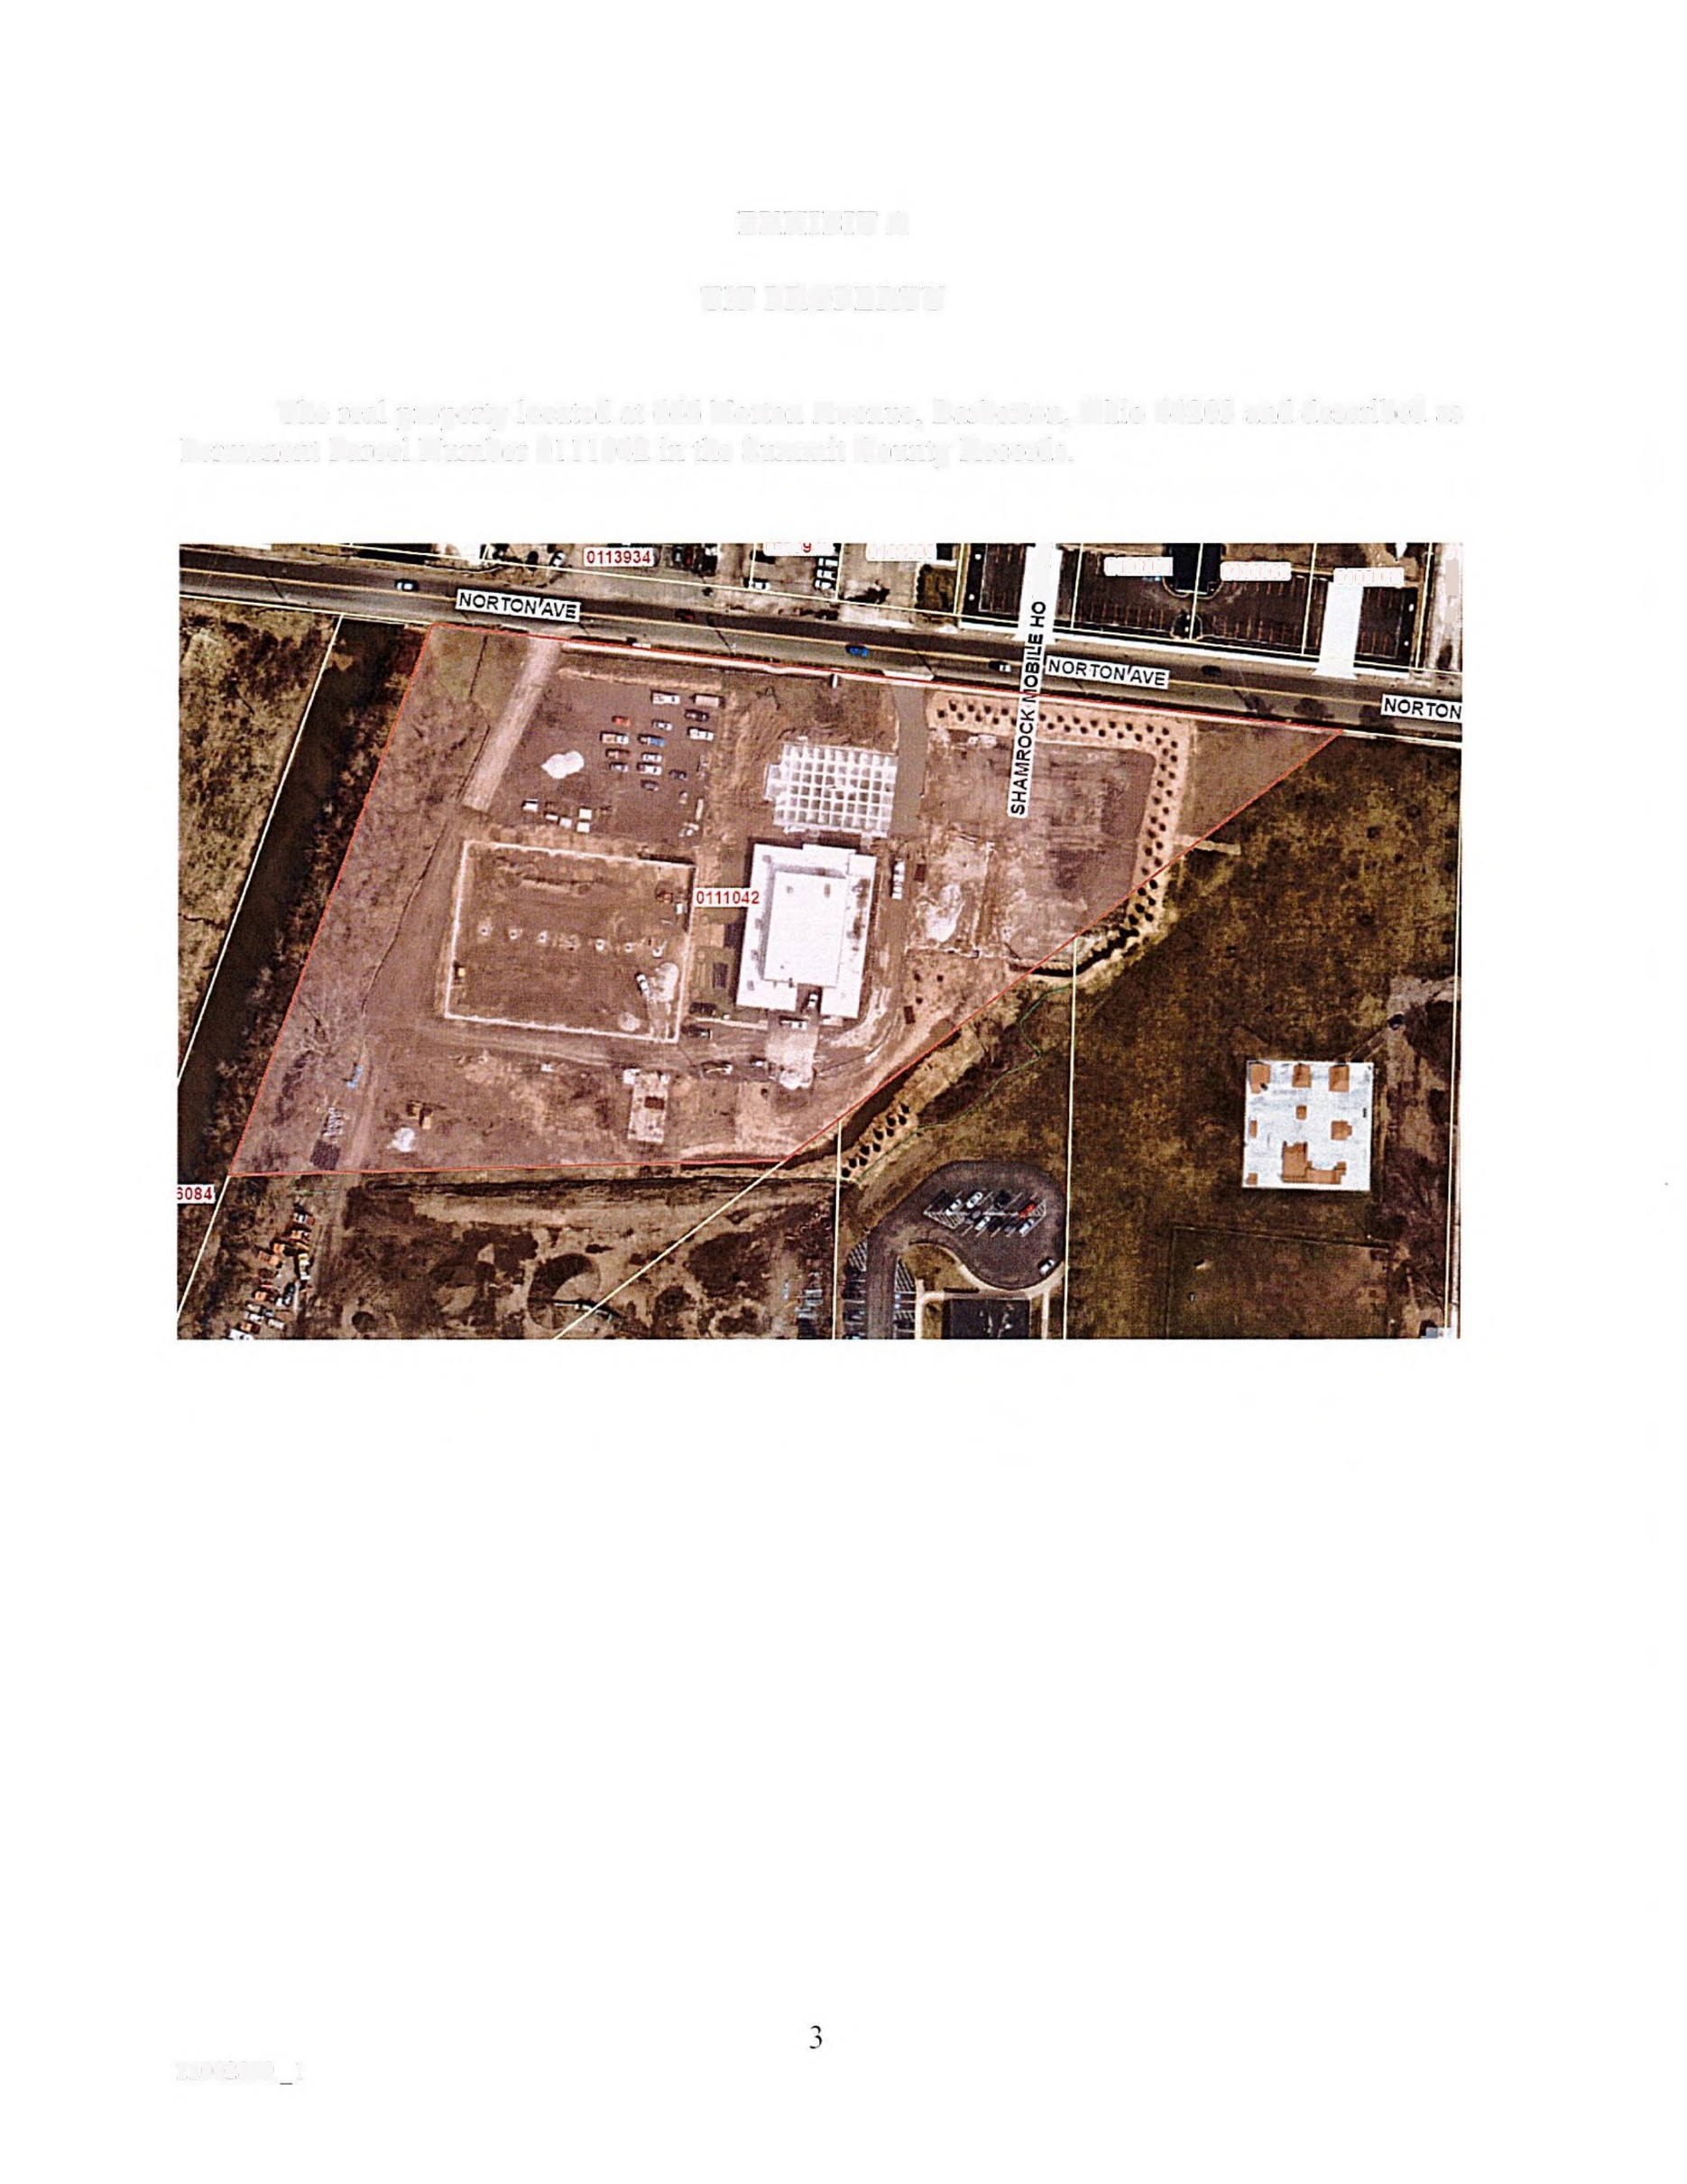
EXHIBIT A

TIF SITE

The real property located at 666 Norton Avenue, Barberton, Ohio 44203 and described as Permanent Parcel Number 0111042 in the Summit County Records.

EXHIBIT B

DESCRIPTION OF THE
PUBLIC INFRASTRUCTURE IMPROVEMENTS

The Public Infrastructure Improvements consist of the following, all of which (i) are "public infrastructure improvements" (as defined in Ohio Revised Code Sections 5709.40(A)(8), (ii) are intended to directly benefit the TIF site, and (iii) include, in each instance, the acquisition of interests in real estate and demolition and remediation related thereto:

• Roadwavs. Construction, reconstruction, extension, opening, improving, widening, grading, draining, curbing or changing of the lines and traffic patterns of roads, highways; streets, intersections, bridges (both roadway and pedestrian), sidewalks, bikeways, medians. and viaducts accessible to and serving the public, and providing signage (including traffic signage and informational/promotional signage), lighting systems, signalization, and traffic controls, and all other appurtenances thereto;

• Water/Sewer. Construction, reconstruction or installation of public utility improvements (including any underground municipally owned utilities), storm and sanitary sewers (including necessary site grading therefore), water and fire protection systems, and all appurtenances thereto;

• Environmental/Health. Implementation of environmental remediation measures necessary to enable the construction of the Public Infrastructure Improvements and the construction of public health facilities;

• Utilities. Construction, reconstruction or installation of gas, electric and communication service facilities and all appurtenances thereto;

• Stormwater. Construction, reconstruction and installation of storm water and flood remediation facilities, including facilities on private property when determined to be necessary for public health, safety and welfare;

• Demolition. Demolition, including demolition on private property when determined to be necessary for public health, safety and welfare;

• Streetscape/Landscape. Construction or installation of streetscape and landscape improvements including trees, tree grates, signage, curbs, sidewalks, scenic fencing, street and sidewalk lighting, trash receptacles, benches, newspaper racks, burial of overhead utility lines and related improvements, together with all appurtenances thereto, including, but not limited to streetscape improvements in conjunction with and along the roadway improvements described in "Roadways" above:

- Professional Services. Engineering, consulting, legal, administrative, and other professional services associated with the planning, design, acquisition, construction, and installation of the foregoing improvements.

The Public Infrastructure Improvements specifically include the costs of financing the Public Infrastructure Improvements, including the items of "costs of permanent improvements" set forth in Ohio Revised Code Section 133. 15(B), and incurred with respect to the Public Infrastructure Improvements, which "costs" specifically include any reimbursement payments for the reimbursement of the costs of the Public Infrastructure Improvements and the debt service on, and other expenses relating to the issuance of, any bonds, notes, or other obligations issued to finance the Public Infrastructure Improvements.

