10/14/2024 Presented by: Mr. Heitic

ORDINANCE NO. 95-2024

TITLE: EXPANDING AND AMENDING
COMMUNITY REINVESTMENT AREA #2

AN ORDINANCE EXPANDING AND AMENDING THE TERMS OF TAX EXEMPTIONS WITHIN COMMUNITY REINVESTMENT AREA #2; AND DECLARING AN EMERGENCY.

WHEREAS, the General Assembly of the State of Ohio, by the enactment of Sections 3735.65 et seq. of the Ohio Revised Code (the “Community Reinvestment Area Program”), has heretofore authorized municipal corporations to designate Community Reinvestment Areas to provide incentives for new residential, commercial or industrial development and/or rehabilitation in such areas, by making available property tax exemption for such new development or rehabilitation; and

WHEREAS, pursuant to the Community Reinvestment Area Program, this Council adopted Ordinance No. 136-2007 (the “Original CRA Ordinance”), in which it approved the designation of the geographic area described in the Original CRA Ordinance and found that the construction of new structures within such geographic area, as described and depicted in the Original CRA Ordinance and known as Community Reinvestment Area #2 would serve to encourage economic stability, maintain real property values, and generate new employment opportunities within the Community Reinvestment Area #2; and

WHEREAS, the Original CRA Ordinance provides for the following terms for tax exemptions within Community Reinvestment Area #2;

- For the remodeling of every residential dwelling unit containing not more than two housing units and upon which the cost of remodeling is at least $2,500, as described in Section 3735.67 of the Ohio Revised Code, an exemption of 50% for 5 years;

- For the construction of dwellings containing not more than one housing unit, as described in Section 3735.67 of the Ohio Revised Code, an exemption of 50% for 5 years;

- For the remodeling of existing commercial and industrial facilities and upon which the cost of remodeling is at least $5,000, as described in Section 3735.67 of the Ohio Revised Code, an exemption of up to 50% for up to 12 years, to be negotiated and approved by this Council on a case-by-case basis in advance of the construction occurring; and

- For the construction of new commercial or industrial facilities, as described in Section 3735.67 of the Ohio Revised Code, an exemption of up to 50% for up to 15 years, to be negotiated and approved by this Council on a case-by-case basis in advance of the construction occurring; and

- Buildings containing 2 and fewer residential housing units are considered residential improvements.

WHEREAS, this Council now desires to amend Community Reinvestment Area #2 to expand it to include the geographic area set forth on Exhibit A, attached hereto and incorporated herein, to include the entire geographic area of the City other than Community Reinvestment Area #1 and the Trucen Farms Community Reinvestment Area in order to grant tax exemptions to encourage economic stability, maintain real property values and generate new employment opportunities; and

WHEREAS, this Council further desires to amend the terms of tax exemptions within Community Reinvestment Area #2 as follows:

- For the remodeling of every residential dwelling property containing not more than two dwelling units and upon which the cost of remodeling is at least $2,500, as described in Section 3735.67 of the Ohio Revised Code, an exemption of 100% for 15 years;

- For the remodeling of every residential dwelling property containing more than two dwelling units and upon which the cost of remodeling is at least $5,000, as described in Section 3735.67 of the Ohio Revised Code, an exemption of 100% for 15 years;

- For the construction of residential dwelling property containing one or more housing units, as described in Section 3735.67 of the Ohio Revised Code, an exemption of 100% for 15 years;

- For the remodeling of existing commercial and industrial facilities and upon which the cost of remodeling is at least $5,000, as described in Section 3735.67 of the Ohio Revised Code, an exemption of up to 100% for up to 15 years, to be negotiated and approved by this Council on a case-by-case basis in advance of the construction occurring; and

- For the construction of new commercial or industrial facilities, as described in Section 3735.67 of the Ohio Revised Code, an exemption of up to 100% for up to 15 years, to be negotiated and approved by this Council on a case-by-case basis in advance of the construction occurring; and

- Pursuant to Section 3735.66 of the Ohio Revised Code, all buildings containing one or more dwelling unit shall be considered residential dwelling property for the purposes of this Ordinance.

WHEREAS, the City has performed an updated housing study (the “Housing Study”) for the geographic area set forth on Exhibit A that will serve as the geographic area of Community Reinvestment Area #2;
NOW, THEREFORE, BE IT ORDAINED by the County of the City of Barberton, County of Summit, State of Ohio, that:

SECTION 1. For the purposes of fulfilling the requirements set forth under Sections 3735.65 to 3735.70 of the Ohio Revised Code, this Council adopts the findings of the Housing Survey on file with the Clerk of Council that Community Reinvestment Area #2 is one in which housing facilities or structures of historical significance are located and new housing construction and repair of existing facilities or structures are discouraged. The findings of the Housing Survey are hereby incorporated into this Ordinance.

SECTION 2. The boundaries of Community Reinvestment Area #2 are hereby amended to expand Community Reinvestment Area #2 to include all areas depicted in Exhibit A attached hereto. This Council hereby finds that the area included within Community Reinvestment Area #2, as forth in Exhibit A, is one in which housing facilities or structures of historical significance are located and new housing construction and repair of existing facilities or structures are discouraged.

SECTION 3. The Original CRA Ordinance is hereby amended to amend the terms of tax exemptions within Community Reinvestment Area #2 as follows:

- For the remodeling of every residential dwelling property containing not more than two dwelling units and upon which the cost of remodeling is at least $2,500, as described in Section 3735.67 of the Ohio Revised Code, an exemption of 100% for 15 years;

- For the remodeling of every residential dwelling property containing more than two dwelling units and upon which the cost of remodeling is at least $5,000, as described in Section 3735.67 of the Ohio Revised Code, an exemption of 100% for 15 years;

- For the construction of residential dwelling property containing one or more housing units, as described in Section 3735.67 of the Ohio Revised Code, an exemption of 100% for 15 years;
- For the remodeling of existing commercial and industrial facilities and upon which the cost of remodeling is at least $5,000, as described in Section 3735.67 of the Ohio Revised Code, an exemption of up to 100% for up to 15 years, to be negotiated and approved by this Council on a case-by-case basis in advance of the construction occurring; and

- For the construction of new commercial or industrial facilities, as described in Section 3735.67 of the Ohio Revised Code, an exemption of up to 100% for up to 15 years, to be negotiated and approved by this Council on a case-by-case basis in advance of the construction occurring; and

- Pursuant to Section 3735.66 of the Ohio Revised Code, all buildings containing one or more dwelling unit shall be considered residential dwelling property for the purposes of this Ordinance.

SECTION 4. Except as amended hereby, the Original CRA Ordinance shall remain in full force and effect.

SECTION 5. That this Council further hereby authorizes and directs the Mayor, the Clerk of Council, the Law Director, the Finance Director, the Housing Officer, or other appropriate officers of the City to prepare and sign all agreements and instruments, to publish or deliver all required notices, submit all required petitions and applications, and take any other actions as may be appropriate to implement this Ordinance. All previous actions taken by such officers are hereby ratified.

SECTION 6. This Council hereby repeals in its entirety Ordinance No. 86-2022, Ordinance No. 149-2022 and any other ordinance previously adopted with by this Council that is inconsistent with the terms of this Ordinance. Furthermore, this Council reaffirms the repeal of Ordinance/Resolution No. 345-1977, 215-1977, 215-1979, 37-1979, 123-1983, 146-1979 145-1985 and 57-1994 that were previously repealed by the Original CRA Ordinance.

SECTION 7. This Council finds and determines that all formal actions of this Council and of any of its committees concerning and relating to the passage of this Ordinance were taken, and that all deliberations of this Council and of any committees that resulted in those formal actions were held, in meetings open to the public in compliance with the law.

SECTION 8. This Ordinance is declared to be an emergency measure necessary for the immediate preservation of the public peace, health and safety of the City, and for the further reason that this Ordinance is required to be immediately effective in order to enable the City to provide for the real property tax exemptions provided for herein that are needed to benefit the City and its residents by creating economic opportunities, enlarging the property tax and income tax bases, and stimulating collateral development within the City; and provided it receives the approval of two-thirds of the members of Council, shall be in full force and effect from and after its passage and approval by the Mayor, or otherwise take effect and be in full force from and after the earliest period allowed by law.

Passed October 28, 2024

__________________________________ ___________________________________
Clerk of Council President of Council

Approved ______________________ 2024

___________________________________
Mayor

EXHIBIT A

TIF SITE

The real property located at 666 Norton Avenue, Barberton, Ohio 44203 and described as Permanent Parcel Number 0111042 in the Summit County Records.

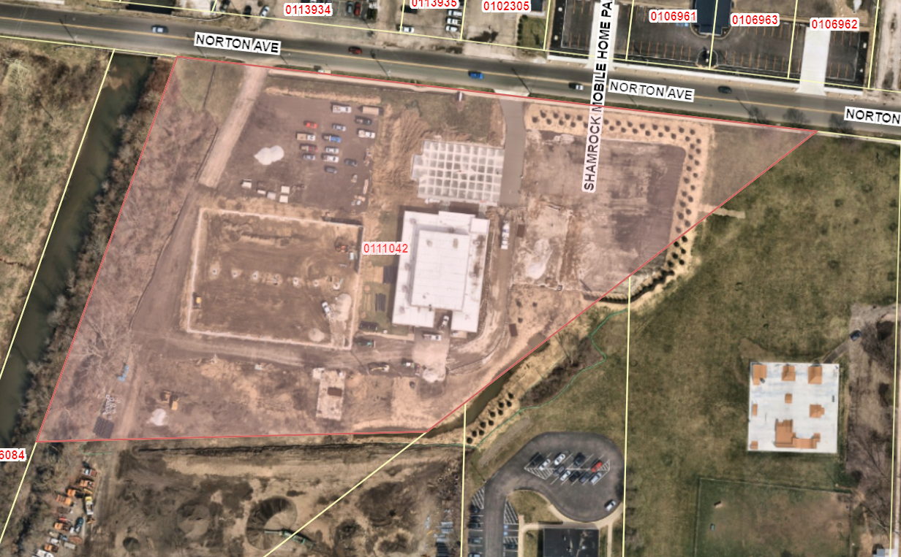

EXHIBIT B

DESCRIPTION OF THE
PUBLIC INFRASTRUCTURE IMPROVEMENTS

The Public Infrastructure Improvements consist of the following, all of which (i) are “public infrastructure improvements” (as defined in Ohio Revised Code Sections 5709.40(A)(8), (ii) are intended to directly benefit the TIF site, and (iii) include, in each instance, the acquisition of interests in real estate and demolition and remediation related thereto:

- Roadways. Construction, reconstruction, extension, opening, improving, widening, grading, draining, curbing or changing of the lines and traffic patterns of roads, highways; streets, intersections, bridges (both roadway and pedestrian), sidewalks, bikeways, medians. and viaducts accessible to and serving the public, and providing signage (including traffic signage and informational/promotional signage), lighting systems, signalization, and traffic controls, and all other appurtenances thereto;

- Water/Sewer. Construction, reconstruction or installation of public utility improvements (including any underground municipally owned utilities), storm and sanitary sewers (including necessary site grading therefore), water and fire protection systems, and all appurtenances thereto;

- Environmental/Health. Implementation of environmental remediation measures necessary to enable the construction of the Public Infrastructure Improvements and the construction of public health facilities;

- Utilities. Construction, reconstruction or installation of gas, electric and communication service facilities and all appurtenances thereto;

- Stormwater. Construction, reconstruction and installation of stormwater and flood remediation facilities, including facilities on private property when determined to be necessary for public health, safety and welfare;

- Demolition. Demolition, including demolition on private property when determined to be necessary for public health, safety and welfare;

- Streetscape/Landscape. Construction or installation of streetscape and landscape improvements including trees, tree grates, signage, curbs, sidewalks, scenic fencing, street and sidewalk lighting, trash receptacles, benches, newspaper racks, burial of overhead utility lines and related improvements, together with all appurtenances thereto, including, but not limited to streetscape improvements in conjunction with and along the roadway improvements described in “Roadways” above;

- Professional Services. Engineering, consulting, legal, administrative, and other professional services associated with the planning, design, acquisition, construction, and installation of the foregoing improvements.

The Public Infrastructure Improvements specifically include the costs of financing the Public Infrastructure Improvements, including the items of “costs of permanent improvements” set forth in Ohio Revised Code Section 133.15(B), and incurred with respect to the Public Infrastructure Improvements, which “costs” specifically include any reimbursement payments for the reimbursement of the costs of the Public Infrastructure Improvements and the debt service on, and other expenses relating to the issuance of, any bonds, notes, or other obligations issued to finance the Public Infrastructure Improvements.

