PROPERTY OWNER:
MAILING ADDRESS:

ADDRESS PAINTED:
TYPE OF STRUCTURE:
NO. OF GALLONS USED:
DATE PAINTED:

PLEASE NOTE:

CITY OF BARBERTON
BUILDING DEPARTMENT

PAINT REBATE APPLICATION

(Limit- one application per property owner)

(Rebate of $25/gallon - Maximum 10 gallons/$250)

Original receipts and photos must be attached to this application for the cost of paint to be rebated. Paint must be purchased and structure painted prior to rebate application being submitted.

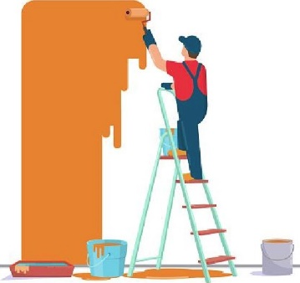
Deadline to have all documentation including application, pictures, and receipts to the Building Dept by December 1st, 2025.

