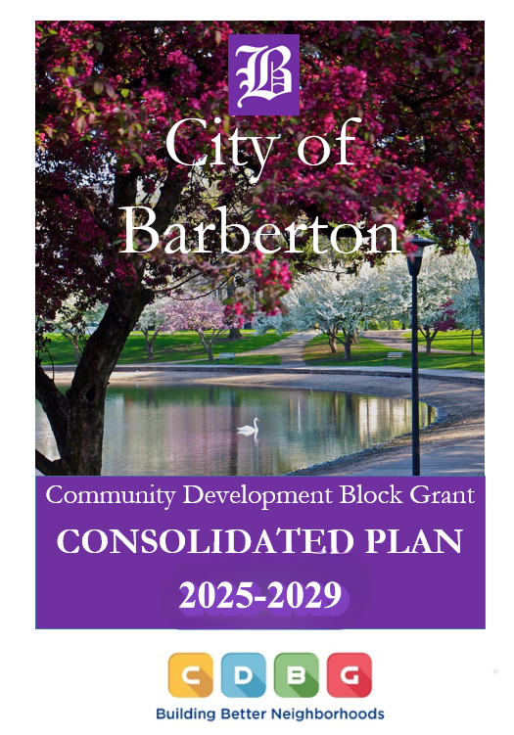

Executive Summary

ES-05 Executive Summary - 24 CFR 91.200(c), 91.220(b)
1. Introduction
Through a collaborative effort involving local stakeholders, non-profits, and community members, the City of Barberton has undertaken a comprehensive approach to planning and development. This effort aims to create a framework that not only addresses current challenges but also establishes a long-term vision for equitable growth and sustainability. The Consolidated Plan serves as the cornerstone of this initiative, bringing together data analysis, community input, and innovative strategies to meet pressing needs effectively.
Following an in-depth review of Census data, local information sources, and input gathered through consultations with non-profit organizations, service providers, and participating communities, five key goals were established for the 2025-2029 Consolidated Plan. Each initiative is grounded one of the five goals identified below and aims to improve quality of life for Barberton residents, particularly those in underserved neighborhoods.
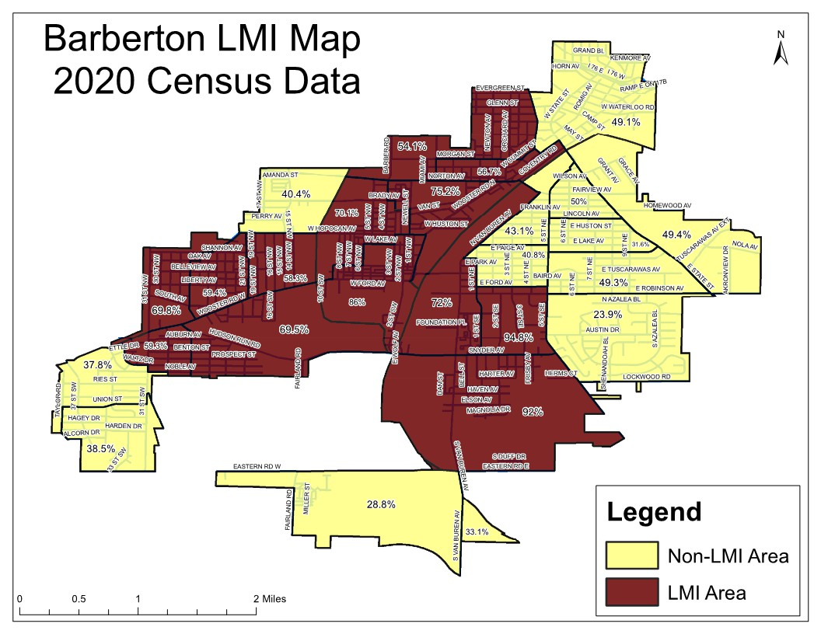
LMI Map
2. Summary of the objectives and outcomes identified in the Plan Needs Assessment Overview
The City of Barberton is committed to advancing integrated community development initiatives that center around the following key priority areas:
GOAL 1: THE CREATION AND RETENTION OF AN ADEQUATE LIVING ENVIRONMENT:
To improve quality of life and foster vibrant neighborhoods for underserved individuals through various public services, infrastructure enhancements, economic growth initiatives, brownfield revitalization, and other targeted community-focused efforts.
GOAL 2: THE PROVISION OF DECENT, SAFE, SANITARY AND AFFORDABLE HOUSING:
To preserve and/or increase the availability of decent, safe, sanitary and affordable housing for underserved individuals in the City of Barberton, and to increase neighborhood viability through eliminating unsafe structures.
GOAL 3: THE PROVISION OF HISTORIC PRESERVATION:
To preserve and protect historic resources of key community landmarks in line with the Barberton Preservation Plan.
GOAL 4: EXPAND ECONOMIC DEVELOPMENT OPPORTUNITY:
Enhance projects and programs geared towards improving the economic wellbeing and quality of life of Barberton by targeting business retention, job creation, and brownfield redevelopment, while building the local tax base.
GOAL 5: PANDEMIC AND EMERGENCY PREPAREDNESS:
Prepare, Prevent, and Respond to events that are critical in nature while mitigating future risks. Increase digital availability and close the broadband access gap by providing internet and broadband services to underserved individuals.
3. Evaluation of past performance
Over the past several years, the City of Barberton has experienced turnover in its administration of CDBG programs. In April 2025, a new administrator was appointed, bringing continuity to existing goals while introducing an expanded focus on economic development opportunities. The implementation of these programs is shaped by factors such as funding levels, findings from the 2020 census, evolving local needs, and other key considerations. To ensure effectiveness, past performance and current conditions are continuously assessed in the development of the city's action plan. Based on these evaluations, underutilized programs have been phased out and replaced with new initiatives that make CDBG funding more impactful—providing tangible benefits that enhance the quality of life for underserved residents.
4. Summary of citizen participation process and consultation process
The proposed summary of the FY 2025-2029 Consolidated Plan and the FY 2025 Annual Action Plan were initially published in the Barberton Gazette, a widely circulated newspaper, and posted on the City's website on June 26, 2025. This ensured that interested parties had sufficient time to review the information and provide feedback. The summary outlined the plan’s purpose and key contents, while the full document was made accessible online at www.cityofbarberton.com and available for review at the Department of Planning & Community Development.
The City of Barberton will maintain all records related to the Consolidated Plan in compliance with the latest RC-2 guidelines. To gather public input, the city published an updated version of the Consolidated Plan on its website, presenting both the proposed draft of the Consolidated Plan and the Annual Action Plan on June 26, 2025. Residents, public agencies, and officials were invited to review the documents and provide feedback via email or letter during a 30-day comment period. Discussions took place regarding the launch of a new Housing Rehabilitation program for qualified owner-occupied residents. Committee members asked several questions on the specific requirements for the program, and expressed excitement for the opportunity to enhance our resident’s quality of life through this new program.
5. Summary of public comments
Despite a notice being published in the Barberton Gazette to inform the public about the opportunity to comment on the plan, the city did not receive any written feedback on the Plans. A discussion did take place at both the Planning Commission meeting and City Council meeting to discuss the launch of a new Home Rehabilitation program. Many members were excited to learn about this new service available for qualified homeowners.
6. Summary of comments or views not accepted and the reasons for not accepting them
No written feedback was submitted to the city concerning the Plans.
7. Summary
The City of Barberton organized multiple meetings to discuss the Consolidated and Action Plan. A discussion took place on the meaning of being an entitlement community and the definition of program income. In addition, the launch of a new Housing Rehabilitation program for qualified owner-occupied residents was presented. Several members expressed excitement for this new program and the opportunity it brings to enhance our resident’s quality of life.

The Process

PR-05 Lead & Responsible Agencies 24 CFR 91.200(b)
1. Describe agency/entity responsible for preparing the Consolidated Plan and those responsible for administration of each grant program and funding source
The following are the agencies/entities responsible for preparing the Consolidated Plan and those responsible for administration of each grant program and funding source.
Agency Role | Name | Department/Agency

CDBG Administrator | BARBERTON | Department of Planning & Community Development
Table 1 – Responsible Agencies

Narrative
The Department of Planning & Community Development serves as the primary agency overseeing the creation of the Consolidated Plan and Annual Plan. In addition, the department manages the Community Development Block Grant (CDBG) program included within it. This submission outlines the plan for fiscal years 2025-2029.

Consolidated Plan Public Contact Information
Department of Planning & Community Development
Attn: Missy Shifferly
576 W Park Ave
City of Barberton, OH 44203
330-848-6729
MShifferly@cityofbarberton.com

PR-10 Consultation – 91.100, 91.110, 91.200(b), 91.300(b), 91.215(I) and 91.315(I)
1. Introduction
The Department of Planning & Community Development serves as the primary agency overseeing the creation of the Consolidated Plan and Annual Action Plan. In addition, the department manages the Community Development Block Grant (CDBG) program outlined within the plans. This submission encompasses the fiscal years 2025–2029 Consolidated Plan and the 2025 Annual Action Plan.
Provide a concise summary of the jurisdiction’s activities to enhance coordination between public and assisted housing providers and private and governmental health, mental health and service agencies (91.215(I)).
The city will maintain its efforts to organize meetings, events, and seminars, fostering collaboration among the Akron Metropolitan Housing Authority (AMHA), public housing providers, Fair Housing representatives, community residents, the Continuum of Care, and various health and social service organizations.
The City actively participates in local non-profit committee meetings aimed at streamlining resources and minimizing service overlap to ensure effective support for underserved individuals. This group also prioritizes identifying community needs and developing strategic approaches to address them efficiently.
The city, in partnership with Fair Housing Contact Service, will continue offering training sessions for residents and landlords to strengthen Fair Housing awareness. These sessions provide essential guidance on Fair Housing laws, rules, and regulations, fostering a more all-encompassing and equitable housing environment across Barberton.
An Informed Barberton is a city-led initiative aimed at gathering resident input through public meetings to identify neighborhood needs and connect communities with available resources. This ongoing outreach program will focus on underserved neighborhoods, assessing both current and future areas of need to ensure meaningful support and development.
During the development of the five-year Consolidated Plan, the city organized multiple discussion sessions to gather input on the community’s needs. Efforts were made to engage an assorted range of groups to shape the plan’s priority goals and objectives. These sessions included elected officials, financial institutions, and both public and private agencies providing housing, health, social services, and economic development support. To ensure accessibility, all meetings were held in handicapped-accessible facilities and widely publicized through newspapers, mailed notices to government and nonprofit organizations, brochures, postings in libraries and public buildings, and the City’s website.
Describe coordination with the Continuum of Care and efforts to address the needs of homeless persons (particularly chronically homeless individuals and families, families with children, veterans, and unaccompanied youth) and persons at risk of homelessness
The Akron/Summit County Continuum of Care representatives regularly collaborate with various nonprofit organizations to assess and address the community’s housing and supportive service needs. These sessions bring together agencies that offer a wide range of essential services throughout Summit County, including housing, healthcare, and social support for vulnerable populations such as children, the elderly, individuals experiencing homelessness, people with disabilities, and those living with HIV/AIDS. A key priority for many of these organizations is the critical need for affordable housing options—whether transitional, rental, or permanent—for individuals facing homelessness.
Describe consultation with the Continuum(s) of Care that serves the jurisdiction's area in determining how to allocate ESG funds, develop performance standards and evaluate outcomes, and develop funding, policies and procedures for the administration of HMIS
As a dedicated member of the Akron/Summit County Continuum of Care, the City of Barberton remains committed to the mission of ending chronic homelessness. With the continued support of Community Development Block Grant (CDBG) funding, the city is confident that achieving this goal is within reach.
2. Describe Agencies, groups, organizations and others who participated in the process and describe the jurisdictions consultations with housing, social service agencies and other entities

Table 2 – Agencies, groups, organizations who participated
1 | Agency/Group/Organization | BARBERTON COMMUNITY DEVELOPMENT CORPORATION
1 | Agency/Group/Organization Type | Community development Corporation  Community Development Financial Institution
1 | What section of the Plan was addressed by Consultation? | Economic Development
1 | How was the Agency/Group/Organization consulted and what are the anticipated outcomes of the consultation or areas for improved coordination? | The city actively participates in the Board's discussions, reviewing and assessing strategic plans to guide its development and decision-making.
2 | Agency/Group/Organization | SUMMIT COUNTY DEPT. OF COMMUNITY & ECONOMIC DEVELOPMENT
2 | Agency/Group/Organization Type | Housing  Services - Housing
2 | What section of the Plan was addressed by Consultation? | Housing Need Assessment  Lead-based Paint Strategy  Owner Occupied Rehabilitation
2 | How was the Agency/Group/Organization consulted and what are the anticipated outcomes of the consultation or areas for improved coordination? | Support programs dedicated to providing assistance with housing-oriented rehabilitation projects for qualified residents.
3 | Agency/Group/Organization | VICTIM ASSISTANCE PROGRAM
3 | Agency/Group/Organization Type | Services - Victims
3 | What section of the Plan was addressed by Consultation? | Victim Advocacy
3 | How was the Agency/Group/Organization consulted and what are the anticipated outcomes of the consultation or areas for improved coordination? | The city engages in various initiatives and evaluations.
4 | Agency/Group/Organization | UNITED WAY OF SUMMIT & MEDINA CO.
4 | Agency/Group/Organization Type | Services - Housing  Services-Children  Services-Elderly Persons  Services-Persons with Disabilities  Services-Persons with HIV/AIDS  Services-Victims of Domestic Violence  Services-homeless  Services-Health  Services-Education  Services-Employment
4 | What section of the Plan was addressed by Consultation? | Homelessness Strategy  Homeless Needs - Chronically homeless  Homeless Needs - Families with children  Homelessness Needs - Veterans  Homelessness Needs - Unaccompanied youth  Non-Homeless Special Needs
4 | How was the Agency/Group/Organization consulted and what are the anticipated outcomes of the consultation or areas for improved coordination? | The city supports the program financially and collaborates with the group to identify and address their specific needs.
5 | Agency/Group/Organization | FAIR HOUSING CONTACT SERVICE
5 | Agency/Group/Organization Type | Service-Fair Housing
5 | What section of the Plan was addressed by Consultation? | Housing Need Assessment
5 | How was the Agency/Group/Organization consulted and what are the anticipated outcomes of the consultation or areas for improved coordination? | The city provides support for fair housing education and compliance testing.
6 | Agency/Group/Organization | AKRON METROPOLITIAN HOUSING AUTHORITY (AMHA)
6 | Agency/Group/Organization Type | Housing  PHA
6 | What section of the Plan was addressed by Consultation? | Housing Need Assessment  Public Housing Needs  Homeless Needs - Chronically homeless  Homeless Needs - Families with children  Homelessness Needs - Unaccompanied youth
6 | How was the Agency/Group/Organization consulted and what are the anticipated outcomes of the consultation or areas for improved coordination? | Public Housing Authority
7 | Agency/Group/Organization | BATTERED WOMEN’S SHELTER
7 | Agency/Group/Organization Type | Services-Victims of Domestic Violence  Services-homeless  Services-Health  Services - Victims
7 | What section of the Plan was addressed by Consultation? | Homeless Needs - Families with children
7 | How was the Agency/Group/Organization consulted and what are the anticipated outcomes of the consultation or areas for improved coordination? | Support efforts to prevent domestic abuse through emergency shelter, advocacy, and educational programs.

Identify any Agency Types not consulted and provide rationale for not consulting
Other local/regional/state/federal planning efforts considered when preparing the Plan
Name of Plan | Lead Organization | How do the goals of your Strategic Plan overlap with the goals of each plan?
Continuum of Care | Summit County | The City of Barberton is a committed partner to the Akron/Summit County Continuum of Care and remains dedicated to advancing the goal of eliminating chronic homelessness. With the support of CDBG funding, the city is optimistic about achieving this important objective in the future.
Table 3 – Other local / regional / federal planning efforts
Describe cooperation and coordination with other public entities, including the State and any adjacent units of general local government, in the implementation of the Consolidated Plan (91.215(l))
The City of Barberton’s administration collaborates with the cities of Akron and Cuyahoga Falls, as well as Summit County, to address shared projects and concerns. These discussions include community needs, strategic planning, and program development, encouraging regional cooperation and progress.
Narrative (optional):
n/a

PR-15 Citizen Participation – 91.105, 91.115, 91.200(c) and 91.300(c)
1. Summary of citizen participation process/Efforts made to broaden citizen participation
Summarize citizen participation process and how it impacted goal-setting
The City of Barberton actively invites all residents—regardless of income level, including those above HUD guidelines—as well as minorities, individuals with limited English proficiency, and those with mobility, visual, or hearing impairments to participate throughout the process.
To ensure community involvement, the City organized multiple public meetings to present the draft versions of the Consolidated Plan and Annual Action Plan, gathering input from citizens, public agencies, officials, and other interested parties. Residents were encouraged to share their thoughts, provide feedback, and engage in discussions at every stage of the plan’s submission. The meetings were conducted as follows:
- June 26, July 3, July 10, & July 17, 2025 - Ad in the local paper, The Barberton Gazette, soliciting comments.
- June 26, 2025 to July 26, 2025 – Public Notice, soliciting comments, posted on the city’s website @ www.cityofbarberton.com
- July 8, 2025 - 5:30 pm, Design Review Board, 576 W. Park Avenue.
- July 14, 2025 – 6:00 pm, City Council Meeting, 576 W. Park Avenue (live streamed)
- July 16, 2025- 5:30 pm, Planning Commission, 576 W. Park Avenue.
- July 28, 2025- 6:00 pm, City Council Meeting, 576 W. Park Avenue (live streamed)
Citizen Participation Outreach
Sort  Order | Mode of  Outreach | Target of Outreach | Summary of  response/  attendance | Summary of  comments  received | Summary of  comments not accepted & reasons | URL (If applicable)
1 | Newspaper Ad | Minorities  Non-English Speaking - Specify other language: any  Persons with disabilities  non-targeted/broad community  Residents of Public and Assisted Housing | No comments | No comments | No comments | www.cityofbarberton.com
2 | Public Meeting: Design Review Board Meeting | Minorities  Non-English Speaking - Specify other language: any  Persons with disabilities  non-targeted/broad community  Residents of Public and Assisted Housing | All (6) members of Design Review Board attended. | The launch of a new Housing Rehab Program for owner occupied residents was presented and discussed. All members expressed excitement for this CDBG program. | No comments | www.cityofbarberton.com
3 | Public Meeting: Planning Commission Meeting | Minorities  Non-English Speaking - Specify other language: any  Persons with disabilities  Non-targeted/broad community  Residents of Public and Assisted Housing | All (7) members of Planning Commission attended. | Committee members asked questions regarding the meaning of being an entitlement community, and program income definition. A discussion also took place on the launch of a new Housing Rehabilitation Program for owner occupied residents. | No comments | www.cityofbarberton.com
4 | Public Meeting: City Council Meeting | Minorities  Non-English Speaking - Specify other language: any  Persons with disabilities  Non-targeted/broad community  Residents of Public and Assisted Housing | (8) members of City Council and (8) residents attended. | The launch of a new Housing Rehab Program for owner occupied residents was presented and discussed. All members are in favor of this CDBG program. | No comments | www.cityofbarberton.com
Table 4 – Citizen Participation Outreach

Needs Assessment

NA-05 Overview
Needs Assessment Overview
To determine priority needs and the basis for funding allocations, several agencies and/or data sources were consulted, including, but not limited to:
- Main Street Barberton
- Neighborhood Development Services (NDS)
- Barberton Community Development Corporation (BCDC)
- County of Summit – Department of Community & Economic Development
- Barberton/Akron/Summit Continuum of Care
- The City of Akron
- The Ohio Department of Development
- Summit County Department of Development
- Summit County Department of Health
- Akron Metropolitan Housing Authority (AMHA)
- Fair Housing Contact Services
- United States Census Bureau
- Barberton Public Library
- Various public hearings, council meetings and neighborhood gatherings
- Community Task Force meetings
- Neighborhood Focus Groups
- Neighborhood surveys
- Private industry
While the factors outlined above help identify key areas of focus, staff capacity and projected funding levels play an even more significant role in determining what can realistically be accomplished during the 2025-2029 Consolidated Plan period. Given these constraints, this plan will primarily address housing, quality of life improvements, and preservation efforts.
Geographically, funding will be allocated to projects within the City of Barberton, with priority given to initiatives in underserved areas throughout the plan period. Additionally, this section highlights the needs of low-income homeowners and renters by household type, as well as the housing and supportive services required by individuals experiencing homelessness or those with special needs. Unless otherwise specified, all data presented is sourced from HUD and the U.S. Census.
LMI Map

NA-10 Housing Needs Assessment - 24 CFR 91.205 (a,b,c)
Summary of Housing Needs
This section outlines the housing and supportive service needs of low-income homeowners and renters, as well as individuals experiencing homelessness or facing special challenges. The following information is based on data from HUD and the U.S. Census, unless otherwise noted. Given the high proportion of elderly and very low-income households in the City of Barberton, there is a pressing need for affordable housing options. To address this, CDBG funds will be utilized to maintain and expand access to safe, decent, and affordable housing for low-to-moderate income residents within the plan jurisdiction.
Ensuring affordable housing remains a priority, as identified in previous Consolidated Strategic Plan periods, and will continue to be a key focus in the upcoming five-year plan for FY 2025-2029. The City of Barberton aims to meet this need through owner-occupied housing rehabilitation efforts, including lead-based paint abatement. Additionally, the city will collaborate with Summit County to leverage resources through the Minor Home Repair Program, Home Weatherization Assistance Program, and the Lead-Based Hazard Reduction Program, further supporting residents in securing safe and stable housing.
Demographics | Base Year: 2009 | Most Recent Year: 2020 | % Change
Population | 26,340 | 26,030 | -1%
Households | 10,550 | 11,220 | 6%
Median Income | $37,717.00 | $41,119.00 | 9%
Table 5 - Housing Needs Assessment Demographics

Data Source: | 2000 Census (Base Year), 2016-2020 ACS (Most Recent Year)

Number of Households Table
 | 0-30% HAMFI | >30-50% HAMFI | >50-80% HAMFI | >80-100% HAMFI | >100% HAMFI
Total Households | 2,090 | 1,905 | 2,595 | 1,285 | 3,340
Small Family Households | 415 | 380 | 830 | 580 | 1,615
Large Family Households | 150 | 145 | 235 | 30 | 300
Household contains at least one person 62-74 years of age | 630 | 650 | 610 | 400 | 725
Household contains at least one person age 75 or older | 380 | 440 | 375 | 255 | 345
Households with one or more children 6 years old or younger | 350 | 325 | 445 | 154 | 215

Table 6 - Total Households Table
Data Source: | 2016-2020 CHAS

Summary Information for Basic Demographic and Socioeconomic Characteristics
Total Population: | 26,030
Total Households: | 11,220
Homeownership Rate: | 58.56
Average Household Size of Occupied Housing Units: | 2.29
Average Household Size of Owner-occupied Housing Units: | 2.34
Average Household Size of Renter occupied Housing Units: | 2.21
Median Household Income in The Past 12 Months: | 41,119
Aggregate Household Income in The Past 12 Months: | 645,826,500
Median Family Income in The Past 12 Months: | 52,167
Median Nonfamily Household Income in The Past 12 Months: | 27,979
2011-15 ACS
Table 7 - For BARBERTON (CDBG Grantee) - Summary Information for Basic Demographic and Socioeconomic Characteristics

Housing Needs Summary Tables
1. Housing Problems (Households with one of the listed needs)
 | Renter |  |  |  |  | Owner
 | 0-30% AMI | >30-50% AMI | >50-80% AMI | >80-100% AMI | Total | 0-30% AMI | >30-50% AMI | >50-80% AMI | >80-100% AMI | Total
NUMBER OF HOUSEHOLDS
Substandard Housing - Lacking complete plumbing or kitchen facilities | 45 | 85 | 0 | 0 | 130 | 0 | 4 | 0 | 0 | 4
Severely Overcrowded - With >1.51 people per room (and complete kitchen and plumbing) | 0 | 0 | 0 | 0 | 0 | 0 | 0 | 0 | 0 | 0
Overcrowded - With 1.01-1.5 people per room (and none of the above problems) | 0 | 0 | 0 | 0 | 0 | 0 | 0 | 0 | 4 | 4
Housing cost burden greater than 50% of income (and none of the above problems) | 815 | 110 | 0 | 0 | 925 | 290 | 90 | 15 | 0 | 395
Housing cost burden greater than 30% of income (and none of the above problems) | 230 | 400 | 205 | 0 | 835 | 130 | 245 | 230 | 20 | 625
Zero/negative Income (and none of the above problems) | 100 | 0 | 0 | 0 | 100 | 15 | 0 | 0 | 0 | 15
Table 8 – Housing Problems Table
Data Source: | 2016-2020 CHAS

2. Housing Problems 2 (Households with one or more Severe Housing Problems: Lacks kitchen or complete plumbing, severe overcrowding, severe cost burden)
 | Renter |  |  |  |  | Owner
 | 0-30% AMI | >30-50% AMI | >50-80% AMI | >80-100% AMI | Total | 0-30% AMI | >30-50% AMI | >50-80% AMI | >80-100% AMI | Total
NUMBER OF HOUSEHOLDS
Having 1 or more of four housing problems | 860 | 195 | 0 | 0 | 1,055 | 290 | 95 | 15 | 4 | 404
Having none of four housing problems | 700 | 855 | 1,155 | 290 | 3,000 | 245 | 765 | 1,430 | 990 | 3,430
Household has negative income, but none of the other housing problems | 0 | 0 | 0 | 0 | 0 | 0 | 0 | 0 | 0 | 0
Table 9 – Housing Problems 2
Data Source: | 2016-2020 CHAS

3. Cost Burden > 30%
 | Renter |  |  |  | Owner
 | 0-30% AMI | >30-50% AMI | >50-80% AMI | Total | 0-30% AMI | >30-50% AMI | >50-80% AMI | Total
NUMBER OF HOUSEHOLDS
Small Related | 325 | 195 | 90 | 610 | 25 | 35 | 30 | 90
Large Related | 50 | 65 | 10 | 125 | 40 | 40 | 4 | 84
Elderly | 435 | 235 | 90 | 760 | 285 | 205 | 120 | 610
Other | 285 | 55 | 15 | 355 | 70 | 60 | 85 | 215
Total need by income | 1,095 | 550 | 205 | 1,850 | 420 | 340 | 239 | 999
Table 10 – Cost Burden > 30%
Data Source: | 2016-2020 CHAS

4. Cost Burden > 50%
 | Renter |  |  |  | Owner
 | 0-30% AMI | >30-50% AMI | >50-80% AMI | Total | 0-30% AMI | >30-50% AMI | >50-80% AMI | Total
NUMBER OF HOUSEHOLDS
Small Related | 0 | 0 | 40 | 40 | 25 | 0 | 0 | 25
Large Related | 0 | 0 | 0 | 0 | 40 | 0 | 0 | 40
Elderly | 320 | 85 | 0 | 405 | 175 | 90 | 15 | 280
Other | 0 | 225 | 30 | 255 | 55 | 0 | 0 | 55
Total need by income | 320 | 310 | 70 | 700 | 295 | 90 | 15 | 400
Table 11 – Cost Burden > 50%
Data Source: | 2016-2020 CHAS

5. Crowding (More than one person per room)
 | Renter |  |  |  |  | Owner
 | 0-30% AMI | >30-50% AMI | >50-80% AMI | >80-100% AMI | Total | 0-30% AMI | >30-50% AMI | >50-80% AMI | >80-100% AMI | Total
NUMBER OF HOUSEHOLDS
Single family households | 0 | 0 | 0 | 0 | 0 | 0 | 0 | 0 | 4 | 4
Multiple, unrelated family households | 0 | 0 | 0 | 0 | 0 | 0 | 0 | 0 | 0 | 0
Other, non-family households | 0 | 0 | 0 | 0 | 0 | 0 | 0 | 0 | 0 | 0
Total need by income | 0 | 0 | 0 | 0 | 0 | 0 | 0 | 0 | 4 | 4
Table 12 – Crowding Information – 1/2
Data Source: | 2016-2020 CHAS

 | Renter |  |  |  | Owner
 | 0-30% AMI | >30-50% AMI | >50-80% AMI | Total | 0-30% AMI | >30-50% AMI | >50-80% AMI | Total
Households with Children Present | 0 | 0 | 0 | 0 | 0 | 0 | 0 | 0
Table 13 – Crowding Information – 2/2

Data Source Comments:

Describe the number and type of single person households in need of housing assistance.
According to the 2023 American Community Survey, there are 4,850 non family households in the City of Barberton of which 3,992 are occupied by single persons which makes up 15% of our population. Single person households are more likely to have lower household incomes than multi-person households. The median income of these Nonfamily households is $47,232 which is considered very low income; therefore, they are more likely to need affordable housing, rental assistance, or assistance with home maintenance and/or repairs.
Estimate the number and type of families in need of housing assistance who are disabled or victims of domestic violence, dating violence, sexual assault and stalking.
Disabled Individuals: According to the 2023 American Community Survey, there are an estimated 4,079 individuals with disabilities living within the City of Barberton. According to United Way, there are 79 individuals who used the aging and disability resource center.
Victims of Domestic Violence: Intimate partner violence (IPV) is violence or aggression that occurs in a close relationship. The term “intimate partner” includes current and former spouses and dating partners. IPV can vary in frequency and severity and occurs on a continuum, ranging from one episode that might or might not have a lasting impact, to chronic and severe episodes over a period of years. IPV includes four types of behavior: Several types of IPV can occur together. IPV is associated with several risk and protective factors. It is connected to other forms of violence and causes serious health and economic consequences. By using a public health approach that addresses risk and protective factors for multiple types of violence, IPV and other forms of violence can be prevented.
The Battered Women’s Shelter of Summit and Medina Counties provides many critical services including Emergency Protective Shelter, Transitional Housing, Adult Protective Services, 24 Hour Hotline, Family Stability Program, TANF Housing Services, HUD Housing Services, and many more.
During 2019, The Battered Women’s Shelter of Summit and Medina Counties operated two shelters with total bed space of 170 beds and reported providing: 43,367 bed nights of emergency shelter and transitional housing with the following self-identified demographics: ETHNICITY-ADULTS: African American (33%), Caucasian (22%), Biracial (6%), Hispanic (4%), Asian (>1%), Native American (>1%), Other (>1%), Did not identify (33%), GENDER-CHILDREN: Male (49%), Female (44%), Did not identify (7%), ETHNICITY-CHILDREN: African American (39%), Caucasian (17%), Biracial (7%), Hispanic (4%), Asian (1%), Native American (0%), Other (>1%), Did not identify (31%), ADULTS: 18-21 (4%), 22-25 (5%), 26-30 (27%), 31-40 (15%), 41-50 (7%), 51-60 (6%), 61-70 (1%), 71-80 (1%), 80+ (1%), Did not identify (33%), CHILDREN: 0-5 months (2%), 6 months-3 years (21%), 4-5 years (10%), 6-10 years (29%), 11-13 years (17%), 14-16 (11%), 17 years (2%), Did not identify (8%), GENDER – ADULTS: Male (4%), Female (65%), Did not identify (31%).
- 24 Hour Hotline responded to 2284 Hotline Calls.
- Crisis intervention through the Family Stability Program to 743 families.
- Services to 156 youth through the Children Who Witness Domestic Violence program.
- 74 Support groups were held.
- Court advocacy was provided to 1,584 individuals.
What are the most common housing problems?
Housing affordability remains a major challenge, with the cost burden and severe cost burden being the most common issues. As illustrated in the charts, 43% of renters and 14% of homeowners spend over 30% of their gross household income on housing, including rent or mortgage payments and utilities. Additionally, 25% of renters and 6% of homeowners allocate more than half of their income toward housing expenses. For many low-to-moderate income individuals, transitioning from renting to homeownership is especially difficult, given economic pressures. Even those who do manage to become homeowners often struggle to maintain safe and sanitary living conditions, as they typically own older, lower-cost homes in need of significant repairs and upgrades—expenses that can be overwhelming for households with limited financial resources.
Are any populations/household types more affected than others by these problems?
Out of 2,849 households reported on the chart above to have a cost burden greater than 30% (rental and owner occupied), the elderly, age 62 and older, account for 32% of this figure.
Describe the characteristics and needs of Low-income individuals and families with children (especially extremely low-income) who are currently housed but are at imminent risk of either residing in shelters or becoming unsheltered 91.205(c)/91.305(c)). Also discuss the needs of formerly homeless families and individuals who are receiving rapid re-housing assistance and are nearing the termination of that assistance
Individuals with low or extremely low incomes who are currently housed but face an imminent risk of homelessness urgently need support. Affordable housing, utility assistance, food aid, and medical care are essential to helping them maintain stability. Similarly, former homeless families and individuals who have received rapid re-housing assistance and are approaching the end of that support share these same critical needs.
If a jurisdiction provides estimates of the at-risk population(s), it should also include a description of the operational definition of the at-risk group and the methodology used to generate the estimates:
Many circumstances contribute to individuals or families becoming homeless, including:
- The continuation of limited income.
- Foreclosure.
- Unemployment.
- Emotional, mental or substance abuse difficulties.
- Domestic violence.
- Lack of affordable, decent and safe housing.
- Lack of sufficient supportive services.
- A lack of unified discharge policies across different care and detention systems.
- Inadequate homeless outreach programs for those with substance abuse issues.
- Underutilization of job training and placement programs.
- Lack of affordable housing options for people with a criminal record.
Completely eradicating chronic homelessness is an alarming challenge—comparable to addressing issues like alcoholism or drug dependency. However, the Continuum of Care in Summit County is actively working to pinpoint the root causes of persistent homelessness and support individuals in overcoming the difficulties that contribute to recurring episodes. While the goal of eliminating chronic homelessness within five years is ambitious, achieving meaningful progress requires a multifaceted approach. To reduce homelessness, the Akron/Summit County Continuum of Care network will concentrate on the following key strategies designed to create lasting change.
• Establish/develop resources within our community to fund homeless prevention.
• Strengthen homeless prevention programs within the community.
• Expand outreach services to the homeless by creating teams to specifically target subpopulations.
• Improving coordination and access to services.
• Expand availability of affordable housing within the community.
• Improve access to affordable housing for homeless people.
• Work with the needs of special sub-populations.
• Evaluate role of faith-based organizations.
• Improve job placement linkages.
• Create new permanent supportive housing beds in Akron and Summit County.
Specify particular housing characteristics that have been linked with instability and an increased risk of homelessness
Housing circumstances contribute to individuals or families becoming homeless, including:
- Foreclosure.
- Lack of affordable, decent and safe housing.
- Lack of affordable housing options for people with a criminal record.
Households that allocate more than 30% of their income to housing are classified as cost burdened, while those spending over 50% fall into the severely cost burdened category. These financial strains leave limited resources for essential expenses like food, clothing, utilities, and medical care. Black and Hispanic households face this challenge at nearly twice the rate of white households, highlighting significant disparities in housing affordability.
Discussion
The City of Barberton does not allocate CDBG funds for rental assistance or for the construction, rehabilitation, or acquisition of single-unit or multi-unit rental housing. Furthermore, the City does not provide financial support to the AMHA.
According to the Office of Disease Prevention and Health Promotion:
Due to a limited rental market with few affordable vacancies, people with the lowest incomes may be forced to rent substandard housing that exposes them to health and safety risks such as vermin, mold, water leaks, and inadequate heating or cooling systems. They may also be forced to move in with others, potentially resulting in overcrowding. Overcrowding is defined as more than 2 people living in the same bedroom or multiple families living in 1 residence. Overcrowding may affect mental health, stress levels, relationships, and sleep, and it may increase the risk of infectious disease.
Housing costs that are more than a household can reasonably afford can lead to foreclosure or eviction (a forced move). Forced moves may also happen if a landlord is in foreclosure or the property is deemed unsafe for living. Foreclosures cause loss of money and possessions and can damage the social fabric of neighborhoods. Evictions that go through the court system result in a permanent record, which can cause potential landlords to refuse to rent to evictees in the future. Research has shown that renters who are forced to move are more likely to relocate to poorer and higher-crime neighborhoods compared to those who move voluntarily. Evictions may be especially traumatizing to residents due to short relocation notices.

NA-15 Disproportionately Greater Need: Housing Problems – 91.205 (b)(2)
Assess the need of any racial or ethnic group that has disproportionately greater need in comparison to the needs of that category of need as a whole.
Introduction
Assess the need of any racial or ethnic group that has a disproportionately greater need in comparison to the needs of that category of need.
A disproportionate need arises when the percentage of individuals within a specific category of need who belong to a racial or ethnic group exceeds the overall percentage of people in that category by at least 10 percentage points. According to the American Community Survey 5-Year Estimates (2019-2023), the City of Barberton is predominantly white, with 84.1% of its population identifying as such, of whom 14.2% live below the poverty line. In contrast, Black or African American residents constitute 9.6% of the population, with 41.2% falling below the poverty level.
Under HUD guidelines, a disproportionately greater need for housing arises when a racial or ethnic group faces housing challenges at a rate that is at least 10 percentage points higher than the population or income level overall. These income levels are determined by the percentage of Area Median Income (AMI). Racial and ethnic classifications follow definitions provided by the U.S. Census and the American Community Survey (ACS). Housing needs are characterized by issues such as physical deficiencies, overcrowding, or a cost burden exceeding 30% of household income.
0%-30% of Area Median Income
Housing Problems | Has one or more of four housing problems | Has none of the four housing problems | Household has no/negative income, but none of the other housing problems
Jurisdiction as a whole | 1,285 | 400 | 220
White | 1,055 | 290 | 205
Black / African American | 210 | 90 | 0
Asian | 0 | 0 | 0
American Indian, Alaska Native | 0 | 0 | 0
Pacific Islander | 0 | 0 | 0
Hispanic | 0 | 0 | 0
Table 14 - Disproportionally Greater Need 0 - 30% AMI
Data Source: | 2016-2020 CHAS

*The four housing problems are:
1. Lacks complete kitchen facilities, 2. Lacks complete plumbing facilities, 3. More than one person per room, 4. Cost Burden greater than 30%

30%-50% of Area Median Income
Housing Problems | Has one or more of four housing problems | Has none of the four housing problems | Household has no/negative income, but none of the other housing problems
Jurisdiction as a whole | 860 | 760 | 0
White | 730 | 660 | 0
Black / African American | 75 | 95 | 0
Asian | 0 | 0 | 0
American Indian, Alaska Native | 0 | 0 | 0
Pacific Islander | 0 | 0 | 0
Hispanic | 50 | 10 | 0
Table 15 - Disproportionally Greater Need 30 - 50% AMI
Data Source: | 2016-2020 CHAS

*The four housing problems are:
1. Lacks complete kitchen facilities, 2. Lacks complete plumbing facilities, 3. More than one person per room, 4. Cost Burden greater than 30%

50%-80% of Area Median Income
Housing Problems | Has one or more of four housing problems | Has none of the four housing problems | Household has no/negative income, but none of the other housing problems
Jurisdiction as a whole | 510 | 2,010 | 0
White | 365 | 1,885 | 0
Black / African American | 45 | 125 | 0
Asian | 10 | 0 | 0
American Indian, Alaska Native | 0 | 0 | 0
Pacific Islander | 0 | 0 | 0
Hispanic | 80 | 0 | 0
Table 16 - Disproportionally Greater Need 50 - 80% AMI
Data Source: | 2016-2020 CHAS

*The four housing problems are:
1. Lacks complete kitchen facilities, 2. Lacks complete plumbing facilities, 3. More than one person per room, 4. Cost Burden greater than 30%
80%-100% of Area Median Income
Housing Problems | Has one or more of four housing problems | Has none of the four housing problems | Household has no/negative income, but none of the other housing problems
Jurisdiction as a whole | 75 | 935 | 0
White | 60 | 915 | 0
Black / African American | 15 | 20 | 0
Asian | 0 | 0 | 0
American Indian, Alaska Native | 0 | 0 | 0
Pacific Islander | 0 | 0 | 0
Hispanic | 0 | 0 | 0
Table 17 - Disproportionally Greater Need 80 - 100% AMI
Data Source: | 2016-2020 CHAS

*The four housing problems are:
1. Lacks complete kitchen facilities, 2. Lacks complete plumbing facilities, 3. More than one person per room, 4. Cost Burden greater than 30%
Discussion
The City of Barberton has a predominantly white population, with 84.1% identifying as such. Black or African American residents make up 9.6% of the community, while 5.8% identify as belonging to two or more racial groups. Less than 1% of the population falls into other racial categories, according to estimates from the 2019-2023 American Community Survey.
In the 0-30% of Area Median Income Group, of homes having 1 or more of the 4 housing problems:
- Jurisdiction as a whole: 1,285
- Whites: 1,055
- Black/African American: 210
- Hispanics: 0
Whites have the greatest need in the 0-30% median income group with Black/African Americans having the next greater need.
In the 30-50% of Area Median Income group, of the homes having 1 or more of the 4 housing problems:
- Jurisdiction as a whole: 860
- Whites: 730
- Black/African Americans: 75
- Hispanics: 50
Whites have the greatest need in the 30-50% Median Income group with Black/African Americans having the second largest need.
In the 50-80% of Area Median Income group, of the homes having 1 or more of the 4 housing problems:
- Jurisdiction as a whole: 510
- Whites: 365
- Black/African Americans: 45
- Hispanics: 80
- Asian: 10
Whites have the greatest need in the 50-80% Median Income group with Hispanics having the second largest need.

NA-20 Disproportionately Greater Need: Severe Housing Problems – 91.205 (b)(2)
Assess the need of any racial or ethnic group that has disproportionately greater need in comparison to the needs of that category of need as a whole.
Introduction
Severe housing issues are notably more frequent when individuals from a specific racial or ethnic group within a given income bracket face these challenges at a significantly higher rate, exceeding the overall rate for that income level by at least 10 percentage points.
Severe housing problems include:
- Overcrowded households with more than 1.5 people per room, not including bathrooms, porches, foyers, halls or half-rooms.
- Households with cost burdens of more than 50% of income.
- Lacks complete kitchen facilities.
- Lacks complete plumbing facilities.
According to the 2023 ACS, the total population of the City of Barberton is 24,977. Of this total:
- White: 84.1%
- Black/African American: 9.6%
- Hispanic: 1.0%
- Asian: 0.1%
0%-30% of Area Median Income
Severe Housing Problems* | Has one or more of four housing problems | Has none of the four housing problems | Household has no/negative income, but none of the other housing problems
Jurisdiction as a whole | 1,085 | 605 | 220
White | 905 | 440 | 205
Black / African American | 165 | 130 | 0
Asian | 0 | 0 | 0
American Indian, Alaska Native | 0 | 0 | 0
Pacific Islander | 0 | 0 | 0
Hispanic | 0 | 0 | 0
Table 18 – Severe Housing Problems 0 - 30% AMI
Data Source: | 2016-2020 CHAS

*The four severe housing problems are:
1. Lacks complete kitchen facilities, 2. Lacks complete plumbing facilities, 3. More than 1.5 persons per room, 4. Cost Burden over 50%

30%-50% of Area Median Income
Severe Housing Problems* | Has one or more of four housing problems | Has none of the four housing problems | Household has no/negative income, but none of the other housing problems
Jurisdiction as a whole | 310 | 1,315 | 0
White | 285 | 1,105 | 0
Black / African American | 10 | 155 | 0
Asian | 0 | 0 | 0
American Indian, Alaska Native | 0 | 0 | 0
Pacific Islander | 0 | 0 | 0
Hispanic | 0 | 55 | 0
Table 19 – Severe Housing Problems 30 - 50% AMI
Data Source: | 2016-2020 CHAS

*The four severe housing problems are:
1. Lacks complete kitchen facilities, 2. Lacks complete plumbing facilities, 3. More than 1.5 persons per room, 4. Cost Burden over 50%

50%-80% of Area Median Income
Severe Housing Problems* | Has one or more of four housing problems | Has none of the four housing problems | Household has no/negative income, but none of the other housing problems
Jurisdiction as a whole | 80 | 2,445 | 0
White | 80 | 2,175 | 0
Black / African American | 0 | 170 | 0
Asian | 0 | 10 | 0
American Indian, Alaska Native | 0 | 0 | 0
Pacific Islander | 0 | 0 | 0
Hispanic | 0 | 80 | 0
Table 20 – Severe Housing Problems 50 - 80% AMI
Data Source: | 2016-2020 CHAS

*The four severe housing problems are:
1. Lacks complete kitchen facilities, 2. Lacks complete plumbing facilities, 3. More than 1.5 persons per room, 4. Cost Burden over 50%
80%-100% of Area Median Income
Severe Housing Problems* | Has one or more of four housing problems | Has none of the four housing problems | Household has no/negative income, but none of the other housing problems
Jurisdiction as a whole | 25 | 985 | 0
White | 25 | 955 | 0
Black / African American | 0 | 35 | 0
Asian | 0 | 0 | 0
American Indian, Alaska Native | 0 | 0 | 0
Pacific Islander | 0 | 0 | 0
Hispanic | 0 | 0 | 0
Table 21 – Severe Housing Problems 80 - 100% AMI
Data Source: | 2016-2020 CHAS

*The four severe housing problems are:
1. Lacks complete kitchen facilities, 2. Lacks complete plumbing facilities, 3. More than 1.5 persons per room, 4. Cost Burden over 50%

Discussion
In the 0-30% of Area Median Income group, of the homes having 1 or more of the 4 severe housing problems:
- The jurisdiction as a whole: 1,085
- Whites: 905
- Black/African Americans: 16
- Hispanics: 0
Whites had disproportionate needs in this group compared to Black/African Americans and Hispanics.
In the 30-50% of Area Median Income group, of the homes having 1 or more of the 4 severe housing problems:
- The Jurisdiction as a whole: 310
- Whites: 285
- Black/African Americans: 10
- Hispanics: 0
Whites had disproportionate needs in this group compared to Black/African Americans and Hispanics.
Severe Housing Problems are most prevalent among individuals in the 0-30% AMI group, with Whites experiencing disproportionately higher needs compared to Black/African Americans and Hispanics. While there is still a notable demand in the 30-50% AMI group, the most significant disparities are observed among Whites.

NA-25 Disproportionately Greater Need: Housing Cost Burdens – 91.205 (b)(2)
Assess the need of any racial or ethnic group that has disproportionately greater need in comparison to the needs of that category of need as a whole.
Introduction:
Assess the need of any racial or ethnic group that has a disproportionately greater need in comparison to the needs of that category of need.
Housing Cost Burden
Housing Cost Burden | <=30% | 30-50% | >50% | No / negative income (not computed)
Jurisdiction as a whole | 7,725 | 1,320 | 1,350 | 225
White | 7,230 | 1,005 | 1,150 | 205
Black / African American | 425 | 160 | 165 | 0
Asian | 10 | 10 | 0 | 0
American Indian, Alaska Native | 0 | 0 | 0 | 0
Pacific Islander | 0 | 0 | 0 | 0
Hispanic | 30 | 130 | 0 | 0
Table 22 – Greater Need: Housing Cost Burdens AMI
Data Source: | 2016-2020 CHAS

Cost Burden > 50% (renter) | 0-30% AMI | 30-50% AMI | 50-80% AMI | All Households
Small Related | N/A | N/A | 40 | 305
Large Related | N/A | N/A | 0 | 50
Elderly | 320 | 85 | 0 | 405
Other | N/A | 225 | 30 | 255
Total Households by Income | 1,560 | 1,045 | N/A | 4,655
2011-15 CHAS
Table 23 - For Barberton (Place) - Cost Burden > 50% (renter)
Discussion:
Household financial burdens vary significantly among racial groups, as shown in the charts above. There are disproportionate household burdens in the below racial groups according to the above chart:
1,005 White households, 160 Black/African American households and 130 Hispanic households pay between 30-50% of their income on housing-related costs.
1,150 White households, 165 Black/African American households and 0 Hispanic households are severely cost burdened and pay over 50% of their income on housing-related costs.
NA-30 Disproportionately Greater Need: Discussion – 91.205(b)(2)
Are there any Income categories in which a racial or ethnic group has disproportionately greater need than the needs of that income category as a whole?
The White population consistently exhibited a higher level of need compared to the general population. Specifically, within the 0-30% AMI range, 100% of Whites experienced disproportionate challenges related to Housing Problems and Severe Housing Problems. However, in the 50-80% AMI and 80-100% AMI ranges, no racial or ethnic group appeared to have a significantly greater need than the overall population within those income categories.
If they have needs not identified above, what are those needs?
Many households struggle to keep up with home maintenance and may require support for essential improvements. Assistance could include minor repairs, accessibility modifications, weatherproofing, and, when necessary, septic and well repairs or replacements.
Are any of those racial or ethnic groups located in specific areas or neighborhoods in your community?
Most Black/African American residents in Barberton are concentrated in the southern part of the city. The specific residential patterns of Hispanic individuals are not clearly defined, as they make up a small percentage of the population (2.4%).

NA-35 Public Housing – 91.205(b)
Introduction
The Akron Metropolitan Housing Authority (AMHA) anticipates receiving funding from various federal programs, with the majority allocated for enhancements to public housing facilities in Akron. However, a portion of these funds will also support improvements in Barberton. In addition to Community Development Block Grant (CDBG) funds, the City of Akron has applied for Continuum of Care grant funding to provide permanent, supportive, and transitional housing opportunities, some of which may be situated in Barberton.
Totals in Use
Program Type
 | Certificate | Mod-Rehab | Public Housing | Vouchers
 |  |  |  | Total | Project -based | Tenant -based | Special Purpose Voucher
 |  |  |  |  |  |  | Veterans Affairs Supportive Housing | Family Unification Program | Disabled  *
# of units vouchers in use | 0 | 8 | 3,996 | 4,818 | 176 | 4,574 | 48 | 5 | 0

Table 24 - Public Housing by Program Type
*Includes Non-Elderly Disabled, Mainstream One-Year, Mainstream Five-year, and Nursing Home Transition

Data Source: | PIC (PIH Information Center)

Characteristics of Residents

Program Type
 | Certificate | Mod-Rehab | Public Housing | Vouchers
 |  |  |  | Total | Project -based | Tenant -based | Special Purpose Voucher
 |  |  |  |  |  |  | Veterans Affairs Supportive Housing | Family Unification Program
Average Annual Income | 0 | 5,871 | 9,871 | 9,233 | 12,018 | 9,136 | 5,863 | 6,790
Average length of stay | 0 | 5 | 6 | 5 | 3 | 5 | 0 | 15
Average Household size | 0 | 3 | 2 | 2 | 1 | 2 | 1 | 1
# Homeless at admission | 0 | 0 | 0 | 0 | 0 | 0 | 0 | 0
# of Elderly Program Participants (>62) | 0 | 1 | 1,006 | 651 | 89 | 559 | 2 | 1
# of Disabled Families | 0 | 1 | 1,028 | 1,227 | 44 | 1,151 | 25 | 3
# of Families requesting accessibility features | 0 | 8 | 3,996 | 4,818 | 176 | 4,574 | 48 | 5
# of HIV/AIDS program participants | 0 | 0 | 0 | 0 | 0 | 0 | 0 | 0
# of DV victims | 0 | 0 | 0 | 0 | 0 | 0 | 0 | 0
Table 25 – Characteristics of Public Housing Residents by Program Type

Data Source: | PIC (PIH Information Center)

Race of Residents
Program Type
Race | Certificate | Mod-Rehab | Public Housing | Vouchers
 |  |  |  | Total | Project -based | Tenant -based | Special Purpose Voucher
 |  |  |  |  |  |  | Veterans Affairs Supportive Housing | Family Unification Program | Disabled  *
White | 0 | 0 | 1,675 | 1,717 | 93 | 1,587 | 28 | 4 | 0
Black/African American | 0 | 8 | 2,260 | 3,079 | 83 | 2,965 | 20 | 1 | 0
Asian | 0 | 0 | 55 | 15 | 0 | 15 | 0 | 0 | 0
American Indian/Alaska Native | 0 | 0 | 5 | 6 | 0 | 6 | 0 | 0 | 0
Pacific Islander | 0 | 0 | 1 | 1 | 0 | 1 | 0 | 0 | 0
Other | 0 | 0 | 0 | 0 | 0 | 0 | 0 | 0 | 0

*Includes Non-Elderly Disabled, Mainstream One-Year, Mainstream Five-year, and Nursing Home Transition
Table 26 – Race of Public Housing Residents by Program Type
Data Source: | PIC (PIH Information Center)

Ethnicity of Residents
Program Type
Ethnicity | Certificate | Mod-Rehab | Public Housing | Vouchers
 |  |  |  | Total | Project -based | Tenant -based | Special Purpose Voucher
 |  |  |  |  |  |  | Veterans Affairs Supportive Housing | Family Unification Program | Disabled  *
Hispanic | 0 | 1 | 27 | 39 | 2 | 37 | 0 | 0 | 0
Not Hispanic | 0 | 7 | 3,969 | 4,779 | 174 | 4,537 | 48 | 5 | 0

*Includes Non-Elderly Disabled, Mainstream One-Year, Mainstream Five-year, and Nursing Home Transition
Table 27 – Ethnicity of Public Housing Residents by Program Type
Data Source: | PIC (PIH Information Center)

Section 504 Needs Assessment: Describe the needs of public housing tenants and applicants on the waiting list for accessible units:
The Public and Indian Housing (PIH) Information Center reports that public housing includes over 1,000 residents with disabilities and more than 1,000 elderly residents aged 62 and older. Additionally, nearly 4,000 families are requesting accessibility features.
The Akron Metropolitan Housing Authority (AMHA) incorporates Section 504 regulations, which address accessibility in public housing, along with ADA requirements, as part of its Transition Plan and Policy. The agency aims to continue converting standard housing into accessible and specially designed units for people with disabilities as part of its broader modernization efforts. These projects are funded through the Capital Program budgets, and AMHA anticipates that approximately 5% of the dwellings undergoing modernization will be adapted to meet Section 504 standards.
According to AMHA, there are 8,642 applicants on the waitlist for Family Low-Income Public Housing (LIPH) units, 954 applicants for Senior Low-Income Public Housing (LIPH) units, and 19,521 individuals awaiting placement through the Housing Choice Voucher Program (HCVP). Across all programs, many applicants fall into the extremely low-income category.
Most immediate needs of residents of Public Housing and Housing Choice voucher holders
As of April 2004, the Akron Metropolitan Housing Authority (AMHA) reported a total of 8,768 applicants on waiting lists for various housing programs across Summit County, reflecting a sharp increase over the past five years. The demand for Section 8 housing surged by 185%, rising from 1,582 applicants in 1999 to 4,502 in 2004. Family public housing saw an even steeper increase of 246%, growing from 443 applicants in 1999 to 1,533 in 2004. Meanwhile, the waiting list for senior public housing remained relatively stable, with 273 applicants in 1999 and 285 in 2004. By April 2004, approximately 75% of those on AMHA’s waiting lists were seeking Section 8 housing.
Based on the composition of these lists, AMHA identified the greatest need for affordable housing among small families and elderly individuals, both disabled and non-disabled. While there are indications of a rising demand for special needs housing, existing waiting list data does not yet reveal clear trends. Among public housing applicants, the highest demand is for single-family homes and multi-family apartments with one or two bedrooms, while larger units with four or more bedrooms are rarely requested. In response to this growing demand, AMHA encourages property owners and landlords to expand affordable rental options in non-traditional areas through the Section 8 Voucher Program.
How do these needs compare to the housing needs of the population at large?
Compared to the overall population, Barberton already has a significant number of rental homes within the community.
Discussion
Currently, Barberton does not intend to use CDBG funds to directly address public housing needs.
NA-40 Homeless Needs Assessment – 91.205(c)
Introduction:
The City of Barberton participates in the Akron/Summit County Continuum of Care, meaning that homelessness-related needs are addressed from a countywide perspective. Most individuals experiencing homelessness are concentrated in Akron, primarily due to the greater availability of shelters and social services. Because Barberton has a lower visible homeless population, the city does not qualify for ESG funding. However, staff collaborate closely with Akron and the Continuum of Care to support homelessness initiatives. Additionally, Barberton has previously utilized—and will continue to allocate—CDBG funds for programs that assist homeless individuals, such as first-time homebuyer assistance and housing rehabilitation efforts.
Homeless Needs Assessment
Population | Estimate the # of persons experiencing homelessness on a given night |  | Estimate the # experiencing homelessness each year | Estimate the # becoming homeless each year | Estimate the # exiting homelessness each year | Estimate the # of days persons experience homelessness
 | Sheltered | Unsheltered
Persons in Households with Adult(s) and Child(ren) | 0 | 121 | 0 | 0 | 0 | 0
Persons in Households with Only Children | 0 | 11 | 0 | 0 | 0 | 0
Persons in Households with Only Adults | 87 | 327 | 0 | 0 | 0 | 0
Chronically Homeless Individuals | 38 | 16 | 0 | 0 | 0 | 0
Chronically Homeless Families | 0 | 0 | 0 | 0 | 0 | 0
Veterans | 7 | 47 | 0 | 0 | 0 | 0
Unaccompanied Child | 0 | 31 | 0 | 0 | 0 | 0
Persons with HIV | 0 | 4 | 0 | 0 | 0 | 0
Table 28 - Homeless Needs Assessment

Alternate Data Source Name:
Point In Time Count

Data Source Comments: | Point-in-Time Count OH-506 Akron/Barberton/Summit County CoC Data 2024
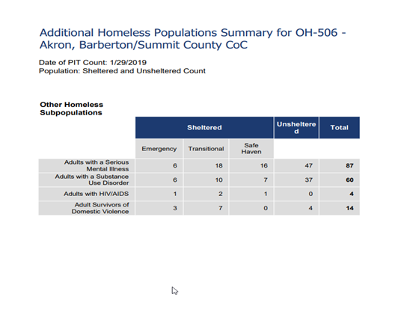
Barberton Homeless Populations Summary
Indicate if the homeless population is: | Has No Rural Homeless

If data is not available for the categories "number of persons becoming and exiting homelessness each year," and "number of days that persons experience homelessness," describe these categories for each homeless population type (including chronically homeless individuals and families, families with children, veterans and their families, and unaccompanied youth):
Data is available above.
Nature and Extent of Homelessness: (Optional)
Race: | Sheltered: | Unsheltered (optional)
White | 216 | 63
Black or African American | 216 | 19
Asian | 7 | 0
American Indian or Alaska Native | 2 | 1
Pacific Islander | 0 | 0
Ethnicity: | Sheltered: | Unsheltered (optional)
Hispanic | 2 | 4
Not Hispanic | 457 | 83

Alternate Data Source Name:
Point In Time Count

Data Source Comments: | Point-in-Time Count OH-506 Akron/Barberton/Summit County CoC Data 2024

Barberton Homeless Populations Summary
Estimate the number and type of families in need of housing assistance for families with children and the families of veterans.
Many families with children in Summit County rely on shelters, with 18% of them facing housing instability. Rising rental costs have outpaced family incomes, making it increasingly difficult for households to cover housing expenses while still affording essential needs. Additionally, homeless veterans make up approximately 7% of the PIT counts. The National Coalition for Homeless Veterans highlights that many displaced and at-risk veterans struggle due to a severe lack of affordable housing, sustainable income, and accessible healthcare. Many veterans also suffer from post-traumatic stress disorder (PTSD) and substance abuse, which are exacerbated by limited social and family support. Furthermore, military training and occupations do not always translate smoothly into civilian careers, putting some veterans at a disadvantage in the job market. For those experiencing homelessness, having access to stable, safe, and clean housing in a supportive environment—free from drugs and alcohol—is a critical priority.
Describe the Nature and Extent of Homelessness by Racial and Ethnic Group.
Homelessness among difference racial and ethnic groups in Summit County is mostly comprised of White, non-Hispanic/non-Latino and Black or African Americans.
Black/American individuals rank the highest in homelessness at 50.5%, followed by Whites at 44.8%.
Describe the Nature and Extent of Unsheltered and Sheltered Homelessness.
While point-in-time counts are only mandated every other year, HUD encourages Continuum of Care programs to conduct annual counts when resources permit. Data from 2024 regarding both sheltered and unsheltered populations has been recorded. While these figures provide valuable insights, they do not account for the number of individuals and families who are forced to double up in the homes of relatives and friends or those living in substandard conditions.
Despite ongoing efforts to combat homelessness in our community, the demand for shelters remains significant. This need is expected to grow as more landlords withdraw from the Section 8 voucher program. Additionally, the reduction in affordable housing and funding cuts to housing programs further complicate the challenges faced by those seeking stable accommodations. As economic conditions worsen, financial strain on already vulnerable populations will continue to intensify.
Discussion:
Addressing chronic homelessness is an immense challenge, but the Continuum of Care is actively working in Summit County to uncover its root causes and support individuals in overcoming the obstacles that lead to recurring homelessness. The organization attributes the rise in homeless households to the nation's economic downturn, which has resulted in job losses and furloughs, making it difficult for families and individuals to afford housing, utilities, and other essential expenses.
Certain vulnerable populations face an even greater risk of homelessness and are often underrepresented in official counts. Individuals with severe mental health conditions are particularly at risk, with 40 sheltered and 47 unsheltered in 2019—making this group the second largest among unsheltered populations after "Persons in households with Adults Only" in the 2019 PIT count. Similarly, adults struggling with substance use disorders remain a significant concern, with 23 sheltered and 37 unsheltered during the same period. Survivors of domestic violence also face housing instability, with 10 sheltered and 4 unsheltered recorded in this snapshot.
The Continuum of Care remains committed to addressing these pressing issues, advocating for solutions that provide stability and support for those most in need.

NA-45 Non-Homeless Special Needs Assessment - 91.205 (b,d)
Introduction:
During the 2025-2029 Consolidated Strategic Plan period, the following objective will be addressed: Increase the range of housing options and related services for individuals with special needs via NDS, High Priority.

Describe the characteristics of special needs populations in your community:
Individuals with special needs—including seniors, those experiencing homelessness, and individuals with mental illness, substance use disorders, or physical disabilities—often require tailored housing and support services. This section highlights the facilities and programs available in Barberton and Summit County that serve non-homeless individuals with special needs.
What are the housing and supportive service needs of these populations and how are these needs determined?
The housing needs of vulnerable populations—including the elderly, individuals with disabilities (mental, physical, and developmental), those struggling with alcohol or drug addiction, dually diagnosed individuals, survivors of domestic violence and their children, and individuals with HIV/AIDS and their families—are supported by various agencies outlined in this report. While federal, state, and local funding is available to assist with housing construction, the specialized nature of these facilities often results in high costs, necessitating additional financial support.
Discuss the size and characteristics of the population with HIV/AIDS and their families within the Eligible Metropolitan Statistical Area:
According to the State of Ohio Department of Health (2023), Summit County reported 29 cases of HIV infection and 4 cases of AIDS, marking an increase from 2015 when 39 individuals were reported with HIV. Cumulatively there are approximately 1,538 individuals were diagnosed with HIV in the county. The HIV/AIDS Surveillance Program actively collects, analyzes, and shares population-based data on individuals living with HIV/AIDS in Ohio. Surveillance efforts, including active and passive monitoring, are conducted in collaboration with healthcare providers, hospitals, and laboratories to track trends and assess the impact of the epidemic.
The Community AIDS Network Akron Pride Initiative (CANAPI) offers outreach, support services, and housing assistance for individuals affected by HIV/AIDS. Housing programs include Harmony Place, a supportive housing initiative; The Micah Program, which provides rapid re-housing; and Helping Hands, a tenant-based rental assistance program. Additionally, CANAPI works with LGBTQ youth aged 13-24 to help them secure stable housing.
If the PJ will establish a preference for a HOME TBRA activity for persons with a specific category of disabilities (e.g., persons with HIV/AIDS or chronic mental illness), describe their unmet need for housing and services needed to narrow the gap in benefits and services received by such persons. (See 24 CFR 92.209(c)(2) (ii))
n/a
Discussion:
In recent years, Barberton's Community Development Block Grant (CDBG) allocations have steadily declined, posing a significant challenge to addressing underserved needs. Limited funding remains one of the greatest obstacles, as other agencies also face growing demand for services and facilities while grappling with reductions in local, state, and federal support. Consequently, the demand for Barberton’s CDBG funds has surged. Additionally, staffing capacity remains a critical hurdle in meeting these needs, alongside zoning restrictions and community resistance (often referred to as "Nimbyism").

NA-50 Non-Housing Community Development Needs – 91.215 (f)
Describe the jurisdiction’s need for Public Facilities:
Given the community's aging infrastructure and economic challenges, ongoing upgrades and enhancements are essential. These improvements may include the development and modernization of neighborhood facilities, the expansion of parks and recreational spaces, and infrastructure projects designed to better support individuals with special needs.
How were these needs determined?
These needs were identified through contributions from elected officials, CHAS data analysis, consultant-led planning efforts, community engagement, and various local studies and reports. Additionally, insights from local non-profits and housing agencies played a key role in shaping these determinations.

Describe the jurisdiction’s need for Public Improvements:
Barberton’s aging infrastructure poses significant challenges, impacting both quality of life and safety. One pressing concern is flood drainage, which has worsened as nearby development redirects overflow into the city. In addition, street repairs, sidewalk maintenance, and improvements to parking facilities—particularly in preservation and economic districts—are urgently needed. The city's waterlines, long overdue for upgrades, further highlight the scope of necessary improvements. These infrastructure issues are compounded by financial constraints, making remediation efforts even more difficult. This is just a glimpse of the broader challenges facing the community.
How were these needs determined?
These needs have been identified based on insights from various City consultants, community engagement, capital improvement plans, and direct reports from citizens as issues emerge.
Describe the jurisdiction’s need for Public Services:
The City of Barberton's administration remains committed to assessing and addressing the evolving public service needs of the community. Given the high percentage of poverty within the city, these needs are extensive and include legal advocacy, affordable housing, mental health services, crime prevention, employment training, transportation for both adults and youths, and support for seniors.
Over the years, the city has taken significant steps to meet these challenges, such as constructing a Senior Center and securing grants to provide transportation vehicles for the Parks Department, enabling youth participation in park programs. However, as Barberton's demographics continue to shift, the demand for services grows and changes, creating an increasing gap between available resources and emerging needs. Limited funding and staffing constraints further complicate the city's ability to bridge this divide, highlighting the urgent need for continued support and investment.
How were these needs determined?
These needs were identified through a combination of public surveys, community feedback, expert assessments, and departmental evaluations.

Housing Market Analysis

MA-05 Overview
Housing Market Analysis Overview:
Housing is an essential human need and a cornerstone of the American Dream. For most Americans, it represents the largest single expense. Access to affordable, quality housing is crucial for fostering stable households, thriving communities, and a strong economy. To accommodate individuals and families at different economic and life stages, an assorted range of housing options is necessary.
Based on the 2023 American Community Survey 5-Year Estimates, the City of Barberton has approximately 10,945 housing units. Notably, around 82.3% (9,016) of these were built before 1979, with 72.7% (7,954) classified as single-unit, detached structures. This section will provide a market analysis, examining key factors influencing Barberton's housing landscape.

MA-10 Number of Housing Units – 91.210(a)&(b)(2)
Introduction
Utilizing HOME funds, the City successfully constructed six new single-family homes between 2002 and 2003, providing affordable housing opportunities for low- to moderate-income first-time homebuyers. Efforts are now underway to gain greater control of HOME funds to support the development of additional affordable housing and assist the lower-income population.
Barberton’s housing landscape is predominantly owner-occupied, with homeownership rates at 59.6% and renter occupied units at 40.4%. These rates align with the national average, but falling below Ohio’s overall rate. Most occupied housing units in the city consist of single-family homes, including detached, attached, and mobile units. A structural analysis of Barberton’s housing stock indicates that 78.3% of occupied dwellings fit within these three categories, while 20.8% consist of multi-unit structures.
Data from the U.S. Department of Housing and Urban Development (HUD) reveals that owner-occupied homes in Barberton tend to be larger than rental properties. While some data from the CHAS Data Book is unavailable, findings indicate that a significant portion of owner-occupied homes feature three or more bedrooms, whereas renter-occupied units typically include two bedrooms. Additionally, according to HUD data compiled from the 2000 Census, most vacant units—both rental and owner-occupied—are two-bedroom properties. The lowest vacancies are found in three-bedroom rental units and owner-occupied homes with zero or one bedroom.
All residential properties by number of units
Property Type | Number | %
1-unit detached structure | 8,940 | 73%
1-unit, attached structure | 435 | 4%
2-4 units | 1,115 | 9%
5-19 units | 585 | 5%
20 or more units | 935 | 8%
Mobile Home, boat, RV, van, etc | 155 | 1%
Total | 12,165 | 100%
Table 29 – Residential Properties by Unit Number
Data Source: | 2016-2020 ACS

Unit Size by Tenure
 | Owners |  | Renters
 | Number | % | Number | %
No bedroom | 0 | 0% | 105 | 2%
1 bedroom | 95 | 1% | 1,145 | 25%
2 bedrooms | 1,440 | 22% | 1,910 | 41%
3 or more bedrooms | 5,030 | 77% | 1,495 | 32%
Total | 6,565 | 100% | 4,655 | 100%
Table 30 – Unit Size by Tenure
Data Source: | 2016-2020 ACS

Describe the number and targeting (income level/type of family served) of units assisted with federal, state, and local programs.
According to Affordable Housing Online, there are 14 low-income housing apartment communities, offering 633 affordable apartments for rent in Barberton, Ohio.
Income Based Apartments in Barberton, Ohio
Barberton features 655 income-based apartments. Tenants of income-based apartments typically pay no more than 30% of their income towards rent and utilities (Source: Affordable Housing Online).
Low Rent Apartments in Barberton, Ohio
There are 304 rent subsidized apartments that do not provide direct rental assistance but remain affordable to low-income households in Barberton (Source: Affordable Housing Online).
Housing Choice Vouchers in Barberton, Ohio
On average, Section 8 Housing Choice vouchers pay Barberton landlords $500 per month towards rent. The average voucher holder contributes $300 towards rent in Barberton.
The maximum amount a voucher would pay on behalf of a low-income tenant in Barberton, Ohio for a two-bedroom apartment is between $935 and $1,143 (Affordable Housing Online).
The following is a breakdown of Affordable Housing (not an exclusive list):
Senior Public Housing - Income Based:
These rental units are available based on income, with eligibility determined by HUD guidelines. Due to demand, waiting lists may exist, and at times, they may be close to new applicants depending on their length and the number of individuals already waiting.
- Alpeter Building (AMHA): 185 units
- Allen Dickson (AMHA): 105 units
- Hilltop House (AMHA): 77 Units
- Heritage Place: 66 Units
Low Income Housing Tax Credit:
The following properties listed below benefit from funding through the Low-Income Housing Tax Credit (LIHTC) program, which designates a portion of its units for lower-income households. To qualify for these units, households must earn below either 50% or 60% of the area's median income, depending on the set-aside option selected by the property owner. Rent for these units is capped at 30% of the designated median income, adjusted based on unit size. However, some rental units on the property are not part of the LIHTC program, meaning they may have higher rents and no income restrictions.
- Elson Point Estate homes: 70 Units
- Village at Anna Dean: 60 Units
- Alexander Square: 35 Units
- Wdk Apartments: 10 Units
- Washington Square (AMHA): 24 Units
Section 8 Project-Based Rental Assistance
The Housing Choice Voucher Program is the federal government's primary initiative aimed at helping very low-income families, seniors, and individuals with disabilities secure safe, sanitary, and affordable housing in the private market. Because the assistance is granted on behalf of the participant, individuals and families have the flexibility to choose their own housing, whether it's a single-family home, townhouse, or apartment.
- Crimson Terrace (AMHA): 80 Units
- Van Buren Homes (AMHA): approximately 200 units

Provide an assessment of units expected to be lost from the affordable housing inventory for any reason, such as expiration of Section 8 contracts.
AMHA oversees and maintains a total of 4,000 housing units, including 26 public assistance buildings and 849 scattered site units. Most of these residences are situated in Akron, Barberton, and Cuyahoga Falls, with additional properties in Stow and Twinsburg offering 225 public assistance units. Over the next five years, no housing units are expected to be removed from the city.
Does the availability of housing units meet the needs of the population?
Like many communities, this city faces a shortage of housing options for individuals with very low incomes. This issue is reflected in long waiting lists for AMHA rental units, as well as homeless shelters, transitional housing, and supportive living spaces. There is also a pressing need for more extensively rehabilitated single-family homes, along with expanded public and assisted housing opportunities.
Describe the need for specific types of housing:
AMHA has determined that the greatest need for affordable housing exists among small families and elderly individuals, including both those with and without disabilities. While there are indications that demand for special needs housing may be increasing, current waiting list data does not clearly establish a trend. Many public housing applicants seek single-family homes or multi-family apartments with one or two bedrooms, whereas demand for units with four or more bedrooms remains minimal. To address these needs, AMHA urges property owners and landlords interested in the Section 8 Voucher Program to expand affordable rental options in non-traditional locations.
Discussion
According to its current waiting list data, AMHA has determined that the most significant demand for affordable housing comes from small families and elderly individuals, regardless of disability status. While AMHA anticipates a potential rise in special needs housing, existing waiting list information does not provide clear trends to confirm this shift.

MA-15 Housing Market Analysis: Cost of Housing - 91.210(a)
Introduction
The following analysis provides a comprehensive overview of Barberton’s housing market, highlighting key trends in housing supply, costs, rent, and affordability. According to the U.S. Department of Housing and Urban Development (HUD), approximately 12 million renter and homeowner households nationwide allocate more than half of their annual income to housing. Families that spend over 30% of their income on housing are considered financially burdened.
Barberton's median value for owner-occupied homes stands at $88,400, significantly lower than Summit County’s median of $137,000. Similarly, the city’s median rent of $698 is below the rates found in Summit County ($783) and Ohio as a whole ($764), based on data from the 2017 American Community Survey (ACS).
Between 2009 and 2015, median rent in Barberton rose by 13%, while median household income only increased by 9%, widening the gap between income growth and housing costs. This disparity has contributed to greater financial strain for residents seeking affordable housing. As of 2017, roughly 38% of Barberton households (4,051) are renters, with 40% of them spending more than 35% of their household income on rent.
Cost of Housing
 | Base Year: 2009 | Most Recent Year: 2020 | % Change
Median Home Value | 85,500 | 88,400 | 3%
Median Contract Rent | 521 | 613 | 18%
Table 31 – Cost of Housing

Data Source: | 2000 Census (Base Year), 2016-2020 ACS (Most Recent Year)

Rent Paid | Number | %
Less than $500 | 1,540 | 33.1%
$500-999 | 2,990 | 64.2%
$1,000-1,499 | 45 | 1.0%
$1,500-1,999 | 10 | 0.2%
$2,000 or more | 65 | 1.4%
Total | 4,650 | 99.9%
Table 32 - Rent Paid
Data Source: | 2016-2020 ACS

Housing Affordability
Number of Units affordable to Households earning | Renter | Owner
30% HAMFI | 570 | No Data
50% HAMFI | 2,060 | 1,245
80% HAMFI | 3,680 | 2,770
100% HAMFI | No Data | 3,788
Total | 6,310 | 7,803
Table 33 – Housing Affordability
Data Source: | 2016-2020 CHAS

Monthly Rent
Monthly Rent ($) | Efficiency (no bedroom) | 1 Bedroom | 2 Bedroom | 3 Bedroom | 4 Bedroom
Fair Market Rent | 527 | 623 | 810 | 0 | 0
High HOME Rent | 0 | 0 | 0 | 0 | 0
Low HOME Rent | 0 | 0 | 0 | 0 | 0
Table 34 – Monthly Rent

Data Source Comments: | FY19 FAIR MARKET RENT DOCUMENTATION SYSTEM - HUD

Is there sufficient housing for households at all income levels?
An examination of data from the 2023 American Community Survey and HUD revealed potential housing demand driven by affordability and the availability of homes across different price ranges. The key findings from this analysis are as follows:
- Extremely Low-Income Households (0-30% HAMFI) – There is a severe shortage of affordable housing for households earning 30% or less of the HUD Area Median Family Income (HAMI). According to Table 6, Barberton has 2,015 extremely low-income households; however, Table 31 shows only 570 affordable rental units available for this income group, with no data provided on housing units in this category. This disparity highlights the urgent need for additional housing options to accommodate households earning below 30% of the HUD Adjusted Median Income (HAMI).
- Low-Income Households >30-50% HAMFI) – Looking at Tables 6 and 31 again, the Low-Income category includes 1,730 households. Within this group, there are 3,270 total affordable housing units available, consisting of 2,060 rental properties and 1,245 owned homes.
- Low-to-Moderate Income Households (>50-80%) – There are 2,770 households in the underserved income group, and approximately 6,175 affordable housing units (3,390 rentals and 2,785 owners) within this income level.

How is affordability of housing likely to change considering changes to home values and/or rents?
From 2009 to 2015, home values declined by 12%, as shown in Chart 9. Meanwhile, rental costs have steadily risen, increasing by 13% over the same period. Despite the drop in housing stock value, rental rates continue to climb. The National Low-Income Housing Coalition reports that an unprecedented number of families are struggling to afford a suitable place to live.
- Nationally, there is a shortage of more than 7 million affordable homes for our nation's 11 million plus extremely low-income families.
- A full-time, minimum wage worker cannot afford a two-bedroom apartment for rent in any state or county.
- Three out of four families with extremely low incomes face severe financial strain, spending over half of their earnings just to cover rent.
How do HOME rents / Fair Market Rent compare to Area Median Rent? How might this impact your strategy to produce or preserve affordable housing?
Housing shortages affect every state and community, leaving families with limited options. Each year, the crisis worsens, contributing to homelessness and making it harder for families to afford essentials like food and healthcare ([source](https://nlihc.org/explore-issues/why-we-care/problem)). Meanwhile, households earning $50,000 or more have significantly greater flexibility in choosing housing that suits their needs. In Barberton, available data indicates that higher-income residents can afford costlier homes than those currently on the market. However, there is no shortage of housing within the $100,000 to $149,999 price range, and the New Haven development is set to offer more than 200 units in this category.
Discussion
In Barberton, nearly half of rental units (48%, or 1,825) cost less than $500 per month, while 51% (1,950) fall within the $500–$999 range. However, there is a critical shortage of affordable housing—both rental and owner-occupied—for households with severely low incomes. Many residents are forced to spend more than 50% of their earnings on housing, making it increasingly difficult to cover essential daily expenses.

MA-20 Housing Market Analysis: Condition of Housing – 91.210(a)
Introduction
The age of a community's housing stock serves as a key indicator of its overall condition and housing needs. Older homes often require more upkeep and may need significant rehabilitation. Vacant and abandoned properties can contribute to vandalism, unsafe structural conditions, and overall neighborhood decline. Additionally, older housing is more likely to contain lead-based paint, asbestos products, outdated plumbing and electrical systems, and allergens that can contribute to respiratory issues.
In Barberton, the housing stock is predominantly older, with only 538 units constructed between 2000 and 2015, and 1,035 units built between 1980 and 1999. A substantial portion—approximately 85%—of the city's homes were built before 1979, making them particularly susceptible to lead-based paint contamination. Over time, rental property has continued to grow in proportion to owner-occupied homes, reflecting ongoing shifts in housing trends.
Describe the jurisdiction's definition of "standard condition" and "substandard condition but suitable for rehabilitation":
Housing Condition Categories and Suitability for Rehabilitation
- Substandard and Not Suitable for Rehabilitation: These dwelling units are in such poor condition that neither structural repairs nor financial investment would make them viable for rehabilitation.
- Substandard but Suitable for Rehabilitation: While these units do not meet standard living conditions, they are structurally sound and financially feasible for rehabilitation. However, this category excludes units requiring only cosmetic improvements, minor livability adjustments, or routine maintenance.
- Standard Condition: These dwellings meet the minimum requirements set by the City of Barberton's various codes. They are in good condition and only require cosmetic enhancements, minor livability corrections, or standard maintenance.
The accompanying table presents the number of housing units, categorized by condition and tenure. The selected conditions aligned with housing issues identified in the Needs Assessment, including:
1. Lack of complete plumbing facilities
2. Lack of complete kitchen facilities
3. More than one person per room
4. Housing cost burden exceeding 30%
Additionally, the table calculates the percentage of total units that each category represents. The default data source for this analysis is the American Community Survey (ACS).
Condition of Units
Condition of Units | Owner-Occupied |  | Renter-Occupied
Condition of Units | Number | % | Number | %
With one selected Condition | 1,040 | 16% | 1,805 | 39%
With two selected Conditions | 20 | 0% | 95 | 2%
With three selected Conditions | 0 | 0% | 0 | 0%
With four selected Conditions | 0 | 0% | 0 | 0%
No selected Conditions | 5,510 | 84% | 2,755 | 59%
Total | 6,570 | 100% | 4,655 | 100%
Table 35 - Condition of Units
Data Source: | 2016-2020 ACS

Year Unit Built
Year Unit Built | Owner-Occupied |  | Renter-Occupied
Year Unit Built | Number | % | Number | %
2000 or later | 0 | 0% | 0 | 0%
1980-1999 | 0 | 0% | 0 | 0%
1950-1979 | 0 | 0% | 0 | 0%
Before 1950 | 0 | 0% | 0 | 0%
Total | 0 | 0% | 0 | 0%
Table 36 – Year Unit Built
Data Source: | 2016-2020 CHAS

Risk of Lead-Based Paint Hazard
Risk of Lead-Based Paint Hazard | Owner-Occupied |  | Renter-Occupied
Risk of Lead-Based Paint Hazard | Number | % | Number | %
Total Number of Units Built Before 1980 | 0 | 0% | 0 | 0%

Housing Units build before 1980 with children present | 159 | 0% | 44 | 0%
Table 37 – Risk of Lead-Based Paint
Data Source: | 2016-2020 ACS (Total Units) 2016-2020 CHAS (Units with Children present)

Vacant Units
 | Suitable for Rehabilitation | Not Suitable for Rehabilitation | Total
Vacant Units | 0 | 0 | 0
Abandoned Vacant Units | 0 | 0 | 0
REO Properties | 0 | 0 | 0
Abandoned REO Properties | 0 | 0 | 0
Table 38 - Vacant Units
Data Source: | 2005-2009 CHAS

Need for Owner and Rental Rehabilitation
Barberton is home to a significant number of older houses, many of which require ongoing maintenance and rehabilitation. These aging properties face increased risks, including lead paint exposure, asbestos materials, outdated plumbing and electrical systems, and asthma-related allergens. To address these concerns, the City collaborates with the Summit County Health Department and the Department of Community & Economic Development to reduce lead-based paint hazards in eligible homes.
Estimated Number of Housing Units Occupied by Low or Moderate Income Families with LBP Hazards
Based on the data, more than 2,800 homes in Barberton have at least one issue requiring rehabilitation. Many of the city's homes, built before 1980, carry the risk of lead-based paint hazards. According to the 2015 American Community Survey (ACS), 86% of owner-occupied housing units and 83% of rental properties in Barberton are affected by lead-based paint, with 280 of these homes housing children.
Discussion
The City of Barberton is committed to revitalizing its older housing units, actively collaborating with organizations to rehabilitate homes in need. Key partners in this effort are Summit County’s Department of Community and Economic Development and Neighborhood Development Services (NDS). Both play a vital role in improving affordable housing conditions throughout the city. Summit County and NDS offer a comprehensive range of housing services, including counseling, homebuyer education, energy conservation programs, housing rehabilitation, new construction, neighborhood organizing, lead abatement, and both direct and deferred loan options. In addition, Summit County’s Department of Community & Economic Development offers several housing rehabilitations programs, including the Minor Home Repair Program. Through these initiatives, Barberton will work together with these organizations to strengthen the community and enhance the quality of housing for residents.
Barberton collaborates with both NDS and the housing non-profit organization, Community Development Services (formerly NCS of Barberton and not funded by the City of Barberton). Community Development Services administers the Community Connection Program, sponsored by First Energy/Ohio Edison, which helps residents improve energy efficiency. This program offers free replacements for refrigerators and deep freezers that fail energy efficiency tests, provides consumer education on reducing electricity costs, installs carbon monoxide detectors, and replaces light bulbs with CFL or LED alternatives. Limited funding is also available for roof and electrical repairs. Additionally, the City of Barberton partners with the Summit County Health Department and the Summit County Department of Community & Economic Development through the Lead-Based Paint Hazard Reduction Program. This initiative aims to reduce lead-based paint risks in homes built before 1978 that house children under six years old or meet visitation guidelines.

MA-25 Public and Assisted Housing – 91.210(b)
Introduction
The Akron Metropolitan Housing Authority (AMHA) oversees public housing facilities and distributes Section 8 vouchers in Barberton, providing housing assistance throughout Summit County. AMHA manages 35 public assistance buildings along with 849 scattered site units, totaling 4,568 units in its system. Most of these housing units are situated in Akron, Barberton, and Cuyahoga Falls. Additionally, AMHA owns properties in Stow and Twinsburg, contributing 225 public assistance units. No housing units in Barberton are projected to be lost in the next five years.
Totals Number of Units
Program Type
 | Certificate | Mod-Rehab | Public Housing | Vouchers
 |  |  |  | Total | Project -based | Tenant -based | Special Purpose Voucher
 |  |  |  |  |  |  | Veterans Affairs Supportive Housing | Family Unification Program | Disabled  *
# of units vouchers available | 0 | 8 | 4,285 | 4,975 | 204 | 4,771 | 229 | 45 | 0
# of accessible units

*includes Non-Elderly Disabled, Mainstream One-Year, Mainstream Five-year, and Nursing Home Transition
Table 39 – Total Number of Units by Program Type
Data Source: | PIC (PIH Information Center)

Describe the number and physical condition of public housing units in the jurisdiction, including those that are participating in an approved Public Housing Agency Plan:
The Akron Metropolitan Housing Authority (AMHA) oversees a network of 35 public assistance buildings and 849 scattered site units, totaling 4,568 housing units. Many of these residences are situated in Akron, Barberton, and Cuyahoga Falls. Many of these properties were built in 1970 or earlier, which significantly affects their physical condition. Due to their age, they may also present increased risks of lead paint exposure, asbestos materials, outdated plumbing and electrical systems, and environmental factors that could contribute to asthma-related health concerns.

Public Housing Condition
Public Housing Development | Average Inspection Score
Table 40 - Public Housing Condition

Describe the restoration and revitalization needs of public housing units in the jurisdiction:
Of the 35 public assistance buildings, 22 were built in 1970 or earlier. Since 1990, all but five have been renovated. AMHA’s oldest development, Elizabeth Park Homes in Akron, originally constructed in 1941, has undergone extensive rehabilitation through the HOPE VI initiative. This project replaced the aging 124-unit public housing complex with 269 newly built townhouses and single-family homes, offering a mix of market-rate, tax-credit affordable, and public housing rental units, along with homes available for purchase.
The Akron Metropolitan Housing Authority incorporates Section 504, which governs accessibility in public housing, and adheres to ADA requirements within its Transition Plan and Policy. As part of its modernization efforts, AMHA continues to convert standard housing into accessible, specially designed residences for individuals with disabilities. Funding for these projects comes from the Capital Program budgets, with approximately 5% of scheduled modernization units expected to meet Section 504 requirements.
Additionally, AMHA has conducted lead-based paint testing across all its properties. Ongoing abatement efforts have been in place for several years and will continue until all identified lead-based paint is either removed or properly encapsulated.
Describe the public housing agency's strategy for improving the living environment of low- and moderate-income families residing in public housing:
Akron Metropolitan Housing Authority (AMHA)
The mission statement for AMHA states:
“The Akron Metropolitan Housing Authority is committed to building stronger neighborhoods by providing quality housing options and professional services for eligible residents of Summit County in partnership with the greater community. The AMHA is striving to be a national pacesetter among housing providers.”
The agency’s activities and efforts are focused on carrying out that mission. Seven major goals were outlined in AMHA’s previous 5-Year Strategic Plan submitted to HUD:
- Increase the availability of decent, safe, and affordable housing.
- Improve the quality of the property assets and physical environment of residents.
- Expand affordable housing choices for eligible people in the jurisdiction.
- Enhance customer service to residents, applicants, and organizations in partnership the AMHA.
- Participate in programs and activities that provide economic and educational opportunities for residents.
- Improve the operational effectiveness and efficiency of the AMHA.
- Ensure Equal Opportunity in Housing.

MA-30 Homeless Facilities and Services – 91.210(c)
Introduction
The Akron/Summit County/Barberton/Cuyahoga Falls community has in place a Continuum of Care that addresses the immediate needs of families and individuals at risk of becoming homeless. Community organizations have developed resource manuals, online assistance, and 211 to assist individuals and families in locating appropriate services.
Facilities and Housing Targeted to Homeless Households
 | Emergency Shelter Beds |  | Transitional Housing Beds | Permanent Supportive Housing Beds
 | Year Round Beds (Current & New) | Voucher / Seasonal / Overflow Beds | Current & New | Current & New | Under Development
Households with Adult(s) and Child(ren) | 108 | 0 | 204 | 112 | 0
Households with Only Adults | 154 | 0 | 170 | 320 | 0
Chronically Homeless Households | 0 | 0 | 0 | 0 | 0
Veterans | 0 | 0 | 0 | 0 | 0
Unaccompanied Youth | 0 | 0 | 0 | 0 | 0
Table 41 - Facilities and Housing Targeted to Homeless Households

Alternate Data Source Name:
2025 Referrals for LMI Resources

Data Source Comments: | Akron/Barberton/Summit County 2024

Additional Data
Chronically homeless individuals: 103 sheltered/106 unsheltered
Homeless veterans: 35 sheltered/62 unsheltered

Describe mainstream services, such as health, mental health, and employment services to the extent those services are used to complement services targeted to homeless persons
The primary objective for individuals transitioning out of homeless programs is securing employment. To support this goal, mainstream service providers collaborate with clients to enhance their access to non-employment income sources. Case managers from partner agencies facilitate referrals to the One-Stop Facility, a workforce development system that connects individuals to essential resources. Benefit Bank Counselors assist with FAFSA applications, SSI/SSDI claims, and the completion of state and federal tax filings.
Once eligibility is determined, a comprehensive list of potential agencies and referrals is compiled for clients to utilize. Both clients and case managers can access 211 services at any time, which offer a database of 1,400 agencies and resources. Additionally, 211 Specialists proactively explore mainstream benefits for low-income callers who may qualify for assistance. The Summit County Department of Job and Family Services provides training sessions for local homeless shelters, equipping them with knowledge about enrollment requirements for mainstream resource programs. Info Line’s 211 Information and Referral service handles inquiries from approximately 85,000 individuals annually.
- Akron/Summit Co. Comm. Action Agency
- Summit County Continuum of Care
- Barberton Area Community Ministries provides food pantry and delivery service for food
- Battered Women’s Shelters
- Catholic Social Services
- Community AIDS Network
- Community Support Services
- Dept. of Jobs & Family Services
- Fair Housing Contact Service
- FEMA – Hunger Shelter Programs
- Good Neighbors
- Open M provides a free medical clinic
- Red Cross
- The Salvation Army
- Veteran’s Service Commission
- Western Reserve Outreach Center
- Haven of Rest
- Infoline Emergency Clearing House
- Summit County Children’s Services
- ACCESS, Inc.
- Harvest Home
- Community Health Center
- Family & Children First Cluster
- H.M. Life Opportunity Services
- Veteran’s Administration
List and describe services and facilities that meet the needs of homeless persons, particularly chronically homeless individuals and families, families with children, veterans and their families, and unaccompanied youth. If the services and facilities are listed on screen SP-40 Institutional Delivery Structure or screen MA-35 Special Needs Facilities and Services, describe how these facilities and services specifically address the needs of these populations.
United Way Medina Summit, The Salvation Army, and H.M. Life Opportunity Services work together to coordinate and implement the homeless prevention and rapid re-housing program for the Continuum of Care (CoC). The Home Again program provides support to individuals and families within the Continuum of Care Services Area who are currently homeless or at risk of losing their housing without this assistance.
Veterans
The Akron Metropolitan Housing Authority (AMHA) received 60 permanent housing certificates under the HUD-VASH program, specifically allocated for homeless veterans. The Department of Veterans Affairs (VA) supports these veterans through case management services, ensuring they receive necessary assistance. All 60 HUD-VASH vouchers are currently in use. Additionally, The Commons at Madaline Park, a permanent supportive housing initiative, has set aside six units exclusively for veterans. In 2013, Valor Home was established, offering a 30-bed facility under the Grant and Per Diem (GPD) program to serve homeless veterans. Further expanding outreach efforts, CSS secured funding to develop a Community Resource and Referral Center (CRRC) Project aimed at connecting and supporting homeless veterans.
Chronically Homeless
The local Continuum of Care (CoC) has established a one-time capital fund to support efforts aimed at ending homelessness in our community. To identify the most pressing housing needs, the CoC is assessing local housing inventory.
In collaboration with the VA and Housing Authority, our CoC is committed to expanding the number of vouchers available for individuals experiencing chronic homelessness. To facilitate this process, client data from the Homeless Management Information System (HMIS) will be analyzed to determine housing status and eligibility for classification as chronically homeless.
Permanent Supportive Housing (PSH) providers will prioritize housing availability for those who meet the eligibility criteria for chronic homelessness. Additionally, partnerships with local developers and supportive service providers will continue to address ongoing housing needs.
A critical factor in any housing initiative is securing adequate funding. While the creation of PSH beds is an essential component, sustainable solutions require CoCs to provide comprehensive and coordinated case management services. These services ensure that clients remain stable and equipped to maintain long-term housing.

Youth
The Youth Emancipation Task Force (YETF), a collaborative effort between social service agencies and non-profit organizations, is dedicated to enhancing the well-being of young people. Its initiatives focus on housing, employment and education, as well as health and mental health services, ensuring young adults have access to vital resources.
To support emancipated and homeless youth, Youth Resource Guides provide essential information on available services. Additionally, OMCDC and CSB run housing programs aimed at addressing homelessness among individuals aged 16 to 21. These programs offer comprehensive support, helping young people secure employment, pursue education, and transition into permanent housing. OMCDC’s Horizon House provides group housing with 16 units, while CSB offers 20 one-bedroom units for young adults previously in CSB custody.
Safe Landing Shelter extends its reach through a Street Outreach program, delivering case management services to homeless youth or those at risk, specifically between the ages of 18 and 22. Through these efforts, the network of organizations works collectively to create stability and opportunity for young adults in need.

MA-35 Special Needs Facilities and Services – 91.210(d)
Introduction
The City of Barberton collaborates with various public agencies to support facilities and services for individuals with special needs. Among these agencies are Summit County Continuum of Care and Akron Metro Public Housing, though others also contribute to these efforts. People with special needs including the elderly, those experiencing homelessness, and individuals facing mental illness, substance use disorders, or physical disabilities—often require specialized housing and services.
This section highlights the available facilities and programs in Barberton and Summit County designed to assist non-homeless individuals with special needs.

Including the elderly, frail elderly, persons with disabilities (mental, physical, developmental), persons with alcohol or other drug addictions, persons with HIV/AIDS and their families, public housing residents and any other categories the jurisdiction may specify, and describe their supportive housing needs
Representatives from the Akron/Summit County Continuum of Care recently met with various non-profit organizations to address the community’s housing and supportive service needs. The participating agencies provide essential services across Summit County, including housing, healthcare, and social support for vulnerable populations such as children, the elderly, individuals experiencing homelessness, people with disabilities, and those living with HIV/AIDS. A key concern shared by many organizations was the pressing need for affordable housing options, whether transitional, rental, or permanent—for those facing homelessness. As an active member of the Akron/Summit County Continuum of Care, the City of Barberton is committed to advancing the President’s goal of ending chronic homelessness. With the support of Community Development Block Grant (CDBG) funding, the city anticipates making meaningful progress toward this objective in the future.
Among Barberton's disabled community, several challenges have been recognized:
- Most disabled individuals are between the ages of 21 and 64. More women are disabled than men in this category.
- The second largest majority of disabled individuals are 65 years or older. More women are disabled than men in this category as well.
- The third largest groupings of disabled individuals are between the ages of 5 and 15, with more females disabled than men.
- The age groups with the least number of disabled individuals are those between the ages of 16 and 20. Women, again, have the largest percent of disabled over men.
- Many people, particularly the elderly, have a condition limiting basic physical activities such as walking, climbing stairs, lifting, etc.
- Some have conditions that make it difficult to go outside the home to shop or visit a physician.
- Some suffer from physical, mental or emotional condition causing difficulty in learning, remembering or concentrating.
- Some experience sensory disability involving sight and/or hearing loss.
- Many individuals have a physical, mental or emotional condition that causes difficulty with everyday functions.
Describe programs for ensuring that persons returning from mental and physical health institutions receive appropriate supportive housing
Community Support Services (CSS) remain committed to preventing homelessness among individuals transitioning from mental health settings. By collaborating with jails, hospitals, and other institutions, CSS ensures that individuals receive the necessary support upon discharge.
The organization employs two recovery specialists who assist individuals with identified mental health conditions as they exit the jail system. These specialists help with medication management, connecting individuals to service providers, securing housing opportunities, and accessing essential resources.
Support continues until individuals establish services with an appropriate provider. Caseworkers frequently play an active role in discharge planning, ensuring a smooth transition. For those leaving psychiatric institutions without engagement in services and facing homelessness, referrals are made to the PATH-funded Homeless Outreach team. This dedicated team works to connect individuals with the services they need while identifying suitable housing options.
In Summit County, the number of individuals discharged from homelessness is minimal. However, the greatest challenge arises when individuals are released from state or federal institutions. Many of these facilities do not provide advance notice when someone with identified needs is being discharged into the county, making it difficult to coordinate support. Additionally, some individuals decline assistance from service providers, rejecting all efforts to help. Despite these obstacles, the lead mental health agency continues to outreach, working to engage and support those in need.
The Summit County ADM Board plays a crucial role in preventing individuals with mental illness from being discharged into homelessness. It funds Access to Recovery, a program that provides housing for homeless individuals facing legal challenges and substance abuse issues. While AMHA primarily serves its own population, it has encouraged the COC to seek a consultant to assess the county’s broader housing needs. To support permanent supportive housing (PSH), AMHA has aligned its Project-Based Voucher (PBV) priorities with developers specializing in this type of housing. Once an individual becomes an AMHA tenant, the organization receives “Request for Services” referral forms to coordinate support, connecting residents with community resources, including agencies focused on mental and physical health. Additionally, AMHA Resident Services actively participates in various community initiatives, such as the Senior Independent Living Coalition, the County of Summit ADM Board, and the Area on Agency Consolidated Plan.
Specify the activities that the jurisdiction plans to undertake during the next year to address the housing and supportive services needs identified in accordance with 91.215(e) with respect to persons who are not homeless but have other special needs. Link to one-year goals. 91.315(e)
During the 2025-2029 Consolidated Strategic Plan period, Barberton will focus on addressing key housing challenges. A housing market analysis and needs assessment has identified a significant shortage of affordable housing units for individuals with severely low incomes.
While the city does not face an overall housing shortage for low-to-moderate income residents, many struggle to transition from renting to homeownership due to rising rent costs and living expenses.
To support severely low-income individuals, Barberton will continue collaborating with the Akron Metropolitan Housing Authority (AMHA). Additionally, many low-to-moderate income homeowners face difficulties maintaining safe and sanitary housing, often living in older properties that require substantial rehabilitation. To assist, we will use Community Development Block Grant (CDBG) funding to partner with Neighborhood Development Services (NDS) for owner-occupied housing rehabilitation projects.
Given the city's aging housing stock, CDBG funds will also be allocated to initiatives in collaboration with the Summit County Health Department and the Summit County Department of Development. Programs such as Lead-Based Paint Abatement and Home Weatherization Assistance will ensure homes remain safe and energy efficient. To further improve financial stability among low-to-moderate income residents, funding will be provided to United Way’s Financial Empowerment Program, offering individualized coaching to help residents build budgeting skills, strengthen banking relationships, and improve credit scores.
A priority of this plan period is expanding homeownership opportunities, including down payment assistance for low-to-moderate income households, with a particular focus on minority homeownership and eliminating chronic homelessness. Through NDS, Barberton will provide financial support to help qualifying residents purchase homes within the city.
Lastly, Barberton will continue funding United Way Summit Medina’s 211 service, connecting residents with essential local resources such as food assistance, substance abuse treatment, and disaster relief. Additionally, we will work with Vantage Aging to support older adults in remaining comfortably in their homes as they age.
This comprehensive strategy underscores Barberton’s commitment to housing stability, financial empowerment, and community well-being.
For entitlement/consortia grantees: Specify the activities that the jurisdiction plans to undertake during the next year to address the housing and supportive services needs identified in accordance with 91.215(e) with respect to persons who are not homeless but have other special needs. Link to one-year goals. (91.220(2))
See above.
Barberton does not allocate CDBG funds for rental assistance, nor for the construction, rehabilitation, or acquisition of single-unit or multi-unit rental housing. Furthermore, the City does not provide financial support to AMHA.
MA-40 Barriers to Affordable Housing – 91.210(e)
Negative Effects of Public Policies on Affordable Housing and Residential Investment
Analysis shows the following barriers to affordable housing exist in Barberton (Negative Effects of Public Policies):
- The availability of affordable single-family homes remains limited, posing challenges for low-to-moderate income buyers striving to transition from renting to homeownership. While Barberton's housing market offers prices below the national average, many of these homes still exceed the financial reach of lower-income households. Ryan Homes, a private developer, is helping to bridge this gap by introducing new construction in the New Haven Neighborhood, with starting prices set at $110,000. Additionally, with the support of NSP funds, the City is offering numerous in-fill lots for individuals interested in building affordable homes within designated lower-income neighborhoods. What once stood as a significant barrier to affordable housing is now evolving into new opportunities for homeownership.
- The high cost of housing rehabilitation poses a significant challenge for low-to-moderate income households, often making essential repairs unaffordable. Amid economic downturns, securing bank financing for these renovations has become increasingly difficult for the average working family.
- Current building and zoning regulations tend to prioritize traditional site layouts over clustered or planned residential developments. These codes often mandate the separation of different housing types, limiting opportunities for mixed-use housing. Additionally, minimum lot size requirements can make it challenging to create smaller, more affordable housing options.
- Opposition to affordable housing initiatives, including group homes and public housing projects, is often referred to as "Nimbyism" (Not in My Back Yard). This reluctance has been a longstanding issue in fair housing law, shaping discussions on community development and accessibility.
- Local ordinances regulating storm water systems, sidewalks, and landscaping often impose excessive costs, creating financial barriers to affordable housing development. Additionally, environmental challenges, such as brownfields, can render certain lower-cost areas unsuitable for residential construction, further limiting housing opportunities.

MA-45 Non-Housing Community Development Assets – 91.215 (f)
Introduction
To identify priority needs and inform funding allocations, input was gathered from data sources. Please see below.
Economic Development Market Analysis
Business Activity
Business by Sector | Number of Workers | Number of Jobs | Share of Workers  % | Share of Jobs  % | Jobs less workers  %
Agriculture, Mining, Oil & Gas Extraction | 32 | 1 | 0 | 0 | 0
Arts, Entertainment, Accommodations | 1,216 | 614 | 12 | 7 | -5
Construction | 526 | 464 | 5 | 6 | 1
Education and Health Care Services | 1,831 | 2,160 | 19 | 26 | 7
Finance, Insurance, and Real Estate | 476 | 125 | 5 | 2 | -3
Information | 139 | 39 | 1 | 0 | -1
Manufacturing | 1,756 | 3,085 | 18 | 37 | 19
Other Services | 415 | 356 | 4 | 4 | 0
Professional, Scientific, Management Services | 950 | 218 | 10 | 3 | -7
Public Administration | 0 | 0 | 0 | 0 | 0
Retail Trade | 1,455 | 763 | 15 | 9 | -6
Transportation and Warehousing | 388 | 78 | 4 | 1 | -3
Wholesale Trade | 590 | 385 | 6 | 5 | -1
Total | 9,774 | 8,288 | -- | -- | --
Table 42 - Business Activity

Data Source Comments: | Data Source: 2011-2015 ACS (Workers) 2015 Longitudinal Employer-Household Dynamics (Jobs)

Labor Force
Total Population in the Civilian Labor Force | 0
Civilian Employed Population 16 years and over | 0
Unemployment Rate | 11.21
Unemployment Rate for Ages 16-24 | 14.24
Unemployment Rate for Ages 25-65 | 8.61
Table 43 - Labor Force

Data Source Comments: | Data Source: 2011-2015 ACS

Occupations by Sector | Number of People
Management, business and financial | 0
Farming, fisheries and forestry occupations | 395
Service | 0
Sales and office | 0
Construction, extraction, maintenance and repair | 0
Production, transportation and material moving | 950
Table 44 – Occupations by Sector

Data Source Comments: | Data Source: 2011-2015 ACS

Travel Time
Travel Time | Number | Percentage
< 30 Minutes | 0 | 0%
30-59 Minutes | 0 | 0%
60 or More Minutes | 480 | 100%
Total | 480 | 100%
Table 45 - Travel Time

Data Source Comments: | Data Source: 2011-2015 ACS

Education:
Educational Attainment by Employment Status (Population 16 and Older)
Educational Attainment | In Labor Force
Educational Attainment | Civilian Employed | Unemployed | Not in Labor Force
Less than high school graduate | 715 | 320 | 655
High school graduate (includes equivalency) | 0 | 460 | 0
Some college or Associate's degree | 0 | 335 | 520
Bachelor's degree or higher | 0 | 45 | 235
Table 46 - Educational Attainment by Employment Status

Data Source Comments: | Data Source: 2011-2015 ACS

Educational Attainment by Age
 | Age
 | 18–24 yrs | 25–34 yrs | 35–44 yrs | 45–65 yrs | 65+ yrs
Less than 9th grade | 15 | 45 | 25 | 150 | 315
9th to 12th grade, no diploma | 430 | 610 | 275 | 580 | 665
High school graduate, GED, or alternative | 920 | 1,455 | 1,200 | 3,715 | 2,485
Some college, no degree | 495 | 690 | 495 | 1,240 | 505
Associate's degree | 185 | 505 | 205 | 460 | 205
Bachelor's degree | 78 | 590 | 270 | 615 | 200
Graduate or professional degree | 0 | 85 | 105 | 185 | 205
Table 47 - Educational Attainment by Age

Data Source Comments: | Data Source: 2011-2015 ACS

Educational Attainment – Median Earnings in the Past 12 Months
Educational Attainment | Median Earnings in the Past 12 Months
Less than high school graduate | 0
High school graduate (includes equivalency) | 0
Some college or Associate's degree | 0
Bachelor's degree | 0
Graduate or professional degree | 0
Table 48 – Median Earnings in the Past 12 Months

Data Source Comments: | Data Source: 2011-2015 ACS

Based on the Business Activity table above, what are the major employment sectors within your jurisdiction?
According to the Business Activity table, our primary employment sectors include Manufacturing, Education, Health Care, and Retail Trade.
Describe the workforce and infrastructure needs of the business community:
Once a thriving manufacturing hub, the City of Barberton played a vital role in industry well into the 1980s. However, as times have changed, the aging infrastructure has become an increasing challenge. Much of the original systems established during the industrial boom have lacked proper maintenance and timely replacements, leaving the city struggling with deteriorating structures. This, coupled with aging buildings requiring extensive upgrades for energy efficiency, has led to many vacant and blighted properties, many of them classified as Brownfields.

Addressing these issues remains a priority for the community, as efforts continue to remediate Brownfield properties and manage asbestos abatement. Providing new owners with competitive solutions for upgrading building efficiency is essential for revitalization. Meanwhile, Barberton’s workforce is primarily centered around Education, Health Care Services, and Manufacturing. The Barberton City School District, through its partnership in the 4 Cities Compact Education program, actively supports workforce development in these key fields. Committed to preparing the next generation, the school system plays a crucial role in equipping young individuals with the skills necessary to meet the evolving needs of the local economy.
Describe any major changes that may have an economic impact, such as planned local or regional public or private sector investments or initiatives that have affected or may affect job and business growth opportunities during the planning period. Describe any needs for workforce development, business support or infrastructure these changes may create.
The City of Barberton faces ongoing challenges as businesses relocate to newer, more efficient properties outside its borders, making job creation and retention a top priority for the community. To address this, investing in modern infrastructure, economic development (ED) incentives—such as low-interest loans and tax abatement programs—and workforce education is essential.
The city continues to collaborate with regional organizations, local foundations, and the County to maximize available funding and offer impactful programs. However, promoting economic development remains difficult due to the City's financial constraints in matching private investment.
Recently, Barberton passed an income tax increase specifically earmarked for road improvements. This initiative has enabled the city to invest and leverage resources to complete $3 million in street improvements in 2014, marking the most significant infrastructure investment in years.
Looking ahead, the city plans to utilize the Community Development Block Grant (CDBG) program to support infrastructure redevelopment in areas most affected by poverty, high population density, and historic preservation needs. Efforts will focus on upgrading essential infrastructure and identifying new programs to enhance building facades and efficiency.
Covid-19 drastically impacted our economy and changed the course of future business interactions. Some meetings are still held virtually and most communication is electronically. There may be future needs for workforce development, as it relates to technology, since businesses are reliant upon digital information.
How do the skills and education of the current workforce correspond to employment opportunities in the jurisdiction?
The City of Barberton faces a workforce shortage in key industries, particularly manufacturing, education, and healthcare. The manufacturing sector has the greatest demand, with 3,085 jobs available but only 1,756 qualified workers to fill them. Similarly, the Education and Health Care Services sector has 2,160 job openings, yet only 1,831 qualified individuals are available. Conversely, there is a surplus of workers in fields such as Professional, Scientific, and Management Services, where 950 professionals compete for just 218 positions. The retail trade sector also faces an imbalance, with 1,455 workers seeking employment while only 763 jobs are available.
To address these workforce gaps, the city actively engages employers to understand their staffing needs and collaborates with the local school district to strengthen workforce development. Programs in nursing and manufacturing provide students with apprenticeship opportunities at major local companies, helping them secure employment before graduation while offering financial support for higher education. Traditionally, the city hosts job fairs to connect candidates with opportunities, particularly in manufacturing. However, considering COVID-19 restrictions, the City is partnering with Summit County and Conexus to organize virtual job and resource fairs to continue supporting job seekers and employers alike.
Describe any current workforce training initiatives, including those supported by Workforce Investment Boards, community colleges and other organizations. Describe how these efforts will support the jurisdiction's Consolidated Plan.
The City of Barberton is partnering with Jobs for Ohio’s Graduates (JOG), Summit County, and other local organizations to equip low-to-moderate income individuals with essential workplace skills. These initiatives focus on soft skills training, interview preparation, workplace etiquette, and other key competencies needed for career success. Some programs will also provide successful coaches to help participants navigate the system and plan their next steps.
To facilitate employment opportunities, virtual job and resource fairs will be held to connect individuals with potential employers. Additionally, the Barberton City School District collaborates with neighboring communities through “The 4 Cities Compact,” offering workforce programs in business, healthcare, technology, public safety, manufacturing, and other industries.
Their “College Credit Plus” program enables students to earn 391 credit hours at the University of Akron and Stark State College, saving families nearly $175,000 in tuition and book expenses.
The Barberton Community Foundation supports local students by awarding $300,000 in scholarships annually, while the city closely works with Ohio Means Jobs of Summit County to provide free online career counseling, linking businesses with job seekers and offering career services to Ohio residents. To further strengthen these efforts, CDBG funds will be allocated toward transportation improvements and community enhancements, ensuring ongoing growth and accessibility to these workforce initiatives.
Jobs for Ohio's Graduates (JOG) provides educational support and workforce readiness services through their "Year 13 Program", which provides opportunities for any recent non-graduate and underemployed Barberton High School student.
Does your jurisdiction participate in a Comprehensive Economic Development Strategy (CEDS)?
No
If so, what economic development initiatives are you undertaking that may be coordinated with the Consolidated Plan? If not, describe other local/regional plans or initiatives that impact economic growth.
n/a
Discussion
The City of Barberton partners with Akron Score and Main Street Barberton to offer workshops for individuals in Barberton who own small businesses or aspire to start their own, utilizing CDBG funds. These workshops provide valuable training in business plan development, marketing strategies, and essential financial management principles.
MA-50 Needs and Market Analysis Discussion
Are there areas where households with multiple housing problems are concentrated? (Include a definition of "concentration")
Barberton faces widespread housing challenges due to the age of its housing supply, and the city's income demographics. Unlike many areas with distinct pockets of housing issues, Barberton’s concerns are distributed throughout the community. However, the east side, near the hospital, as well as the New Haven and Austin Estates neighborhoods, stand out as exceptions with relatively fewer housing problems.
Are there any areas in the jurisdiction where racial or ethnic minorities or low-income families are concentrated? (Include a definition of "concentration")
Barberton has a predominantly white population, with census data showing that 87.6% of residents identify as such. While a significant concentration of Black/African American households is located in the southern portion of the city, low-income households are spread throughout Barberton rather than being confined to specific neighborhoods. Unlike cities with distinct ethnic or economic enclaves, Barberton’s lower-income and minority communities are dispersed across most areas, except for the east side near the hospital, the New Haven neighborhood, and the Austin Estates neighborhood, which have comparatively fewer low-income households.
What are the characteristics of the market in these areas/neighborhoods?
Barberton is experiencing a surge in infill housing construction as part of an effort to revitalize its downtown neighborhood. The City's redevelopment plan aims to remove blighted structures once they become vacant, foreclosed, or available for sale.
Homeownership is a defining characteristic of Barberton, with 61.8% of occupied housing units being owner-occupied. Most housing consists of single-family residences, including detached, attached, and mobile homes. According to the 2017 American Community Survey (ACS), the median number of rooms per housing unit is 5.7. Of the city's homes, 22% (2,618 units) contain five rooms, while a small portion—1.4% or 165 homes—feature just one room.
Are there any community assets in these areas/neighborhoods?
Despite the City of Barberton having a significant number of low-income households, it is rich in community assets that support residents. The local school district stands out as one of the tops in the state, earning excellence ratings multiple years in a row. Additionally, the city provides various programs and agencies dedicated to assisting individuals with lower incomes. Barberton is also home to numerous valuable amenities, including the local YMCA, Active Adult Center, and a vibrant community lake, which hosts a variety of events and concerts throughout the year.
Are there other strategic opportunities in any of these areas?
Neighborhood Development Services will continue to develop affordable housing if funding continues. In addition, Summit County's Department of Community and Economic Development will facilitate a Minor Repair Rehab Program for owner-occupied residents that qualify.
- Low-Income Housing Tax Credit has spurred construction of new affordable rental units.
- Lower interest rates have meant reduced costs for construction of affordable housing.
- Previous public and private affordable housing efforts have been successful.
- In the past, the City and Community Development Services (CDS), formerly known as Neighborhood Conservation Services, have been successful in securing grants for rehabilitation and new construction, as well as previous public and private affordable housing efforts. The city will continue to apply for funding from the Ohio and US EPA for Brownfield development/redevelopment.MA-60 Broadband Needs of Housing occupied by Low- and moderate-income households. 91.210(a)(4), 91.310(a)(2)
Describe the need for broadband wiring and connections for households, including low- and moderate-income households and neighborhoods.
The issue of being under-connected is becoming increasingly problematic, with researchers and policymakers voicing concerns about its role in widening socioeconomic disparities, according to HUD. Broadband internet access has become essential for accessing opportunities in education, employment, healthcare, social services, and the creation and sharing of digital content. However, those who rely most on these services, particularly low-income families and children, often face significant barriers to getting online.
To address this challenge, the City of Barberton, in collaboration with the Summit County Health Department, has partnered with PCs for People to provide computers and Wi-Fi to low-moderate-income families. Additionally, there are plans to extend this service to seniors. Throughout the 2025-2029 Consolidated Plan period, the city will continue its commitment to bridging the digital divide through initiatives designed to enhance internet accessibility for underserved communities.
Describe the need for increased competition by having more than one broadband Internet service provider serve the jurisdiction.
The high cost of internet access is a significant hurdle for underserved individuals. Increasing competition among broadband providers can drive prices down, making connectivity more affordable. If local governments choose to offer internet services, costs could be reduced even further, expanding access to those who need it most.

MA-65 Hazard Mitigation - 91.210(a)(5), 91.310(a)(3)
Describe the jurisdiction’s increased natural hazard risks associated with climate change.
According to Summit County’s Hazard Mitigation Plan, published in June 2018, the region faces a substantial risk of severe storms, with a 215% likelihood of occurrence each year and a 23% probability of a disaster declaration.
Extreme heat is also a concern, as Summit County experiences periods of high temperatures and humidity during the summer months. While NOAA’s NCDC online data does not currently list any excessive heat events for the county, extreme heat is typically defined as prolonged periods—lasting two to three days—of elevated temperatures and humidity.
Extreme Cold: A Serious Winter Hazard - When winter temperatures plummet well below normal, staying warm and safe becomes a serious challenge. Severe cold often accompanies winter storms, increasing the risk of power outages and dangerous exposure. Whether indoors or outside, prolonged exposure to frigid temperatures can lead to serious or even life-threatening health issues. According to the Centers for Disease Control and Prevention (CDC), hypothermia is responsible for approximately 739 deaths annually in the United States.
Certain groups are especially vulnerable, including young children, the elderly, individuals stranded outdoors, laborers exposed to harsh conditions, animals, and those living in poorly insulated or unheated homes. The homeless population also faces heightened risks. While Summit County is well-practiced in managing winter weather, extreme cold events can still pose significant threats, disrupting daily life and making conditions hazardous. In severe cases, widespread sheltering efforts may be necessary, and cold-related casualties can occur.
Additionally, severe storms in Summit County can include tornadoes and flooding, causing significant damage. The financial impact of these events is recorded for all affected counties across Ohio. More information can be found through FEMA’s disaster declaration data: FEMA Disaster Declarations (https://www.fema.gov/data-visualization-disaster-declarations-states-and-counties).
Infectious diseases stem from microscopic organisms like viruses, bacteria, parasites, and fungi, which can lead to a wide range of illnesses. These include mild conditions such as the common cold and flu, as well as more severe diseases like Lyme disease, polio, and life-threatening infections such as Hantavirus and AIDS. Due to their potential to cause widespread outbreaks, infectious diseases pose a significant public health risk. A major outbreak could indicate a newly emerging pathogen, an epidemic, or even a public health hazard related to bioterrorism. Such events can overwhelm healthcare systems, forcing the closure of schools, churches, community centers, and tourist sites, leading to substantial financial losses.
To maintain essential services during such crises, Continuity of Operations plans are put in place. In response to growing public health challenges, Summit County has established a unified health district, with Summit County Public Health overseeing healthcare services across the region.
Describe the vulnerability to these risks of housing occupied by low- and moderate-income households based on an analysis of data, findings, and methods.
People living in homes with poor insulation or without heating and air conditioning, as well as those experiencing homelessness, face heightened risks from extreme temperatures. However, severe cold and heat can impact anyone. Summit County is particularly vulnerable to these harsh conditions, which can cause disruptions and create dangerous situations. In extreme cases, mass sheltering may be necessary, and casualties can occur.
Additionally, climate change has significant effects on food supply, leading to shortages and rising prices that disproportionately impact low-income individuals, making it harder to access nutritious food. According to MercyCorps.org, climate change threatens air quality, diminishes water resources, and disrupts food production. It also affects livelihoods, displaces families, and drives people into poverty.
Strategic Plan

SP-05 Overview
Strategic Plan Overview
The City of Barberton is committed to improving residents’ quality of life by delivering responsible and sustainable services. Since 1995, the U.S. Department of Housing and Urban Development (HUD) has required communities receiving funding from multiple HUD programs to develop a Consolidated Plan. This strategic plan simplifies the application process for six different grant programs while helping communities address housing, economic, and community development needs in a comprehensive manner. It outlines specific objectives and annual goals, allowing both local citizens and government officials to track progress and make necessary amendments over a five-year span.
Barberton benefits from HUD’s entitlement program, the Community Development Block Grant (CDBG), which was established by Congress in 1974 under Title 24, Part 570. The primary goal of the CDBG program is to support housing, community, and economic development efforts for underserved individuals—defined as those whose annual family income is at or below 80% of the median family income. The City allocates funds to activities that align with these objectives.
Leading these efforts, the Barberton Department of Planning and Community Development oversees the development of the Consolidated Plan and administers the CDBG program. The current Consolidated Plan covers fiscal years 2025 to 2029, including a detailed one-year Action Plan for FY 2025.

SP-10 Geographic Priorities – 91.215 (a)(1)
Geographic Area
Table 49 - Geographic Priority Areas
1 | Area Name: | ALL LMA'S OF THE CITY
1 | Area Type: | Local Target area
1 | Other Target Area Description:
1 | HUD Approval Date:
1 | % of Low/ Mod:
1 | Revital Type: | Comprehensive
1 | Other Revital Description:
1 | Identify the neighborhood boundaries for this target area. | The City of Barberton is composed of approximately 55% Low-to-Moderate Income (LMI) Census Block Groups. However, certain areas, such as Austin Estates and the newly developed New Haven, do not fall within LMI-designated zones. Additionally, several blocks located in the far western part of the city are also not classified as LMI areas.
1 | Include specific housing and commercial characteristics of this target area. | The City of Barberton is composed of approximately 55% Low-to-Moderate Income (LMI) Census Block Groups. However, certain areas, such as Austin Estates and the newly developed New Haven, do not fall within LMI-designated zones. Additionally, several blocks located in the far western part of the city are also not classified as LMI areas.
1 | How did your consultation and citizen participation process help you to identify this neighborhood as a target area? | 2020 Census Data - Barberton LMI Map
1 | Identify the needs in this target area. | Affordable Housing, Public Health & Safety, Eliminate Slum & Blight, Infrastructure improvements, and Economic Opportunities
1 | What are the opportunities for improvement in this target area? | Affordable Housing, Public Health & Safety, Eliminate Slum & Blight, Infrastructure Improvements, & Economic Opportunities
1 | Are there barriers to improvement in this target area?
2 | Area Name: | HISTORIC DOWNTOWN DISTRICT
2 | Area Type: | Local Target area
2 | Other Target Area Description:
2 | HUD Approval Date:
2 | % of Low/ Mod:
2 | Revital Type: | Comprehensive
2 | Other Revital Description:
2 | Identify the neighborhood boundaries for this target area. | Due to the City's aging housing stock and capital infrastructure, most of downtown needs repaired.
2 | Include specific housing and commercial characteristics of this target area. | Historic Downtown District
2 | How did your consultation and citizen participation process help you to identify this neighborhood as a target area?
2 | Identify the needs in this target area. | Public Health & Safety, Eliminate Slum & Blight, Infrastructure Improvements, Economic Opportunities, & Historical Preservation
2 | What are the opportunities for improvement in this target area? | Public Health & Safety, Eliminate Slum & Blight, Infrastructure Improvements, Economic Opportunities, & Historical Preservation
2 | Are there barriers to improvement in this target area?
3 | Area Name: | LMA'S OF CITY
3 | Area Type: | CDFI area
3 | Other Target Area Description:
3 | HUD Approval Date:
3 | % of Low/ Mod: | 55
3 | Revital Type: | Comprehensive
3 | Other Revital Description:
3 | Identify the neighborhood boundaries for this target area. | The City of Barberton is composed of approximately 55% Low-to-Moderate Income (LMI) Census Block Groups. However, certain areas, such as Austin Estates and the newly developed New Haven, do not fall within LMI-designated zones. Additionally, several blocks located in the far western part of the city are also not classified as LMI areas.
3 | Include specific housing and commercial characteristics of this target area.
3 | How did your consultation and citizen participation process help you to identify this neighborhood as a target area?
3 | Identify the needs in this target area.
3 | What are the opportunities for improvement in this target area?
3 | Are there barriers to improvement in this target area?
4 | Area Name: | SOUTH BARBERTON
4 | Area Type: | Local Target area
4 | Other Target Area Description:
4 | HUD Approval Date:
4 | % of Low/ Mod:
4 | Revital Type: | Comprehensive
4 | Other Revital Description:
4 | Identify the neighborhood boundaries for this target area. | The City of Barberton is composed of approximately 55% Low-to-Moderate Income (LMI) Census Block Groups.
4 | Include specific housing and commercial characteristics of this target area.
4 | How did your consultation and citizen participation process help you to identify this neighborhood as a target area?
4 | Identify the needs in this target area.
4 | What are the opportunities for improvement in this target area?
4 | Are there barriers to improvement in this target area?
5 | Area Name: | WUNDERLICH NEIGHBORHOOD
5 | Area Type: | Local Target area
5 | Other Target Area Description:
5 | HUD Approval Date:
5 | % of Low/ Mod:
5 | Revital Type: | Comprehensive
5 | Other Revital Description:
5 | Identify the neighborhood boundaries for this target area. | The City of Barberton is composed of approximately 55% Low-to-Moderate Income (LMI) Census Block Groups.
5 | Include specific housing and commercial characteristics of this target area.
5 | How did your consultation and citizen participation process help you to identify this neighborhood as a target area?
5 | Identify the needs in this target area.
5 | What are the opportunities for improvement in this target area?
5 | Are there barriers to improvement in this target area?

General Allocation Priorities
Describe the basis for allocating investments geographically within the jurisdiction (or within the EMSA for HOPWA)
The City of Barberton is dedicating its resources to support the areas that require the most help.

SP-25 Priority Needs - 91.215(a)(2)
Priority Needs
Table 50 – Priority Needs Summary
1 | Priority Need Name | AFFORDABLE HOUSING
1 | Priority Level | High
1 | Population | Extremely Low  Low  Moderate  Large Families  Families with Children  Elderly
1 | Geographic Areas Affected | ALL LMA'S OF THE CITY
1 | Associated Goals | Acquisition & Demolition  Code Enforcement - Eliminate Slum & Blight  Housing Rehabilitation Program  Pandemic & Emergency Preparedness  Public Services
1 | Description | The city partners with Neighborhood Development Services (NDS), Summit County Public Health, and the Summit County Department of Community and Economic Development to tackle housing challenges for underserved residents. Using Community Development Block Grant (CDBG) funds, various programs are available, including home rehabilitation for owner-occupied properties, affordable housing initiatives, lead-based paint abatement, and hot water assistance.  Eligibility is determined based on homeowner applications and income qualifications. Any Barberton resident who meets the low- to moderate-income criteria may qualify for CDBG housing assistance.
1 | Basis for Relative Priority | Limited funding remains a major barrier to addressing underserved needs. Many agencies are facing increased demand for services and facilities, while grappling with reductions in local, state, and federal funding. Consequently, the need for CDBG funds has grown significantly in recent years.  Another key challenge is staff capacity. Without additional financial resources, sub recipients are unable to hire more personnel or expand their assistance to additional individuals. Additional obstacles include zoning restrictions and the impacts of NIMBY-ism.
2 | Priority Need Name | PUBLIC HEALTH & SAFETY – ELIMINATE SLUM & BLIGHT
2 | Priority Level | High
2 | Population | Extremely Low  Low  Moderate  Middle  Large Families  Families with Children  Elderly
2 | Geographic Areas Affected | WUNDERLICH NEIGHBORHOOD  LMA'S OF CITY  ALL LMA'S OF THE CITY  SOUTH BARBERTON
2 | Associated Goals | Acquisition & Demolition  Capital Infrastructure - Public Improvements  Code Enforcement - Eliminate Slum & Blight  Economic Development & Facade Improvements  Housing Rehabilitation Program
2 | Description | To ensure the public health and safety of our residents, eliminating slum and blight to affected areas or structures is detrimental. The creation and retention of an adequate living environment is vital in ensuring public health and safety.
2 | Basis for Relative Priority | This includes investments in essential infrastructure and enhancements within neighborhoods, aimed at elevating the quality of life and improving services for our underserved residents.
3 | Priority Need Name | INFRASTRUCTURE PUBLIC IMPROVEMENTS
3 | Priority Level | High
3 | Population | Extremely Low  Low  Moderate  Middle  Large Families  Families with Children  Elderly  Public Housing Residents  Elderly  Persons with Mental Disabilities  Persons with Physical Disabilities  Persons with Developmental Disabilities
3 | Geographic Areas Affected | ALL LMA'S OF THE CITY  HISTORIC DOWNTOWN DISTRICT
3 | Associated Goals | Administration & Planning  Capital Infrastructure - Public Improvements  Economic Development & Facade Improvements  Pandemic & Emergency Preparedness
3 | Description | Enhance public facilities or infrastructure activities by investing in essential infrastructure within neighborhoods. This City of Barberton remains committed to aiming at elevating the quality of life and improving services for all residents in Barberton, including our underserved residents.
3 | Basis for Relative Priority | Due to the city's aging housing stock and capital infrastructure, many neighborhoods are in need of repair. Public improvements are vital to enhancing the quality of life and mobility for those living not only in underserved areas, but throughtout the City of Barberton.
4 | Priority Need Name | ECONOMIC OPPORTUNITIES
4 | Priority Level | High
4 | Population | Extremely Low  Low  Moderate  Middle  Large Families  Families with Children
4 | Geographic Areas Affected | WUNDERLICH NEIGHBORHOOD  LMA'S OF CITY  ALL LMA'S OF THE CITY  HISTORIC DOWNTOWN DISTRICT  SOUTH BARBERTON
4 | Associated Goals | Administration & Planning  Capital Infrastructure - Public Improvements  Code Enforcement - Eliminate Slum & Blight  Economic Development & Facade Improvements  Pandemic & Emergency Preparedness  Public Services
4 | Description | Provide funding to businesses for expansion or growth that provide job opportunities for underserved individuals, as well as provide a larger tax base to the city.
4 | Basis for Relative Priority | Barberton has faced significant economic challenges, particularly with the relocation of Babcock and Wilcox, once the city’s largest employer, providing over 100 high-level jobs. Additionally, the loss of many manufacturing positions to overseas companies has further impacted the local economy. To foster growth and revitalization, we are committed to attracting new businesses and offering a range of incentive programs to encourage investment in our community.
5 | Priority Need Name | NON-HOUSING COMMUNITY DEVELOPMENT
5 | Priority Level | High
5 | Population | Extremely Low  Low  Moderate  Middle  Large Families  Families with Children  Elderly  Public Housing Residents
5 | Geographic Areas Affected | WUNDERLICH NEIGHBORHOOD  LMA'S OF CITY  ALL LMA'S OF THE CITY  HISTORIC DOWNTOWN DISTRICT  SOUTH BARBERTON
5 | Associated Goals | Administration & Planning  Capital Infrastructure - Public Improvements  Economic Development & Facade Improvements  Pandemic & Emergency Preparedness  Public Services
5 | Description | Private individuals and non-profit organizations are welcome to submit proposals year-round. Once received, eligible proposals undergo review and discussion by the Planning Commission, City Administrators, and City Council to determine potential funding allocations. Additionally, the city partners with the Barberton Community Development Corporation (BCDC) and Main Street Barberton to support local economic development efforts. BCDC offers multiple programs that utilize Community Development Block Grant (CDBG) funds, including:  - The Barberton Community Development Corporation (BCDC) oversees several loan funds to support local businesses and economic development. It administers the City of Barberton's Community Development Block Grant (CDBG) Revolving Loan Fund, providing financial assistance to businesses. Additionally, the CDBG Façade Improvement Program focuses on facade and exterior improvements, enhancing curb appeal to attract customers and stimulate job creation through updated aesthetics and marketing strategies.  - BCDC’s primary revolving loan fund is the Economic Development Association (EDA) Revolving Loan Fund, followed by the Small Business Association (SBA) Revolving Loan Fund. In addition, BCDC manages a loan fund of approximately $4.5 million for the Barberton Community Foundation (BCF). Under the current Program-Related Investment (PRI) agreement, interest retention percentages are determined on a case-by-case basis, with BCDC currently receiving approximately $20,000 annually.
5 | Basis for Relative Priority | Limited funding and staff capacity present the biggest challenges in addressing underserved needs within the City of Barberton. To maximize the impact of Community Development Block Grant (CDBG) funds, the City actively collaborates with both public and private organizations, strategically leveraging resources whenever possible to secure additional funding for high-priority initiatives. Other barriers include staffing limitations, zoning restrictions, and resistance to development, often referred to as Nimbyism.
Narrative (Optional)
The City of Barberton is partnering with Main Street Barberton, who aims at fostering economic, commercial, and civic growth within the community, to identify key priorities and guide funding decisions. Various agencies and data sources have been consulted, which include but not limited to:
- Barberton/Akron/Summit Continuum of Care
- Local Non-profit Coalition
- The City of Akron
- Summit County Department of Community & Economic Development
- United States Census Bureau
- Akron Metropolitan Housing Authority
- City of Barberton Municipal Courts
- Barberton Public Library
- Various public hearings, council meetings and neighborhood meetings
- Community Task Force meetings
- Neighborhood Focus Groups
- Barberton Community Development Corporation (BCDC)
- Neighborhood Reinvestment Corporation (NRC)
- Fair Housing Advocates Association (FHAA)
- Neighborhood Development Services (NDS)
- Private industry
- Main Street Barberton
- 2023 American Community Survey, 2010 Census, HUD website, pre-populated tables in report.
Considering staff capacity and projected funding levels, the scope of the 2025-2029 Consolidated Strategic Plan has been shaped by both necessity and feasibility. As a result, the plan will primarily focus on housing, enhancing quality of life, fostering a suitably livable environment, and preservation initiatives. Financial resources will be allocated to projects within the City of Barberton, with priority given to those situated in low-to-moderate income areas throughout the planned period.

SP-30 Influence of Market Conditions – 91.215 (b)
Influence of Market Conditions
Affordable Housing Type | Market Characteristics that will influence  the use of funds available for housing type
Tenant Based Rental Assistance (TBRA) | Due to heavy demand, these resources are limited and quickly depleted. However, the community has a strong network of organizations that work closely to maximize assistance available to clients. The City of Barberton does not directly use CDBG funds for rental assistance.
TBRA for Non-Homeless Special Needs | According to the 2017 ACS, 38% of Barberton's housing is renter-occupied. Of these rental units, 20.9% have monthly rents below $500, while approximately 68.5% fall within the $500–$999 range. The fair market rent for an efficiency apartment (0–1 bedroom) is $527 per month, and the city has 1,825 rental units available for less than $500. While this suggests an adequate number of units, a significant portion of the population struggles to afford fair market rent or even lower-priced housing. As property values decline, rental rates continue to rise, outpacing income growth. Consequently, there remains a shortage of affordable housing for very low-income households.
New Unit Production | While new housing is being developed in the New Haven area, prices ranging from $180,000 to $200,000 remain out of reach for individuals with low to moderate incomes. Existing zoning and building regulations favor traditional site designs over cluster or planned residential developments, restricting mixed-use housing and requiring housing types to be separated. Minimum lot size requirements further complicate efforts to create smaller, more affordable homes. Additionally, local ordinances impose costly requirements for storm water systems, sidewalks, and landscaping, adding financial burdens to affordable housing projects.  Environmental challenges, such as brownfields, also limit viable building locations in the more affordable areas of the community.
Rehabilitation | Housing rehabilitation is often costly, making it difficult for underserved households to afford necessary repairs. With the economic downturn, being able to get bank financing for rehabilitation is becoming harder for the average working family.
Acquisition, including preservation | Although funding remains scarce, persistent efforts are dedicated to acquiring properties and preserving historical sites despite challenging market conditions.
Table 51 – Influence of Market Conditions

SP-35 Anticipated Resources - 91.215(a)(4), 91.220(c)(1,2)
Introduction
Building on the factors outlined earlier, staff capacity and projected funding levels played an even more significant role in shaping the priorities for the FY 2025-2029 Consolidated Plan and the FY 2025 Annual Action Plan. As a result, the plan will focus on housing, enhancing quality of life, creating suitable living environments, and preservation efforts.
Funding will be allocated to projects within the City of Barberton, with a particular focus on initiatives benefiting underserved areas throughout the duration of the plan.
Anticipated Resources
Program | Source of Funds | Uses of Funds | Expected Amount Available Year 1 |  |  |  | Expected Amount Available Remainder of Con Plan  $ | Narrative Description
Program | Source of Funds | Uses of Funds | Annual Allocation: $ | Program Income: $ | Prior Year Resources: $ | Total:  $ | Expected Amount Available Remainder of Con Plan  $ | Narrative Description
CDBG | public - federal | Acquisition  Admin and Planning  Economic Development  Housing  Public Improvements  Public Services | $661,601 | $75,000 | 0 | $736,601 | $2,900,000 | Annual allocation varies each year. It is anticipated that the city will receive $650,000 each year from 2026-2029 which is approximately $2,600,000.00. Program income is expected to yield approximately $75,000.00 per year with a total of $300,000.00 for the remainder of the consolidated plan.
CDBG – CV | public - federal | Public Services - CV | $42,233.67 | 0 | 0 | $42,233.67 | 0 | CDBG Covid funds from 2020 will be allocated in the first year (FY 2025) of the following Consolidated Plan.
Table 52 - Anticipated Resources

Explain how federal funds will leverage those additional resources (private, state and local funds), including a description of how matching requirements will be satisfied
Funding proposals from private individuals and non-profits are accepted year-round. Eligible submissions, as determined by staff, undergo review and discussion by the Planning Commission, City Administrators, and City Council to decide on funding allocations, if applicable.
Additionally, the city collaborates with the Barberton Community Development Corporation (BCDC) to address the City’s economic development activities. BCDC has several programs leveraged with CDBG funds. Programs include:
- BCDC administers the City of Barberton's CDBG Revolving Loan Fund to assist businesses with economic development. 2. The CDBG Façade Improvement Program is dedicated to facade and exterior improvements which enhance the curb appeal of structures, thus creating and retaining jobs through upgraded aesthetics marketing practices;3. The Economic Development Association (EDA) Revolving Loan Fund is BCDC's primary RLF followed by the Small Business Association (SBA) RLF.4. BCDC manages a loan fund for the Barberton Community Foundation (BCF) of approximately $4.5 Million. The current PRI agreement allows for a case-by-case basis on percentages of interest retained by BCDC. Currently this amounts to approximately $50,000 per year.
Funding and staff capacity are the main obstacles for meeting underserved needs in Barberton. To optimize CDBG dollars, the City collaborates with public and private organizations to leverage funds for priority activities. Other issues include zoning restrictions and Nimbyism.
This program year and throughout the Consolidated Plan, the city will continue training its staff. City staff will also work with the County to provide CDBG training and workshops for sub-recipients on topics like fair housing, timeliness, and compliance with federal requirements such as Davis Bacon.
If appropriate, describe publicly owned land or property located within the jurisdiction that may be used to address the needs identified in the plan
The City of Barberton continues to work with BCDC to acquire property throughout the city. The City also utilizes the State regulated Land Reutilization program to acquire vacant properties. These properties are then utilized to accomplish needs such as:
1) Creating green space and lessening density in underserved neighborhoods, while also eliminating slum and blight.
2) Acquiring properties in underserved areas so that retention ponds can be created to help reduce flooding in these neighborhoods.
3) Acquiring properties to assist with Economic Development needs by razing slum and blighted properties so that new commercial buildings can be built for commercial purpose of creating jobs for underserved individuals.
Discussion
This program year and throughout the Consolidated Plan, the city will continue training its staff. City staff will also work with the County to provide CDBG training and workshops for sub-recipients on topics like fair housing, timeliness, and compliance with federal requirements such as Davis Bacon.
SP-40 Institutional Delivery Structure – 91.215(k)
Explain the institutional structure through which the jurisdiction will carry out its consolidated plan including private industry, non-profit organizations, and public institutions.
Responsible Entity | Responsible Entity Type | Role | Geographic Area Served
BARBERTON | Government | Economic Development  Homelessness  Non-homeless special needs  Ownership  Planning  Rental  neighborhood improvements  public facilities  public services | Jurisdiction
Table 53 - Institutional Delivery Structure
Assess of Strengths and Gaps in the Institutional Delivery System
An assessment of the current institutional structure identifies gaps needing to be addressed. In Barberton's housing system, lenders, non-profits, and government are actively involved in financing affordable housing. This collaborative approach combines expertise in government financing, private lending, and development. The team has utilized state and federal programs to leverage private investment in the city.
A notable aspect is the involvement of only one non-profit developer of affordable housing, which leads to more direct interaction between the participants. However, due to the limited number of developers, the resources available do not meet the demand, thereby reducing potential impact.
A second issue in the system is the lack of coordination between housing providers and social service providers. Often, resources meant to support each other do not work together, leading to missed opportunities for complementary efforts.
A third issue is the limited understanding of affordable housing within the community. There is a perception in the community that Barberton has a disproportionate share of public housing responsibilities and lacks participation in decision-making processes. This communication gap with AMHA has resulted in an environment that is less receptive to some affordable housing alternatives. The City and AMHA are collaborating to improve communication and work together to address poverty across the city. For instance, the city purchased an apartment complex out of foreclosure using CDBG funding. The plan is to rehabilitate the facility with State NSP funding and then transfer ownership to AMHA for use as public housing.
Citizens' meetings highlighted the need for better code enforcement and coordination between the City and Summit County for housing programs. Seniors lack awareness about the assistance available to them. The City is working to address these issues.
Barberton's non-housing system benefits from a low-interest economic development loan program through the Barberton Community Development Corporation, providing over 200 loans since 1985 and creating over 1,300 jobs. CDBG and EDA funds have supported business loans for industrial, commercial, and small downtown businesses, with matching funds from local banks. The city aims to attract higher-paying jobs.
The City should allocate more funds to infrastructure improvements in underserved neighborhoods.
Availability of services targeted to homeless persons and persons with HIV and mainstream services
Homelessness Prevention Services | Available in the Community | Targeted to Homeless | Targeted to People with HIV
Homelessness Prevention Services
Counseling/Advocacy | X | X | X
Legal Assistance | X | X
Mortgage Assistance | X | X | X
Rental Assistance | X | X | X
Utilities Assistance | X |  | X

Street Outreach Services
Law Enforcement | X
Mobile Clinics
Other Street Outreach Services | X

Supportive Services
Alcohol & Drug Abuse | X | X
Child Care | X | X | X
Education | X | X | X
Employment and Employment Training | X | X
Healthcare | X | X | X
HIV/AIDS | X | X | X
Life Skills | X |  | X
Mental Health Counseling | X | X | X
Transportation | X | X

Other
Table 54 - Homeless Prevention Services Summary
Describe how the service delivery system including, but not limited to, the services listed above meet the needs of homeless persons (particularly chronically homeless individuals and families, families with children, veterans and their families, and unaccompanied youth)
The Akron/Summit County/Barberton community has established a Continuum of Care to address the immediate needs of families and individuals at risk of homelessness. Various agencies offer short-term rental assistance, utility bill payment support, and food aid. Legal services are available for those facing eviction or foreclosure. Although these resources are limited and quickly exhausted due to high demand, the community boasts a robust network of organizations that collaborate closely to maximize the assistance provided to clients.
The Continuum of Care collaborates with ACCESS Shelter, Battered Women’s Shelter, CANAPI (Community AIDS Network Akron Pride Initiative), the cities of Barberton, Akron, and Cuyahoga Falls, Haven of Rest, Ohio Department of Jobs and Family Services, Oriana House, AMHA, among other entities, enhance the capacity of service providers in preventing and ending homelessness, and to efficiently coordinate resources.
The Continuum of Care recognizes that increasing the availability of affordable housing for individuals with the lowest incomes is essential in addressing homelessness in this community.
The City and Continuum of Care partners with various programs covering foster care, mental health, healthcare, corrections, and more. Some of these programs are managed and enforced by the Public Children’s Service Agency, Ohio General Assembly, Ohio Department of Mental Health, and Ohio Department of Rehabilitation and Correction.
Describe the strengths and gaps of the service delivery system for special needs population and persons experiencing homelessness, including, but not limited to, the services listed above
Gaps:
Limited access to affordable housing hinders underserved individuals and families from leaving shelters, highlighting the need for targeted prevention efforts. Increased funding is essential to meet local demands for supportive services. Budget cuts have led to staff reductions and duty consolidation in public agencies, straining their ability to meet demands.
Strengths:
The Continuum of Care and its community partners are committed to addressing homelessness. HMIS data helps target resources and guide policies. In a community, HMIS benefits include:
- Front-line staff can offer quicker, more effective services through streamlined referrals and case management.
- Agency administrators can manage operations with access to various reports.
- Policymakers and advocates can use system-wide data to understand homelessness, service effectiveness, and gaps.
Provide a summary of the strategy for overcoming gaps in the institutional structure and service delivery system for carrying out a strategy to address priority needs
During the period covered by this Consolidated Plan, Barberton will undertake the following actions to address gaps identified in housing service delivery:
Limited number of developers of affordable housing active in Barberton - The City is collaborating with the Akron Area Homebuilders to initiate a demonstration project for affordable new construction. This initiative aims to familiarize the industry with Barberton and the resources available. The city plans to redevelop the 4th Street Corridor and West Hopocan Avenue with an affordable parade of homes. Blighted and foreclosed homes will continue to be demolished using NSP funding to pave the way for these new developments.
Lack of coordination with service providers - The City intends to establish a Housing Advisory Board to guide housing development, leveraging the Acquisition Committee's responsibilities. This board will include key members necessary to integrate housing activities within the city and will involve service providers to ensure coordinated efforts. It will also assist in formulating policies for collaboration between the City and Summit County, concerning housing rehabilitation and code enforcement. However, finding committed volunteers becomes increasingly challenging each year due to economic hardships.
Understanding of affordable housing and communication with AMHA - Successful private development projects may foster community understanding that "affordable housing" does not equate to "public housing," thereby reducing associated stigma. The City is pursuing more direct and frequent communication with AMHA to ensure coordinated efforts and monitor progress on mutually important issues.
SP-45 Goals Summary – 91.215(a)(4)
Goals Summary Information
Sort Order | Goal Name | Start Year | End Year | Category | Geographic Area | Needs Addressed | Funding | Goal Outcome Indicator
1 | Administration & Planning | 2025 | 2029 | Program Compliance | WUNDERLICH NEIGHBORHOOD  LMA'S OF CITY  ALL LMA'S OF THE CITY  HISTORIC DOWNTOWN DISTRICT  SOUTH BARBERTON | Economic Opportunities  Non-Housing Community Development  Infrastructure Public Improvements | CDBG: $400,000 | Other:  5 Other
2 | Acquisition & Demolition | 2025 | 2029 | Affordable Housing  Non-Housing Community Development | WUNDERLICH NEIGHBORHOOD  LMA'S OF CITY  ALL LMA'S OF THE CITY  SOUTH BARBERTON | Affordable Housing  Public Health & Safety - Eliminate Slum & Blight | CDBG: $627,601 | Buildings Demolished:  50 Buildings
3 | Capital Infrastructure - Public Improvements | 2025 | 2029 | Non-Housing Community Development  Infrastructure Improvements | WUNDERLICH NEIGHBORHOOD  LMA'S OF CITY  ALL LMA'S OF THE CITY  HISTORIC DOWNTOWN DISTRICT  SOUTH BARBERTON | Economic Opportunities  Non-Housing Community Development  Public Health & Safety - Eliminate Slum & Blight  Infrastructure Public Improvements | CDBG: $875,000 | Public Facility or Infrastructure Activities other than Low/Moderate Income Housing Benefit:  7500 Persons Assisted  Public Facility or Infrastructure Activities for Low/Moderate Income Housing Benefit:  250 Households Assisted
4 | Code Enforcement - Eliminate Slum & Blight | 2025 | 2029 | Affordable Housing  Health & Safety/ Eliminate Slum & Blight | WUNDERLICH NEIGHBORHOOD  LMA'S OF CITY  ALL LMA'S OF THE CITY  HISTORIC DOWNTOWN DISTRICT  SOUTH BARBERTON | Affordable Housing  Economic Opportunities  Public Health & Safety - Eliminate Slum & Blight | CDBG: $250,000 | Housing Code Enforcement/Foreclosed Property Care:  3000 Household Housing Unit
5 | Economic Development & Facade Improvements | 2025 | 2029 | Non-Housing Community Development  Economic Opportunities | WUNDERLICH NEIGHBORHOOD  LMA'S OF CITY  ALL LMA'S OF THE CITY  HISTORIC DOWNTOWN DISTRICT  SOUTH BARBERTON | Economic Opportunities  Non-Housing Community Development  Public Health & Safety - Eliminate Slum & Blight  Infrastructure Public Improvements | CDBG: $500,000 | Facade treatment/business building rehabilitation:  10 Business  Jobs created/retained:  10 Jobs  Businesses assisted:  2 Businesses Assisted
6 | Housing Rehabilitation Program | 2025 | 2029 | Affordable Housing | WUNDERLICH NEIGHBORHOOD  LMA'S OF CITY  ALL LMA'S OF THE CITY  HISTORIC DOWNTOWN DISTRICT  SOUTH BARBERTON | Affordable Housing  Public Health & Safety - Eliminate Slum & Blight | CDBG: $505,000 | Homeowner Housing Rehabilitated:  50 Household Housing Unit
7 | Public Services | 2025 | 2029 | Affordable Housing  Non-Housing Community Development  General Supportive Services to benefit Low/Mod Income Individuals | WUNDERLICH NEIGHBORHOOD  LMA'S OF CITY  ALL LMA'S OF THE CITY  HISTORIC DOWNTOWN DISTRICT  SOUTH BARBERTON | Affordable Housing  Economic Opportunities  Non-Housing Community Development | CDBG: $479,000 | Public service activities other than Low/Moderate Income Housing Benefit:  4500 Persons Assisted  Public service activities for Low/Moderate Income Housing Benefit:  1100 Households Assisted
8 | Pandemic & Emergency Preparedness | 2025 | 2029 | Non-Housing Community Development  Public Health & Safety | WUNDERLICH NEIGHBORHOOD  LMA'S OF CITY  ALL LMA'S OF THE CITY  HISTORIC DOWNTOWN DISTRICT  SOUTH BARBERTON | Affordable Housing  Economic Opportunities  Non-Housing Community Development  Infrastructure Public Improvements | CDBG - CV Funds: $42,233.67 | Public service activities other than Low/Moderate Income Housing Benefit:  100 Persons Assisted  Public service activities for Low/Moderate Income Housing Benefit:  40 Households Assisted  Jobs created/retained:  1 Jobs  Businesses assisted:  1 Businesses Assisted
Table 55 – Goals Summary

Goal Descriptions
1 | Goal Name | ADMINISTRATION & PLANNING
1 | Goal Description | Funds are allocated to ensure compliance with reporting and documentation requirements, support ongoing CDBG activities, and facilitate planning for future projects.
2 | Goal Name | ACQUISITION & DEMOLITIAN
2 | Goal Description | Remove vacant, blighted housing and commercial structures that are infeasible to rehabilitate, and which represent a threat to health and safety in order to preserve and protect values and improve living conditions. Acquisition of property for future low/mod housing or economic development.
3 | Goal Name | CAPITAL INFRASTRUCTURE – PUBLIC IMPROVEMENTS
3 | Goal Description | Public Improvements to enhance the quality of life and mobility for those living in underserved areas.
4 | Goal Name | CODE ENFORCEMENT – ELIMINATE SLUM & BLIGHT
4 | Goal Description | Code Enforcement of property maintenance to eliminate slum and blight and ensure the health and safety of our residents.
5 | Goal Name | ECONOMIC DEVELOPMENT & FAÇADE IMPROVEMENTS
5 | Goal Description | To assist for-profit businesses with either no-interest or forgivable loans to help keep their businesses in Barberton or help a new business get started.
6 | Goal Name | HOUSING REHABILITATION PROGRAM
6 | Goal Description | Housing rehabilitation for underserved households to create and maintain decent, safe, and sanitary housing. Program will provide lead abatement services, home weatherization activities, and minor home repairs for qualified owner-occupied households.
7 | Goal Name | PUBLIC SERVICES
7 | Goal Description | Provide supportive services that meet the national objective to underserved individuals.
8 | Goal Name | PANDEMIC & EMERGENCY PREPAREDNESS
8 | Goal Description | Health Preparedness and Response to events related to public health issues, both directly and indirectly, while mitigating future risks. In addition, increasing digital availability by closing the broadband access gap with available internet and broadband services to underserved individuals.
Estimate the number of extremely low-income, low-income, and moderate-income families to whom the jurisdiction will provide affordable housing as defined by HOME 91.315(b)(2)
According to the 2011-2015 ACS, 57% of Barberton households are classified as Low-to-Moderate Income level. Of these households, 17% fall under the extremely low-income category. Small families (2-4 members) constitute the majority (41%) of households in Barberton. Additionally, households with at least one person aged 62-75 or older represent about 37% of total households, with 60% of seniors falling into the Low-to-Moderate Income category.
Neighborhood Development Services, a community-based housing organization, is the main developer of affordable housing in Barberton. To date, only a few for-profit private developers have constructed affordable housing in the city. Among those developments, a total of 133 affordable rental units were built, including a 62-unit apartment complex for the elderly on the City's west side and a 71-unit single-family development on the south side. Furthermore, a LIHTC project on the City's east side includes approximately 25 living units above commercial shops.
The downtown historic district features an apartment complex utilizing both low-income housing and historic rehabilitation tax credits. This project involved converting a vacant department store into 36 one-bedroom and studio apartments for lower-income elderly and/or disabled tenants.
Presently, 45 units of scattered site New Frontier Homes have been proposed to provide family supportive housing aimed at preserving and strengthening vulnerable and homeless families in Summit County, with 2 of those units located in Barberton.
The proposed development will be financed through a construction loan repaid with Housing Tax Credit, HDAP funds from OHFA, and potentially capital funds from the Ohio Department of Mental Health & Addiction Services or a Federal Home Loan Bank Grant.

SP-50 Public Housing Accessibility and Involvement – 91.215(c)
Need to Increase the Number of Accessible Units (if Required by a Section 504 Voluntary Compliance Agreement)
The Akron Metropolitan Housing Authority (AMHA) incorporates Section 504 and ADA requirements into its Transition Plan. AMHA will continue converting standard housing to accessible housing for people with disabilities as part of modernization efforts, funded by the Capital Program budgets. About 5% of dwellings scheduled for modernization will meet Section 504 standards.
Activities to Increase Resident Involvements
The City held a Community Development Exposition to engage Barberton residents in learning about the use of federal, state, and local funds for housing, economic development, infrastructure, health, and related activities. Representatives from public and private agencies providing assisted housing, health services, and social services attended.
Is the public housing agency designated as troubled under 24 CFR part 902?
No
Plan to remove the ‘troubled’ designation
N/A-
The Akron Metropolitan Housing Authority is not classified as "troubled" by HUD and is performing adequately. Thus, Barberton does not plan to provide financial or other assistance during this Consolidated Plan period.

SP-55 Barriers to affordable housing – 91.215(h)
Barriers to Affordable Housing
Analysis shows the following barriers to affordable housing exist in Barberton (Negative Effects of Public Policies):
- The availability of affordable single-family homes remains limited, posing challenges for low-to-moderate income buyers striving to transition from renting to homeownership. While Barberton's housing market offers prices below the national average, many of these homes still exceed the financial reach of lower-income households. Ryan Homes, a private developer, is helping to bridge this gap by introducing new construction in the New Haven Neighborhood, with starting prices set at $110,000. Additionally, with the support of NSP funds, the City is offering numerous in-fill lots for individuals interested in building affordable homes within designated lower-income neighborhoods. What once stood as a significant barrier to affordable housing is now evolving into new opportunities for homeownership.
- The high cost of housing rehabilitation poses a significant challenge for low-to-moderate income households, often making essential repairs unaffordable. Amid economic downturns, securing bank financing for these renovations has become increasingly difficult for the average working family.
- Current building and zoning regulations tend to prioritize traditional site layouts over clustered or planned residential developments. These codes often mandate the separation of different housing types, limiting opportunities for mixed-use housing. Additionally, minimum lot size requirements can make it challenging to create smaller, more affordable housing options.
- Opposition to affordable housing initiatives, including group homes and public housing projects, is often referred to as "Nimbyism" (Not in My Back Yard). This reluctance has been a longstanding issue in fair housing law, shaping discussions on community development and accessibility.
- Local ordinances regulating storm water systems, sidewalks, and landscaping often impose excessive costs, creating financial barriers to affordable housing development. Additionally, environmental challenges, such as brownfields, can render certain lower-cost areas unsuitable for residential construction, further limiting housing opportunities.
Strategy to Remove or Ameliorate the Barriers to Affordable Housing
The following initiatives have had a positive effect on the current barriers/public policy:
- Neighborhood Development Services (NDS) will continue developing affordable housing if funding persists.
- The Low-Income Housing Tax Credit has facilitated the development of new affordable rental housing units.
- Lower interest rates have reduced construction costs for affordable housing.
- Previous public/private affordable housing efforts have been successful.
- The city and Neighborhood Conservation Services have successfully secured grants for rehabilitation, new construction, and public/private affordable housing initiatives.
- The city will continue to apply for funding from the Ohio and US EPA for Brownfield development/redevelopment.
- The city will provide information to the community on affordable housing.
The Planning Department and Fair Housing Contact Services staff educate others about how restrictive zoning codes affect affordable housing availability. Educational seminars are part of the County’s fair housing counseling initiatives.
Barriers to Affordable Housing
Affordable housing faces barriers in all communities. Some can be addressed through policy changes, while others stem from societal, financial, and market conditions that are harder to change.
Analysis shows the following barriers to affordable housing exist in Barberton:
- There is a limited supply of affordable single-family housing units, which makes it challenging for low-to-moderate income homebuyers to move from renting to owning. The current average price for many houses in Barberton is below the national average but often exceeds what many low-to-moderate income households can afford. Ryan Homes, a private developer, is offering new construction in the New Haven Neighborhood starting at $110,000.
- Housing rehabilitation is often costly, making it unaffordable for low-to-moderate income families. The economic downturn has made bank financing for these repairs increasingly difficult to obtain.
- Existing building and zoning codes favor conventional site design over cluster or planned residential developments, enforce separation of housing types, and require minimum lot sizes that hinder the creation of smaller, affordable housing.
- Resistance to the development of affordable housing, particularly group homes, affordable and public housing developments. This is frequently labeled as Nimbyism (Not in My Back Yard) and has been the subject of fair housing law for years.
- Local ordinances regarding storm water systems, sidewalks, and landscaping frequently impose additional costs on affordable housing development projects, rendering them cost prohibitive.
- Environmental conditions (Brownfields) prevent home construction in affordable community areas.

SP-60 Homelessness Strategy – 91.215(d)
Reaching out to homeless persons (especially unsheltered persons) and assessing their individual needs
The Akron/Summit County Continuum of Care has adopted the following vision statement:
“Akron/Summit County is a community in which homelessness has been eliminated. Everyone has access to resources and support needed to obtain and maintain decent, safe and affordable housing that enhances quality of life.”
The City of Akron leads the Continuum of Care planning in Summit County. The plan aims to address chronic homelessness by identifying its causes and assisting individuals to overcome them. The Akron/Summit County Continuum of Care network will concentrate on the following key elements to reduce homelessness:
• Establish/develop resources within our community to fund homeless prevention.
• Strengthen homeless prevention programs within the community.
• Expand the outreach services for the homeless by forming specialized teams to address specific subpopulations.
• Improving coordination and access to services.
• Expand availability of affordable housing within the community.
• Improve access to affordable housing for homeless people.
• Work with the needs of special sub-populations.
• Evaluate role of faith-based organizations.
• Improve job placement linkages.
• Create new permanent supportive housing beds in Akron and Summit County.
Addressing the emergency and transitional housing needs of homeless persons
The Akron/Summit County/Barberton community has a Continuum of Care to address the immediate needs of families and individuals at risk of homelessness. Agencies provide short-term rental assistance, utility bill assistance, and food assistance. Legal services are available for those at risk of eviction or foreclosure. These resources are limited and can be quickly depleted due to high demand, but the community has a network of organizations working together to maximize the assistance available to clients. The Continuum of Care aims to strengthen this connection by engaging in their participation in the Network during the Consolidated Plan period.
Helping homeless people transition to permanent housing and independence. This includes reducing their time being homeless, providing access to affordable housing, and preventing former homeless individuals and families from becoming homeless again.
Helping homeless persons (especially chronically homeless individuals and families, families with children, veterans and their families, and unaccompanied youth) make the transition to permanent housing and independent living, including shortening the period of time that individuals and families experience homelessness, facilitating access for homeless individuals and families to affordable housing units, and preventing individuals and families who were recently homeless from becoming homeless again.
The Continuum of Care collaborates with the City of Akron, the local Homeless Prevention and Rapid Re-Housing Program (HPRP) recipient, in developing and implementing the Homeless Prevention and Rapid Re-Housing Plan. The city promotes cooperation among community-based organizations assisting homeless or low-income individuals needing housing and utility support. Summit County Job and Family Services will train local shelters on enrolling clients in mainstream resource programs. Regular meetings between the City and Continuum of Care aim to enhance access to resources for those homeless or at risk. Providers use the Ohio Benefit Bank's web system to check eligibility for benefits like healthcare, energy assistance, childcare subsidies, and food stamps. Below are some goals and achievements of the Continuum of Care:
- Create new, permanent housing beds for the chronically homeless.
- Increase the percentage of homeless people staying in permanent housing over 6 months to at least 71.5%
- Increase the percentage of homeless people moving from transitional housing to permanent housing to at least 63.5%
- Increase the percentage of homeless people employed to at least 19%
- Decrease the number of homeless households with children.
Help low-income individuals and families avoid becoming homeless, especially extremely low-income individuals and families who are likely to become homeless after being discharged from a publicly funded institution or system of care, or who are receiving assistance from public and private agencies that address housing, health, social services, employment, education or youth needs
Assist underserved individuals and families in preventing homelessness, especially those at risk after discharge from public institutions or systems of care, or who receive help from agencies addressing housing, health, social services, employment, education, or youth needs.
The Continuum of Care community connects potentially homeless families and individuals to programs and services. The Akron Police Department and the Alcohol, Drug Addiction, and Mental Health Services Board have formed a Crisis Intervention Team (CIT). CIT trains officers for a week on mental illness and homelessness, focusing on response and treatment guidance. The CSS Outreach Team will hold seminars across the County to raise awareness about serious mental illness in the homeless population. Target audiences include businesses, churches, hotels, emergency rooms, libraries, and shelters.
Community Support Services partners with AMHA to provide Returning Home Ohio. This program combines affordable housing with support services to help individuals live stable, independent, and healthy lives.
The Returning Home Ohio (RHO) program supports individuals exiting the Ohio prison system who are homeless or at risk of homelessness. RHO is a permanent supportive housing initiative for those diagnosed with severe mental illness, such as schizophrenia, or HIV.
RHO, a collaboration between Ohio Department of Rehabilitation and Correction and CSH, aims to prevent homelessness and reduce recidivism. The program links local resources and community organizations for additional services and rental subsidies, which are crucial components. (Community Support Services)
The Ohio Department of Mental Health and Addiction Services (OhioMHAS) strives to provide safe, decent, affordable housing for Ohioans with mental illness. The PATH program supports individuals with serious mental illness, including those with co-occurring substance use disorders, who are homeless or at risk of homelessness.
SP-65 Lead based paint Hazards – 91.215(i)
Actions to address LBP hazards and increase access to housing without LBP hazards
The city aims to reduce the number of units containing lead-based paint hazards to increase the inventory of lead-safe housing available to underserved families. In 1993, the city adopted a lead poisoning hazards and abatement ordinance to enhance the existing lead-screening program through the Summit County Health Department. The Health Department screens patients at well-baby clinics and participants in the Women Infants and Children (WIC) program. If high levels of lead are detected, public health nurses provide case management for the child, and the Environmental Health section is notified to initiate home testing referrals.
The Environmental Health department addresses lead cases reported by self-referrals from residents and conducts informational sessions on the environmental hazards of lead. Additionally, the Health Department of Akron and Barberton collaborate with Neighborhood Development Services and Summit County Department of Community & Economic Development through their housing rehabilitation programs to perform lead inspections of structures, including identifying "defective paint."
All families residing in units built before 1978 receive a written notice concerning the hazards of lead-based paint. This notice informs them that the unit may contain lead-based paint, explains methods for abating the hazard, lists symptoms of lead poisoning, and advises them to consult a physician if symptoms are present. Should lead-based paint be suspected in a unit, a sample is taken for testing. If the sample confirms the presence of lead, corrective action is taken to address the defective paint.
How are the actions listed above related to the extent of lead poisoning and hazards?
According to the 2015 ACS, there are 10,550 housing units in the City of Barberton, of which 8,955 (85%) were built prior to 1979. Lead-based paint was used until 1979, so it can be assumed that any house built before 1979 has lead-based paint.
NDS and Summit County have integrated lead-based paint hazard reduction into its housing policies and programs. The city estimated that approximately 8,000 homes as of 2020 may still contain lead-based paint hazards, many of which are occupied by low to moderate income people. The city and NDS will continue to work towards eliminating lead hazards in collaboration with the Summit County Health Department and Summit County Department of Community & Economic Development and their Lead-based Paint Program.
How are the actions listed above integrated into housing policies and procedures?

Integration of Lead-Based Paint Hazards Reduction into Barberton’s Housing Policies and Programs.
Neighborhood Development Services, Inc. and Summit County Department of Community & Economic Development conduct code inspections and lead risk assessments on federally funded rehab projects built before 1978. Summit County Health Department handles lead paint testing. Results include a lead inspection report, abatement specifications, and clearance upon completion. Licensed abatement contractors and certified lead-safe renovators perform all related work, adhering to HUD Title X and Ohio EPA/RRP standards.
Neighborhood Development Services, Inc. has four lead-certified staff members. One project manager is both a State Licensed Abatement Contractor and Lead Clearance Technician, while other inspectors are State Licensed Abatement Contractors.

SP-70 Anti-Poverty Strategy – 91.215(j)
Jurisdiction Goals, Programs and Policies for reducing the number of Poverty-Level Families
Summit County’s Department of Job and Family Services (DJFS) helps people in poverty secure food, medical care, and shelter. They also offer job placement and training programs to assist individuals transitioning from welfare to self-sufficiency. Additionally, various programs aimed at reducing poverty are managed by DJFS. Some of those programs include:
- Family Self-Sufficiency
- Head Start (Akron Public Schools)
- Welfare to Work
- Workforce Development Initiative.
In addition to these programs, Barberton Public Schools offers Head Start programs.
The City will collaborate with United Way of Summit & Medina's Financial Empowerment Program, which provides financial counseling at two offices in Barberton to help individuals improve their financial health.
How are the Jurisdiction poverty reducing goals, programs, and policies coordinated with this affordable housing plan
The following activities will be undertaken to assist in the removal of households from poverty status:
- Affordable Housing Activities: The city supports AMHA (Akron Metropolitan Housing Authority) programs that help residents achieve economic self-sufficiency.
- Community Development Corporations (CDCs): Administer CDBG funding for housing activities to assist individuals in becoming self-sufficient. This program includes low-interest loans, deferred loans, emergency loans, interest subsidies, and rental rehabilitation loans to aid low-income individuals in rehabilitating their properties. The City will also support applications for affordable housing activities from other entities to the extent that the applications are consistent with the Consolidated Plan.
- Homelessness: The lack of affordable housing causes significant stress in our community. Homeless individuals face higher health risks and frequently use emergency rooms. Children miss school, and parents miss work due to the need to find space at shelters.
Homeless individuals face many challenges. Their primary need is housing, but maintaining rent or a mortgage is difficult due to issues like substance abuse, mental illness, or family dysfunction. They require referrals to appropriate social service agencies for proper care. Long-term case management services are essential for follow-up after leaving shelters or transitional housing.
- Economic Development: The City collaborates with the Barberton Community Development Corporation and Main Street Barberton to manage economic development projects made possible with our CDBG Revolving Loan Fund.
Each loan requires the creation or retention of a specific number of jobs for low-income individuals. The Barberton Community Development Corporation limits loans to $35,000 per job created. Various organizations, including labor unions, public health departments, hospitals, and other non-profit and for-profit entities, support BCDC's initiatives.

SP-80 Monitoring – 91.230
Describe the standards and procedures that the jurisdiction will use to monitor activities carried out in furtherance of the plan and will use to ensure long-term compliance with requirements of the programs involved, including minority business outreach and the comprehensive planning requirements
Throughout the 2025–2029 Consolidated Plan period, the City of Barberton will closely monitor all activities and projects funded by Community Development Block Grant (CDBG) dollars, in accordance with contract documents executed with implementing agencies. Oversight efforts will include, but are not limited to, reviewing fiscal recordkeeping, compliance with federal prevailing wage and labor standards, acquisition and relocation procedures, minority business outreach, debarment checks, and alignment with CDBG national objectives, eligibility criteria, income limits, and overall quality of work.
The city has developed a comprehensive monitoring and collaboration strategy to assess the housing activities completed by Summit County Department of Community & Economic Development and Neighborhood Development Services (NDS). The community and economic development initiatives undertaken by the Barberton Community Development Corporation (BCDC) will also be included in this monitoring strategy. NDS projects undergo annual reviews that focus on the same key areas, while BCDC oversight also encompasses evaluations of construction practices, loan application and documentation processes, financial management, and general program administration.
To ensure ongoing compliance with HUD regulations, a Barberton Planning Department staff member is actively engaged in program development, financing, and serves on the BCDC Board and Main Street Barberton Board. The city will submit all required HUD documentation, including the Consolidated Annual Performance and Evaluation Report (CAPER), within 90 days of the program year’s end. Progress toward the City’s goals and objectives is monitored monthly, with the CAPER detailing the City’s success in implementing projects and meeting Annual Action Plan performance targets.

Expected Resources

AP-15 Expected Resources – 91.220(c)(1,2)
Introduction
Building on the factors outlined earlier, staff capacity and projected funding levels played an even more significant role in shaping the priorities for the FY 2025-2029 Consolidated Plan and the FY 2025 Annual Action Plan. As a result, the plan will focus on housing, enhancing quality of life, creating suitable living environments, and preservation efforts.
Funding will be allocated to projects within the City of Barberton, with a particular focus on initiatives benefiting underserved areas throughout the duration of the plan.
Anticipated Resources
Program | Source of Funds | Uses of Funds | Expected Amount Available Year 1 |  |  |  | Expected Amount Available Remainder of Con Plan  $ | Narrative Description
Program | Source of Funds | Uses of Funds | Annual Allocation: $ | Program Income: $ | Prior Year Resources: $ | Total:  $ | Expected Amount Available Remainder of Con Plan  $ | Narrative Description
CDBG | public - federal | Acquisition  Admin and Planning  Economic Development  Housing  Public Improvements  Public Services | $661,601 | $75,000 | 0 | $736,601 | $2,900,000 | Annual allocation varies each year. It is anticipated that the city will receive $650,000 each year from 2026-2029 which is approximately $2,600,000.00. Program income is expected to yield approximately $75,000.00 per year with a total of $300,000.00 for the remainder of the consolidated plan.
CDBG - CV | public - federal | Other | $42,233.67 | 0 | 0 | $42,233.67 | 0 | CDBG Covid funds from 2020 will be allocated in the first year (FY 2025) of the following Consolidated Plan.
Table 56 - Expected Resources – Priority Table
Explain how federal funds will leverage those additional resources (private, state and local funds), including a description of how matching requirements will be satisfied
Funding proposals from private individuals and non-profits are accepted year-round. Eligible submissions, as determined by staff, undergo review and discussion by the Planning Commission, City Administrators, and City Council to decide on funding allocations, if applicable.
Additionally, the city collaborates with the Barberton Community Development Corporation (BCDC) to address the City’s economic development activities. BCDC has several programs leveraged with CDBG funds. Programs include:
- BCDC administers the City of Barberton's CDBG Revolving Loan Fund to assist businesses with economic development. 2. The CDBG Façade Improvement Program is dedicated to facade and exterior improvements which enhance the curb appeal of structures, thus creating and retaining jobs through upgraded aesthetics marketing practices;3. The Economic Development Association (EDA) Revolving Loan Fund is BCDC's primary RLF followed by the Small Business Association (SBA) RLF.4. BCDC manages a loan fund for the Barberton Community Foundation (BCF) of approximately $4.5 Million. The current PRI agreement allows for a case-by-case basis on percentages of interest retained by BCDC. Currently this amounts to approximately $50,000 per year.
Funding and staff capacity are the main obstacles for meeting underserved needs in Barberton. To optimize CDBG dollars, the City collaborates with public and private organizations to leverage funds for priority activities. Other issues include zoning restrictions and Nimbyism.
This program year and throughout the Consolidated Plan, the city will continue training its staff. City staff will also work with the County to provide CDBG training and workshops for sub-recipients on topics like fair housing, timeliness, and compliance with federal requirements such as Davis Bacon.

If appropriate, describe publicly owned land or property located within the jurisdiction that may be used to address the needs identified in the plan
The City of Barberton continues to work with BCDC to acquire property throughout the city. The City also utilizes the State regulated Land Reutilization program to acquire vacant properties. These properties are then utilized to accomplish needs such as:
1) Creating green space and lessening density in underserved neighborhoods, while also eliminating slum and blight.
2) Acquiring properties in underserved areas so that retention ponds can be created to help reduce flooding in these neighborhoods.
3) Acquiring properties to assist with Economic Development needs by razing slum and blighted properties so that new commercial buildings can be built for commercial purpose of creating jobs for underserved individuals.

Discussion
This program year and throughout the Consolidated Plan, the city will continue training its staff. City staff will also work with the County to provide CDBG training and workshops for sub-recipients on topics like fair housing, timeliness, and compliance with federal requirements such as Davis Bacon.

Annual Goals and Objectives

AP-20 Annual Goals and Objectives
Goals Summary Information
Sort Order | Goal Name | Start Year | End Year | Category | Geographic Area | Needs Addressed | Funding | Goal Outcome Indicator
1 | Administration & Planning | 2020 | 2024 | Program Compliance | WUNDERLICH NEIGHBORHOOD  LMA'S OF CITY  ALL LMA'S OF THE CITY  HISTORIC DOWNTOWN DISTRICT  SOUTH BARBERTON | Affordable Housing  Economic Opportunities  Non-Housing Community Development  Public Health & Safety - Eliminate Slum & Blight  Infrastructure Public Improvements | CDBG: $100,000 | Other: 1 Other
2 | Acquisition & Demolition | 2025 | 2029 | Affordable Housing  Non-Housing Community Development | WUNDERLICH NEIGHBORHOOD  LMA'S OF CITY  ALL LMA'S OF THE CITY  SOUTH BARBERTON | Affordable Housing  Non-Housing Community Development | CDBG: $127,601 | Buildings Demolished: 8 Buildings
3 | Capital Infrastructure - Public Improvements | 2020 | 2024 | Non-Housing Community Development  Infrastructure Improvements | ALL LMA'S OF THE CITY  HISTORIC DOWNTOWN DISTRICT | Economic Opportunities  Non-Housing Community Development  Infrastructure Public Improvements | CDBG: $175,000 | Public Facility or Infrastructure Activities other than Low/Moderate Income Housing Benefit: 3000 Persons Assisted  Public Facility or Infrastructure Activities for Low/Moderate Income Housing Benefit: 50 Households Assisted
4 | Code Enforcement - Eliminate Slum & Blight | 2020 | 2024 | Affordable Housing  Health & Safety/ Eliminate Slum & Blight | WUNDERLICH NEIGHBORHOOD  LMA'S OF CITY  ALL LMA'S OF THE CITY  SOUTH BARBERTON | Affordable Housing  Public Health & Safety - Eliminate Slum & Blight | CDBG: $50,000 | Housing Code Enforcement/Foreclosed Property Care: 100 Household Housing Unit
5 | Economic Development & Facade Improvements | 2020 | 2024 | Non-Housing Community Development  Economic Opportunities | LMA'S OF CITY  ALL LMA'S OF THE CITY  HISTORIC DOWNTOWN DISTRICT | Economic Opportunities  Non-Housing Community Development  Infrastructure Public Improvements | CDBG: $100,000 | Facade treatment/business building rehabilitation: 2 Business  Jobs created/retained: 10 Jobs  Businesses assisted: 2 Businesses Assisted
6 | Housing Rehabilitation Program | 2020 | 2024 | Affordable Housing | WUNDERLICH NEIGHBORHOOD  LMA'S OF CITY  ALL LMA'S OF THE CITY  SOUTH BARBERTON | Affordable Housing  Public Health & Safety - Eliminate Slum & Blight | CDBG: $85,000 | Homeowner Housing Rehabilitated: 10 Household Housing Unit
7 | Public Services | 2020 | 2024 | Affordable Housing  Non-Housing Community Development  General Supportive Services to benefit Low/Mod Income Individuals | WUNDERLICH NEIGHBORHOOD  LMA'S OF CITY  ALL LMA'S OF THE CITY  SOUTH BARBERTON | Affordable Housing  Economic Opportunities  Non-Housing Community Development | CDBG: $99,000.00 | Public service activities other than Low/Moderate Income Housing Benefit: 900 Persons Assisted  Public service activities for Low/Moderate Income Housing Benefit: 220 Households Assisted
8 | Pandemic & Emergency Preparedness | 2025 | 2029 | Non-Housing Community Development  Public Health & Safety | WUNDERLICH NEIGHBORHOOD  LMA'S OF CITY  ALL LMA'S OF THE CITY  HISTORIC DOWNTOWN DISTRICT  SOUTH BARBERTON | Affordable Housing  Non-Housing Community Development  Public Health & Safety - Eliminate Slum & Blight | CDBG: $42,233.67 | Public service activities for Low/Moderate Income Housing Benefit: 40 Households Assisted
Table 57 – Goals Summary

Goal Descriptions
1 | Goal Name | ADMINISTRATION & PLANNING
1 | Goal Description | Funds are allocated to ensure compliance with reporting and documentation requirements, support ongoing CDBG activities, and facilitate planning for future projects.
2 | Goal Name | ACQUISTION & DEMOLITION
2 | Goal Description | Remove vacant, blighted housing and commercial structures that are infeasible to rehabilitate, and which represent a threat to health and safety in order to preserve and protect values and improve living conditions. Acquisition of property for future low/mod housing or economic development.
3 | Goal Name | CAPITAL INFRASTRUCTURE – PUBLIC IMPROVEMENTS
3 | Goal Description | Public Improvements to enhance the quality of life and mobility for those living in underserved areas.
4 | Goal Name | CODE ENFORCEMENT – ELIMINATE SLUM & BLIGHT
4 | Goal Description | Code Enforcement of property maintenance to eliminate slum and blight, and ensure the health and safety of our residents.
5 | Goal Name | ECONOMIC DEVELOPMENT & FACADE IMPROVEMENTS
5 | Goal Description | Provide support to local businesses through no-interest or forgivable loans to encourage them to remain in Barberton or to help new businesses get established in the community.
6 | Goal Name | HOUSING REHABILITATION PROGRAM
6 | Goal Description | Housing rehabilitation for underserved households to create and maintain decent, safe, and sanitary housing. The program will provide lead abatement services, home weatherization activities, and minor home repairs for qualified owner-occupied households.
7 | Goal Name | PUBLIC SERVICES
7 | Goal Description | Advance the health and safety of underserved residents by expanding essential community services.
8 | Goal Name | PANDEMIC & EMERGENCY PREPAREDNESS
8 | Goal Description | Health Preparedness and Response to events related to public health issues, both directly and indirectly, while mitigating future risks. In addition, increasing digital availability by closing the broadband access gap with available internet and broadband services to underserved individuals.

Projects

AP-35 Projects – 91.220(d)
Introduction
The Community Development Block Grant (CDBG) funding for the Fiscal Year 2025 Annual Action Plan is expected to meet or exceed the following objectives listed below.
Objectives Identified in the Plan
Emphasis during this program year will be placed upon activities that:
- Promote and expand access to decent, safe, sanitary, and affordable housing for underserved residents in the City of Barberton, while enhancing neighborhood stability with removal of hazardous or substandard structures.
- Improve the quality of life and foster vibrant, healthy neighborhoods for underserved individuals, by delivering a range of public services, implementing critical infrastructure projects, supporting economic growth and revitalization, and undertaking targeted initiatives that respond to the unique needs of the community.
- Preserve and protect historic landmarks in alignment with the Barberton Preservation Plan.
The City of Barberton’s FY25 housing priorities include the following:
- Preserving the current supply of affordable housing by investing in rehabilitation efforts.
- Enhancing neighborhood livability and public safety by enforcing building codes and removing hazardous structures.
- Promote the development of new affordable housing units through partnerships with private investors.
- Take proactive steps to minimize the risk of homelessness across the city. Ensure all Barberton residents have access to comprehensive and equitable fair housing services.
The City of Barberton’s FY25 non-housing community development priorities include the following:
- Address and eliminate slum conditions and blight to foster community revitalization.
- Enhance public infrastructure and amenities within underserved neighborhoods.
- Advance the health and safety of underserved residents by expanding essential community services.
- Support and grow economic development initiatives that create employment opportunities for underserved residents.

Projects
# | Project Name
1 | PY 2025 CDBG Administration
2 | PY 2025 Acquisition & Demolition
3 | PY 2025 Capital Infrastructure - Public Improvements
4 | PY 2025 Code Enforcement
5 | PY 2025 Economic Development & Facade Improvements
6 | PY 2025 Housing Rehabilitation Program
7 | PY 2025 Public Services
8 | PY 2025 CDBG - CV Emergency Assistance
Table 58 – Project Information

Describe the reasons for allocation priorities and any obstacles to addressing underserved needs
Barberton faces significant challenges in addressing underserved community needs due to limited funding and staff capacity. To maximize the impact of Community Development Block Grant (CDBG) dollars, the city actively partners with both public and private organizations. Whenever possible, it leverages available funds to pursue new sources of support for identified priority initiatives. The City remains committed to seeking additional funding from federal, state, and private entities.

AP-38 Project Summary
Project Summary Information
1 | Project Name | PY 2025 CDBG ADMINISTRATION
1 | Target Area | WUNDERLICH NEIGHBORHOOD  LMA'S OF CITY  ALL LMA'S OF THE CITY  HISTORIC DOWNTOWN DISTRICT  SOUTH BARBERTON
1 | Goals Supported | Administration & Planning
1 | Needs Addressed | Affordable Housing  Public Health & Safety - Eliminate Slum & Blight  Infrastructure Public Improvements  Economic Opportunities  Non-Housing Community Development
1 | Funding | CDBG: $100,000.00
1 | Description | Funds are allocated to ensure compliance with reporting and documentation requirements, support ongoing CDBG activities, and facilitate planning for future projects.
1 | Target Date | 9/30/2026
1 | Estimate the number and type of families that will benefit from the proposed activities | These services will provide benefits to all underserved neighborhoods.
1 | Location Description | ALL LMA'S OF THE CITY
1 | Planned Activities | Funds are allocated to ensure compliance with reporting and documentation requirements, support ongoing CDBG activities, and facilitate planning for future projects.
2 | Project Name | PY 2025 ACQUISITION & DEMOLITION
2 | Target Area | WUNDERLICH NEIGHBORHOOD  LMA'S OF CITY  ALL LMA'S OF THE CITY  SOUTH BARBERTON
2 | Goals Supported | Acquisition & Demolition  Code Enforcement - Eliminate Slum & Blight
2 | Needs Addressed | Affordable Housing  Public Health & Safety - Eliminate Slum & Blight
2 | Funding | CDBG: $127,601.00
2 | Description | Remove vacant, blighted housing and commercial structures that are infeasible to rehabilitate, and which represent a threat to health and safety in order to preserve and protect values and improve living conditions. Acquisition of property for future low/mod housing or economic development.
2 | Target Date | 9/30/2026
2 | Estimate the number and type of families that will benefit from the proposed activities | Goal: Demolish (8) deteriorated and condemned structures.
2 | Location Description | - WUNDERLICH NEIGHBORHOOD  - LMA'S OF CITY  - ALL LMA'S OF THE CITY  - SOUTH BARBERTON
2 | Planned Activities | Remove vacant, blighted housing and commercial structures that are infeasible to rehabilitate, and which represent a threat to health and safety in order to preserve and protect values and improve living conditions. Acquisition of property for future low/mod housing or economic development.
3 | Project Name | PY 2025 CAPITAL INFRASTRUCTURE – PUBLIC IMPROVEMENTS
3 | Target Area | WUNDERLICH NEIGHBORHOOD  LMA'S OF CITY  ALL LMA'S OF THE CITY  HISTORIC DOWNTOWN DISTRICT  SOUTH BARBERTON
3 | Goals Supported | Capital Infrastructure - Public Improvements
3 | Needs Addressed | Public Health & Safety - Eliminate Slum & Blight  Infrastructure Public Improvements  Economic Opportunities  Non-Housing Community Development
3 | Funding | CDBG: $175,000.00
3 | Description | Public Improvements to enhance the quality of life and mobility for those living in underserved areas.
3 | Target Date | 9/30/2026
3 | Estimate the number and type of families that will benefit from the proposed activities | Enhance public facilities or infrastructure improvements completed within the 2025 Annual Action Plan will benefit:  - Public Facility or Infrastructure Activities other than Low/Moderate Income Housing Benefit: 3,000 persons assisted  - Public Facility or Infrastructure Activities for Low/Moderate Income Housing Benefit: 50 Households assisted
3 | Location Description | - HISTORIC DOWNTOWN DISTRICT  - ALL LMA'S OF THE CITY
3 | Planned Activities | Enhance public facilities or infrastructure improvements completed within the 2025 Annual Action Plan will benefit all underserved households - Planned Activity: Block 7 Improvement Project
4 | Project Name | PY 2025 CODE ENFORCEMENT
4 | Target Area | WUNDERLICH NEIGHBORHOOD  LMA'S OF CITY  ALL LMA'S OF THE CITY  SOUTH BARBERTON
4 | Goals Supported | Acquisition & Demolition  Code Enforcement - Eliminate Slum & Blight
4 | Needs Addressed | Affordable Housing  Public Health & Safety - Eliminate Slum & Blight
4 | Funding | CDBG: $50,000.00
4 | Description | Code Enforcement of property maintenance to eliminate slum and blight, and ensure the health and safety of our residents.
4 | Target Date | 9/30/2026
4 | Estimate the number and type of families that will benefit from the proposed activities | Housing Code Enforcement/ Foreclosed Property Care: 100 Housing Units
4 | Location Description | ALL LMA'S OF THE CITY
4 | Planned Activities | Code Enforcement of property maintenance to eliminate slum and blight, and ensure the health and safety of our residents.
5 | Project Name | PY 2025 ECONOMIC DEVELOPMENT & FACADE IMPROVEMENTS
5 | Target Area | ALL LMA'S OF THE CITY  HISTORIC DOWNTOWN DISTRICT
5 | Goals Supported | Administration & Planning  Capital Infrastructure - Public Improvements  Economic Development & Facade Improvements
5 | Needs Addressed | Economic Opportunities  Non-Housing Community Development
5 | Funding | CDBG: $100,000.00
5 | Description | Provide support to local businesses through no-interest or forgivable loans to encourage them to remain in Barberton or to help new businesses establish themselves in the community. In addition, we will support facade improvements for eligible Barberton businesses.
5 | Target Date | 9/30/2026
5 | Estimate the number and type of families that will benefit from the proposed activities | Commercial building rehabilitation & Facade Improvements: 2 businesses  Jobs created that will benefit underserved individuals: 6  Jobs retained that will benefit underserved individuals: 4
5 | Location Description | HISTORIC DOWNTOWN DISTRICT & ALL LMA'S OF THE CITY
5 | Planned Activities | Department of Planning & Community Development will synergize with Main Street Barberton in providing support to eligible businesses.
6 | Project Name | PY 2025 HOUSING REHABILITATION PROGRAM
6 | Target Area | WUNDERLICH NEIGHBORHOOD  LMA'S OF CITY  ALL LMA'S OF THE CITY  SOUTH BARBERTON
6 | Goals Supported | Code Enforcement - Eliminate Slum & Blight  Housing Rehabilitation Program  Public Services
6 | Needs Addressed | Affordable Housing  Public Health & Safety - Eliminate Slum & Blight
6 | Funding | CDBG: $85,000.00
6 | Description | Housing rehabilitation program for underserved households to create and maintain decent, safe, and sanitary housing.
6 | Target Date | 9/30/2026
6 | Estimate the number and type of families that will benefit from the proposed activities | Homeowner Housing rehabiliation for qualified residents. Goal: 10 Housing units will benefit, however the number is contingent on the amount of rehabilitation needed per housing unit.
6 | Location Description | ALL LMA'S OF THE CITY
6 | Planned Activities | Summit County Department of Community & Economic Development will facilitate the program and leverage grant funds to ensure all repairs have been completed. The program will provide lead abatement services, home weatherization activities, and minor home repairs for qualified owner-occupied households.
7 | Project Name | PY 2025 PUBLIC SERVICES
7 | Target Area | WUNDERLICH NEIGHBORHOOD  LMA'S OF CITY  ALL LMA'S OF THE CITY  SOUTH BARBERTON
7 | Goals Supported | Public Services  Pandemic & Emergency Preparedness
7 | Needs Addressed | Affordable Housing  Public Health & Safety - Eliminate Slum & Blight  Non-Housing Community Development
7 | Funding | CDBG: $99,000.00
7 | Description | Programs that advance the health and safety of our underserved residents by expanding essential community services.
7 | Target Date | 9/30/2026
7 | Estimate the number and type of families that will benefit from the proposed activities | Public service activities will benefit 350 underserved households.
7 | Location Description | ALL LMA'S OF THE CITY
7 | Planned Activities | Programs to assist victims of violence or other trauma related events, meal delivery services to elderly or shut-ins, workforce education for Barberton graduates, fair housing education programs, and 211 info line for housing, food, and other pertinent life-sustaining resources.
8 | Project Name | PY 2025 CDBG - CV EMERGENCY ASSISTANCE
8 | Target Area | WUNDERLICH NEIGHBORHOOD  LMA'S OF CITY  ALL LMA'S OF THE CITY  HISTORIC DOWNTOWN DISTRICT  SOUTH BARBERTON
8 | Goals Supported | Housing Rehabilitation Program  Public Services  Pandemic & Emergency Preparedness
8 | Needs Addressed | Affordable Housing  Economic Opportunities  Non-Housing Community Development
8 | Funding | CDBG: $42,233.67
8 | Description | Health Preparedness and Response to events related to public health issues, both directly and indirectly, while mitigating future risks. In addition, increasing digital availability by closing the broadband access gap with available Internet and broadband services to underserved residents.
8 | Target Date | 9/30/2026
8 | Estimate the number and type of families that will benefit from the proposed activities | These services will provide benefits to all underserved individuals.  - Public service activities for Low/Moderate Income Housing Benefit: 40 Households assisted  - Tenant-based rental assistance/rapid rehousing: 40 Households assisted
8 | Location Description | ALL LMA'S OF THE CITY
8 | Planned Activities | Emergency financial assistance with essential costs to eligible households. Internet, technology, and broadband services provided to underserved residents.

AP-50 Geographic Distribution – 91.220(f)
Description of the geographic areas of the entitlement (including areas of low-income and minority concentration) where assistance will be directed
Barberton, located in northeast Ohio, spans 8.6 square miles and had a population of 26,230 according to the 2017 American Community Survey. It offers a wide range of services and amenities to both residents and businesses. The city is part of Summit County, which lies just south of Ohio’s most populous county, Cuyahoga. While Cleveland serves as the central city of Cuyahoga County (with a 2018 Census estimate of 383,793 residents), Akron is the hub of Summit County, with an estimated population of 198,006 that same year.
Geographic Distribution
Target Area | Percentage of Funds
WUNDERLICH NEIGHBORHOOD
LMA'S OF CITY
ALL LMA'S OF THE CITY | 100
HISTORIC DOWNTOWN DISTRICT
SOUTH BARBERTON
Table 59 - Geographic Distribution

Rationale for the priorities for allocating investments geographically
Barberton identifies areas with a concentration of low- to moderate-income residents as census tracts or block groups where at least 51% of the population meets the low- to moderate-income criteria, based on HUD guidelines. All projects outlined in the 2025 Action Plan are located within census tracts established by the 2010 Census.
Affordable Housing

AP-55 Affordable Housing – 91.220(g)
Introduction
The City of Barberton selects subrecipients through an “open door” or unsolicited application process. This open approach enables the city to remain responsive to evolving community needs. Once received, proposals are internally reviewed by planning staff to ensure alignment with the city’s Consolidated Plan. Eligible proposals are then evaluated collaboratively by the Planning Department, Mayor, Planning Commission, and other City administrators to determine funding levels, if any.
For this program year, the city is partnering with Summit County Department of Community & Economic Development to address housing concerns affecting underserved residents. Summit County offers several programs including minor home repair program, lead assessment and abatement, and home weatherization activities. The following collaboration will allow 2 entitlement communities the opportunity to leverage and maximize our grant funds while making the most impactful difference on the quality of our resident’s lives.
Any Barberton resident who meets low-to-moderate income guidelines may qualify for CDBG housing assistance. Public housing rental support in Barberton is provided by the Akron Metropolitan Housing Authority (AMHA); however, CDBG funds are not allocated to support AMHA programs.
One Year Goals for the Number of Households to be Supported
Homeless | 5
Non-Homeless | 5
Special-Needs | 0
Total | 10
Table 60 - One Year Goals for Affordable Housing by Support Requirement

One Year Goals for the Number of Households Supported Through
Rental Assistance | 0
The Production of New Units | 0
Rehab of Existing Units | 10
Acquisition of Existing Units | 0
Total | 10
Table 61 - One Year Goals for Affordable Housing by Support Type
Discussion
Lending institutions in Barberton and the greater Akron area offer a range of specialized mortgage options, including First-Time Homebuyer and Home Improvement loans, aimed at supporting underserved households. Banks such as KeyBank, PNC, Charter One, Huntington, Chase, Third Federal, Fifth Third, and U.S. Bank provide programs tailored to assist low- to moderate-income residents in Barberton. The Barberton Community Development Corporation (BCDC) collaborates closely with these private lenders, as its economic development loans require a 70% match in funding. Many of these lenders also serve on the boards of the BCDC and Neighborhood Development Services, contributing to the community's growth and revitalization.

AP-60 Public Housing – 91.220(h)
Introduction
In a previous fiscal year, the City of Barberton hosted a Community Development Exposition aimed at fostering greater public involvement and collaboration with social services and other public agencies. The event focused on educating residents about how federal, state, and local funds are being used to address housing, economic development, infrastructure, and health-related challenges within the City. Attendees included representatives from public and private organizations offering assisted housing, healthcare, and social services. These participants shared information about the needs of Barberton’s homeless population, those at risk of homelessness, and vulnerable groups including children, seniors, individuals with disabilities, and their families.
Feedback gathered during the Exposition and from various public hearings was considered in this fiscal year's Annual Action Plan. Additionally, during the development of the five-year Consolidated Plan, the City held multiple discussion sessions with various stakeholders—elected officials, financial institutions, service providers, and residents—to gather community input and shape the Plan’s goals and priorities. All meetings were held in accessible locations and widely promoted through newspapers, direct mailings, brochures, public postings, and the City’s website. For more information on the agencies consulted and the populations addressed, please refer to the section above.
Actions planned during the next year to address the needs to public housing
The city, Akron Metropolitan Housing Authority (AMHA), and Summit County are actively collaborating to improve communication and develop strategies to decentralize poverty throughout the community. Through its Housing Choice Voucher Homeownership Program, AMHA assists eligible families living in homes owned by one or more family members. Additionally, AMHA provides post-purchase counseling services to support new homeowners.
Actions to encourage public housing residents to become more involved in management and participate in homeownership
The City of Barberton will continue to host a variety of neighborhood ward meetings, forums, and task force gatherings to engage elected officials, administrators, and community representatives in shaping both the new Consolidated Plan and Annual Action Plan. In partnership with Fair Housing, AMHA, and Summit County, the city will also offer educational workshops and seminars to inform residents about homeownership opportunities and assistance programs. Additionally, the city is working with United Way’s Financial Empowerment Program to support underserved individuals in managing their finances, improving credit scores, reducing debt, and building a stronger financial foundation. This initiative aims to help residents get back on track financially and prepare them for homeownership through effective budgeting strategies.

These planning sessions bring together voices—including community members, City Council, Department Heads, and Administrators—to discuss key issues such as housing, economic development, parks and green spaces, downtown revitalization, and the City’s overall image. Feedback from these meetings directly informs both the Consolidated and Annual Action Plans. Addressing long-standing priorities such as job creation, infrastructure upgrades in underserved neighborhoods, and enhanced senior services and housing remains central to the city’s mission and will continue to be emphasized in the latest planning efforts.
If the PHA is designated as troubled, describe the manner in which financial assistance will be provided or other assistance
n/a
AP-65 Homeless and Other Special Needs Activities – 91.220(i)
Introduction
Summit County Developmental Disabilities (DD), based in Barberton, provides supportive services designed to help both adults and children with developmental disabilities thrive and reach their full potential. In addition, several public agencies offer housing and related services in the Barberton area, including, but not limited to, the following:
- Summit County Continuum of Care
- Akron Metropolitan Housing Authority
- Akron-Summit Community Action Agency
- Alcohol, Drug Addiction and Mental Health Services Board
- Area Agency on Aging
- Community Support Services
- Habitat for Humanity
- Summit Housing Development
- Children Services Board
- Board of Mental and Developmental Disabilities
Many of these public agencies receive funding and coordinate services with counterparts at the state and federal level.
Describe the jurisdictions one-year goals and actions for reducing and ending homelessness including reaching out to homeless persons (especially unsheltered persons) and assessing their individual needs
The city is committed in reaching out to homeless people (especially unsheltered individuals) and assessing their individual needs.
The city is collaborating with Community Support Services (CSS) this year to conduct outreach to homeless encampments and other areas with significant unhoused populations. CSS provides a range of services including assessment, planning, facilitation, and advocacy to support individuals' health and wellness needs. Through strong communication and the strategic use of resources, their case management efforts aim to achieve high-quality, cost-effective outcomes. Representatives from the Akron/Summit Continuum of Care and Summit County government continue to meet regularly with local nonprofit organizations to address issues related to homelessness and supportive services within the community. Additionally, the Summit County Quality of Life committee meets frequently to focus on matters such as homelessness and social services. Agencies participating in these efforts offer a variety of housing, health, and support services across Summit County for vulnerable groups—such as children, seniors, individuals experiencing homelessness, people with disabilities, and those living with HIV/AIDS. One of the most pressing concerns among these organizations is the widespread need for affordable housing, whether transitional, rental, or permanent. As a member of the Akron/Summit County Continuum of Care, the City of Barberton remains committed to ending chronic homelessness in our community.
Addressing the emergency shelter and transitional housing needs of homeless persons
During a previous fiscal year, the city hosted a Community Development Exposition aimed at fostering greater engagement among residents, social service providers, and public agencies. The event focused on educating Barberton residents about how federal, state, and local funds are being utilized to tackle key issues such as housing, economic development, infrastructure, healthcare, and related community initiatives. Attendees included representatives from a variety of public and private organizations offering services in assisted housing, health care, and social support.
Helping homeless persons (especially chronically homeless individuals and families, families with children, veterans and their families, and unaccompanied youth) make the transition to permanent housing and independent living, including shortening the period of time that individuals and families experience homelessness, facilitating access for homeless individuals and families to affordable housing units, and preventing individuals and families who were recently homeless from becoming homeless again
Representatives contributed valuable insights into Barberton’s homeless population, those at risk of homelessness, and the housing needs of children, seniors, individuals with disabilities, and their families. Feedback collected from the Exposition and a series of public hearings was once again considered during the preparation of this Fiscal Year’s Annual Action Plan. In developing the current Plan, the City collaborated with neighboring municipalities and regional agencies, including the Akron Metropolitan Housing Authority (AMHA), Summit County, the Cities of Akron and Cuyahoga Falls, and the Summit County Continuum of Care Committee. These partnerships focused on data collection and addressing cross-jurisdictional challenges. The Plan also provides detailed discussions on public housing strategies and lead-based paint concerns.
Earlier sections addressed the neighborhood forums and task force meetings, whose feedback continues to guide the prioritization of City initiatives.
In addition, drafts of the Annual Plans from the State of Ohio, Summit County, and the Akron Metropolitan Housing Authority were carefully reviewed to ensure alignment and uncover new opportunities for collaboration within the city and neighboring areas. Programs like Neighborhood Stabilization and Moving Ohio Forward have significantly benefited the City's most underserved communities. The city remains committed to partnering with Summit County municipalities and agencies to strengthen services and programs for underserved residents.
Helping low-income individuals and families avoid becoming homeless, especially extremely low-income individuals and families and those who are: being discharged from publicly funded institutions and systems of care (such as health care facilities, mental health facilities, foster care and other youth facilities, and corrections programs and institutions); or, receiving assistance from public or private agencies that address housing, health, social services, employment, education, or youth needs
Lending institutions in Barberton and the greater Akron area offer a range of mortgage products tailored to underserved households, including special mortgages, First-Time Homebuyer loans, and Home Improvement loans. Banks such as KeyBank, PNC, Charter One, First Merit, Chase, Third Federal, Fifth Third, and U.S. Bank have developed programs specifically to assist residents in Barberton. Neighborhood Development Services (NDS) actively collaborates with these lenders to encourage private homeownership investment in the city, though economic challenges have made this more difficult than in previous years.
By building strong partnerships with these institutions, NDS can expand financial services to clients, helping more individuals and families achieve homeownership. These collaborations also allow lenders to invest in their Community Reinvestment Act (CRA) funds in meaningful, community-building ways.
Notable successes include Hyacinth Acres Phases I and II and Elson Acres in south Barberton. Hyacinth Acres brought thirty-eight single-family homes to the area, with primary mortgages from private lenders and secondary financing through federal grants. Elson Acres added another twenty single-family homes, using a similar financing structure, with Nehemiah funds supporting the second mortgages.
Additionally, the Barberton Community Development Corporation (BCDC) works closely with private lenders, especially since its economic development loans require a 70% funding match. Many of these lenders also serve on the boards of both BCDC and NDS, strengthening the commitment to revitalizing the community.

AP-75 Barriers to affordable housing – 91.220(j)
Introduction:
Affordable housing challenges are present in communities nationwide. While certain obstacles can be mitigated through legislative action or changes in local procedures, others remain deeply rooted in socio-economic and market dynamics, making them more difficult to overcome. In the City of Barberton, analysis has identified several specific barriers contributing to the issue. Some include:
- The limited availability of affordable single-family homes makes it challenging for low- to moderate-income, first-time buyers to move from renting to owning.
- While many homes on the market are priced below the national average, their costs still exceed what many low-to-moderate income households can afford.
- The high cost of housing rehabilitation makes it challenging for underserved households to afford essential repairs. Accessing bank financing for these improvements is often more difficult for individuals and families with limited incomes.
- Minimum lot size requirements can drive up land costs, reducing the viability of developing smaller, more affordable homes.
- Local ordinances, zoning regulations, and building codes related to stormwater management, sidewalks, and landscaping often impose high costs, creating significant financial barriers to the development of affordable housing.
- Brownfield sites and similar environmental conditions often prevent new housing development in some of the community’s more affordable areas. Recent changes in the State legislature have led to reduced funding for Ohio’s brownfield remediation grant programs, further limiting revitalization efforts.
- Community resistance, commonly known as NIMBYism (Not In My Backyard), often plays a significant role in determining the placement of affordable housing developments. For years, these attitudes have been at the center of debates and legal efforts surrounding fair housing policies.
- Limited or inadequate public transportation significantly restricts where affordable housing can be effectively located, reducing viable options for residents.
The city aims to broaden its housing outreach efforts by incorporating strategies that ensure vital housing information reaches traditionally underserved communities. Tactics such as advertising through targeted media channels, sharing details at local churches or community events, and conducting tailored outreach to specific groups have proven effective in breaking down barriers to affordable housing. Throughout the 2025 plan period, the city remains committed to reducing obstacles and mitigating negative impacts on housing accessibility.

Actions it planned to remove or ameliorate the negative effects of public policies that serve as barriers to affordable housing such as land use controls, tax policies affecting land, zoning ordinances, building codes, fees and charges, growth limitations, and policies affecting the return on residential investment
Plans were made to eliminate or reduce the harmful impact of public policies that hinder access to affordable housing. These include land use regulations, tax laws related to property, zoning restrictions, building codes, development fees, growth management strategies, and measures that influence the profitability of residential investment.
The city is committed to removing or reducing barriers to affordable housing whenever possible. During 2025, the city:
- Will continue to ensure the availability of suitable sites for affordable housing development and will actively pursue state and federal funding sources to support its construction.
- Continue to support all the city’s local organizations as valued assets in our community.
- Subject to available funding, the city, in partnership with a housing provider, will undertake the development of affordable housing.
- The city will continue to support Low-Income Housing Tax Credit projects as they arise.
- Continue to utilize the Ohio and USEPA Brownfield programs to remediate underutilized sites.
- The City will maintain its policy of providing CRA tax abatements to homes situated within designated CRA Districts.
Discussion:
The city remains committed to preserving and enhancing its supply of affordable housing by continuing to offer housing rehabilitation assistance. Fair housing initiatives will also maintain a vital role in identifying and addressing obstacles to housing access. The City will persist in taking proactive measures to affirmatively further fair housing and mitigate any adverse impacts stemming from local public policies. Furthermore, the City of Barberton will actively participate in the regional Analysis of Impediments to Fair Housing Choice.

AP-85 Other Actions – 91.220(k)
Introduction:
The City of Barberton is committed to advancing both housing and community development initiatives. Its housing priorities focus on: (1) preserving affordable housing through rehabilitation efforts; (2) enhancing neighborhood livability and safety via code enforcement and demolition of hazardous structures; (3) promoting the construction of new affordable housing units; (4) reducing the risk of homelessness; and (5) ensuring access to fair housing services for all residents.
In terms of non-housing community development, the City prioritizes: (1) upgrading public facilities and infrastructure in neighborhoods serving seniors and individuals with disabilities; (2) improving public health and safety through expanded services; (3) fostering economic growth to create employment opportunities for underserved residents; and (4) combating slum and blight conditions through rigorous code enforcement.
Actions planned to address obstacles to meeting underserved needs
The city remains committed to partnering with non-profit organizations, local governments, and AMHA to support underserved communities. Through collaboration on various projects and initiatives, we aim to maximize our collective resources for the benefit of our residents. We will also continue to participate in seminars and training sessions to enhance our expertise and effectiveness in the field.
Actions planned to foster and maintain affordable housing
The City of Barberton is committed to strengthening its housing landscape through several key priorities: (1) preserving existing affordable housing by collaborating with Summit County on rehabilitation initiatives; (2) enhancing neighborhood safety and livability through active code enforcement and the demolition of hazardous buildings; (3) promoting the development of new affordable housing units; (4) minimizing the risk of homelessness through targeted outreach and support programs; and (5) ensuring fair housing services are accessible to all residents of Barberton.
Actions planned to reduce lead-based paint hazards
The City of Barberton aims to reduce the number of housing units with lead-based paint hazards, thereby expanding the availability of lead-safe homes for underserved families. To support this effort, the City will combine Community Development Block Grant (CDBG) funds used for Owner-Occupied Rehabilitation with a Lead Hazard Reduction Grant from the Summit County Public Health District and Summit County Department of Community & Economic Development.
Actions planned to reduce the number of poverty-level families
The following activities will be undertaken to assist in the removal of households from poverty status:
1. Affordable Housing Activities
Akron Metropolitan Housing Authority (AMHA): While the city supports the mission and programs of AMHA that promote economic self-sufficiency among residents, it does not allocate Community Development Block Grant (CDBG) funds to support AMHA directly.
Neighborhood Development Services (NDS): The city partners with NDS to administer CDBG-funded housing initiatives aimed at helping individuals achieve self-sufficiency. NDS provides a range of services, including down payment assistance, homebuyer education, rehabilitation loans, interest subsidies, foreclosure prevention, new construction, and rental rehabilitation.
Summit County Department of Community & Economic Development: The city partners with Summit County to administer CDBG-funded housing rehabilitation programs. Summit County provides multiple programs including a minor home repair program, lead safe program, home weatherization assistance, household sewage treatment, and older adult home modification program.
2. Economic Development
The City partners with the Barberton Community Development Corporation (BCDC) to manage revolving loan funds dedicated to supporting economic development. These loans are available to qualifying businesses and are contingent upon the creation of a specified number of jobs for individuals with low incomes. BCDC limits funding to a maximum of $35,000 per full-time job created. With the addition of Main Street Barberton, located in the historic downtown district, we look forward to strengthening our partnership and collaboration with this organization, while supporting each other for real change and growth.
3. Additional Assistance
The following groups/agencies, located outside the city, may also assist in the removal of Barberton households from poverty status. The following agencies offer job training or apprentice opportunities:
- Private Industry Council (PIC)/Job Training Partnership Act
- Ohio Means Jobs
- Department of Human Services JOBS program
- Ohio Bureau of Employment Services
- Programs operated/funded by the United Way
- Small and minority business programs
- SCORE assists small business get off the ground with mentoring
- Public and private efforts to promote business development
- Minority Business Lending Program
- Tri-County Jobs for Ohio’s Graduates (JOG)

Actions planned to develop institutional structure
Aside from those provided by AMHA, housing and economic development programs in the city are collaboratively carried out by the Barberton Planning Department, Neighborhood Development Services, Fair Housing Advocates Association, Fair Housing Contact Services, Main Street Barberton, and the Barberton Community Development Corporation. The following section outlines the roles of these agencies and organizations in delivering housing services.
Actions planned to enhance coordination between public and private housing and social service agencies
The City of Barberton collaborates with various government agencies, non-profit organizations, and private sector partners to strengthen coordination in addressing the housing and supportive service needs of low-to-moderate income individuals. Throughout the duration of the Consolidated Plan period, the city will maintain its active involvement in the local Continuum of Care. Additionally, Barberton will continue to nurture partnerships with local lenders to promote and support homeownership. These efforts will be sustained over the course of the Plan and will include joint initiatives with staff from the Akron Metropolitan Housing Authority (AMHA) and the City of Barberton.
Discussion:
The City of Barberton will continue to take other actions, as necessary, to coordinate the delivery of CDBG funded services. In addition, the city will continue to work with agencies to identify needs for possible future CDBG.

Program Specific Requirements
AP-90 Program Specific Requirements – 91.220(l)(1,2,4)
Introduction:
The City has allocated all anticipated CDBG funds for Program Year 2025 to the projects outlined in this report.
All projects anticipated to be funded with available CDBG resources for the year are listed in the Projects Table. Additionally, the following outlines program income that is available and incorporated into the planned projects.
Community Development Block Grant Program (CDBG)
Reference 24 CFR 91.220(l)(1)
Projects planned with all CDBG funds expected to be available during the year are identified in the Projects Table. The following identifies program income that is available for use that is included in projects to be carried out.
1. The total amount of program income that will have been received before the start of the next program year and that has not yet been reprogrammed | $75,000
2. The amount of proceeds from section 108 loan guarantees that will be used during the year to address the priority needs and specific objectives identified in the grantee's strategic plan. | 0
3. The amount of surplus funds from urban renewal settlements | 0
4. The amount of any grant funds returned to the line of credit for which the planned use has not been included in a prior statement or plan | 0
5. The amount of income from float-funded activities | 0
Total Program Income: | $75,000

Other CDBG Requirements
1. The amount of urgent need activities | 0

2. The estimated percentage of CDBG funds that will be used for activities that benefit persons of low and moderate income.Overall Benefit - A consecutive period of one, two or three years may be used to determine that a minimum overall benefit of 70% of CDBG funds is used to benefit persons of low and moderate income. Specify the years covered that include this Annual Action Plan. | 70.00%

Currently, no urgent need activities are planned for the 2025 program year. Should that change, all required public hearings and citizen participation processes will be conducted, and an amendment to this action plan will be prepared and submitted to HUD accordingly.
Attachments

Citizen Participation Comments
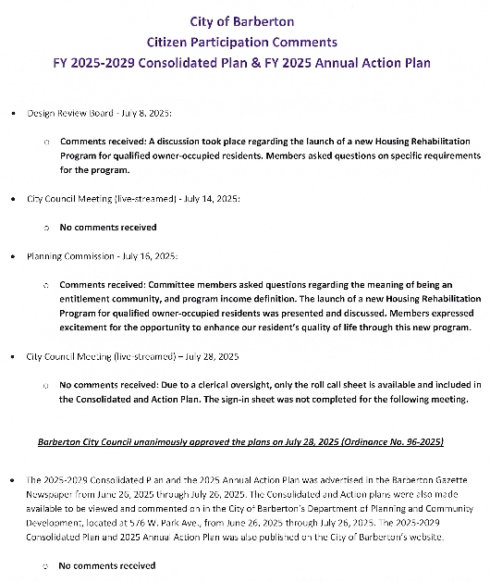
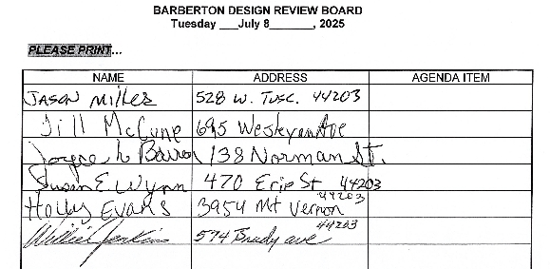
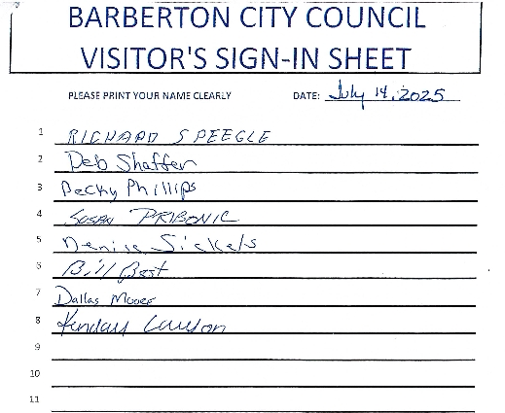
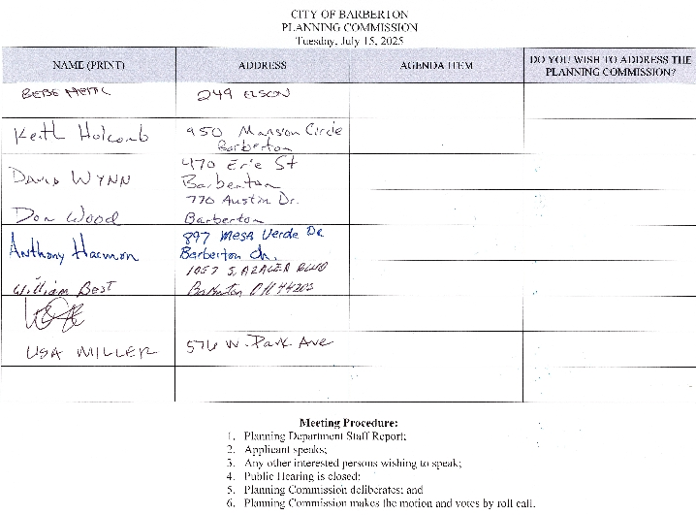
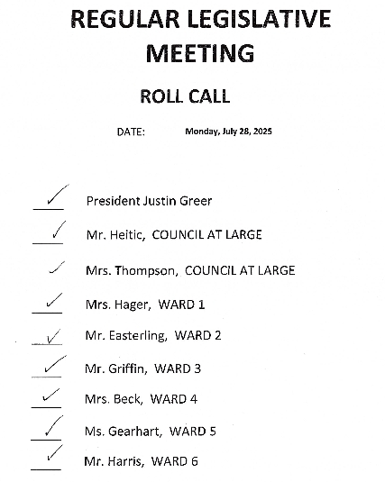
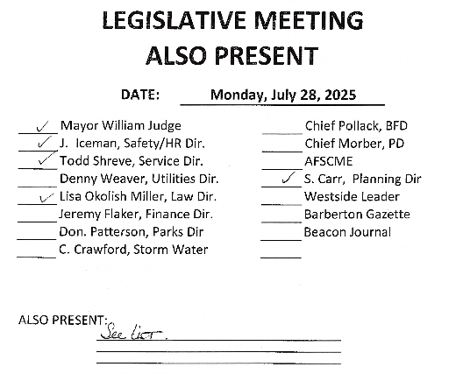
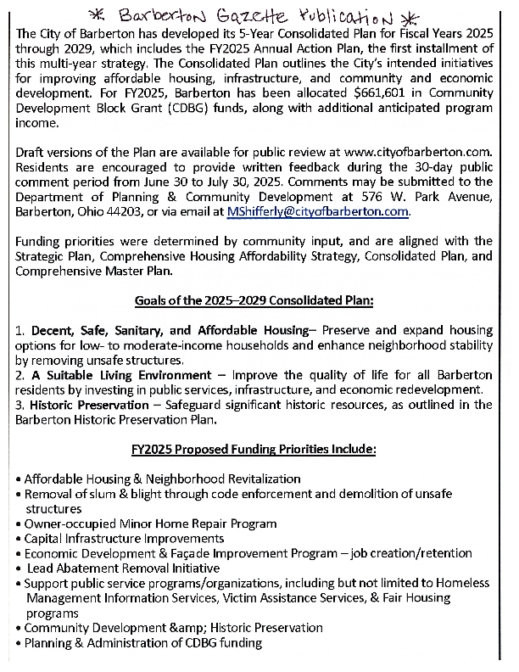
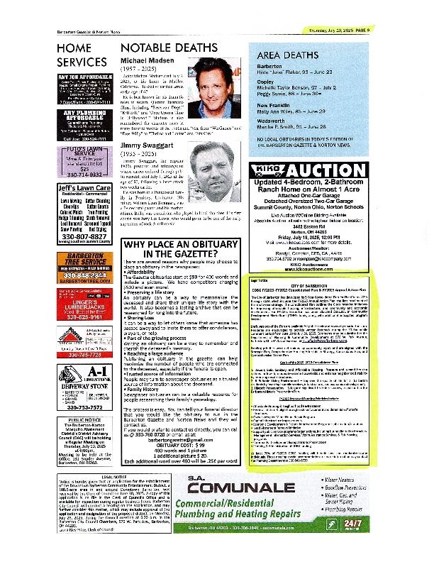
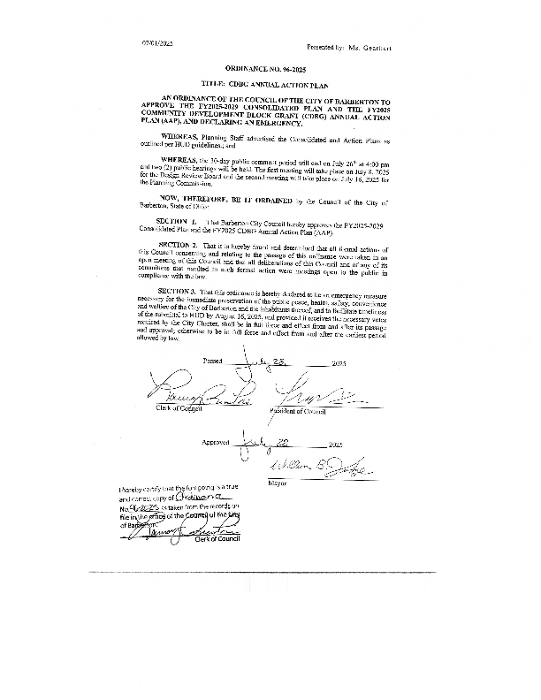

Grantee Unique Appendices
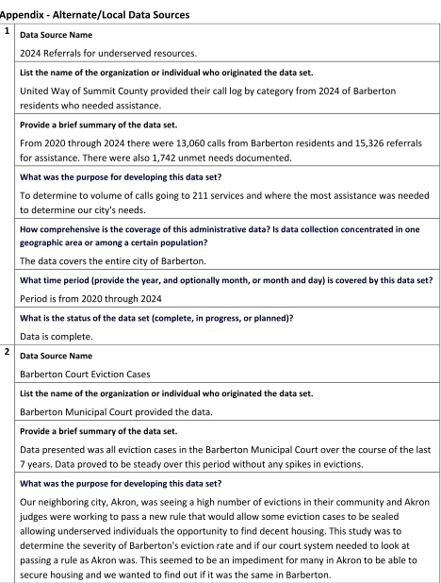
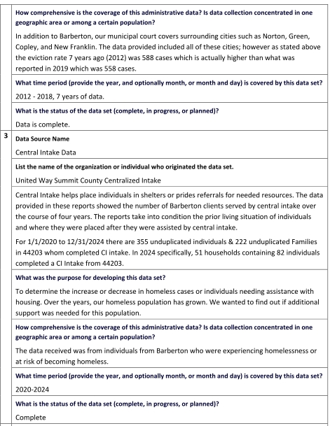
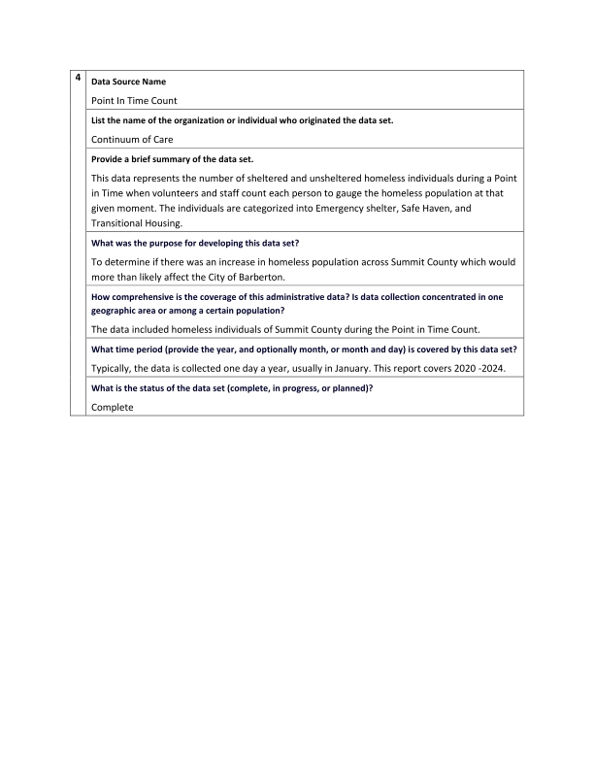

Grantee SF-424's and Certification(s)
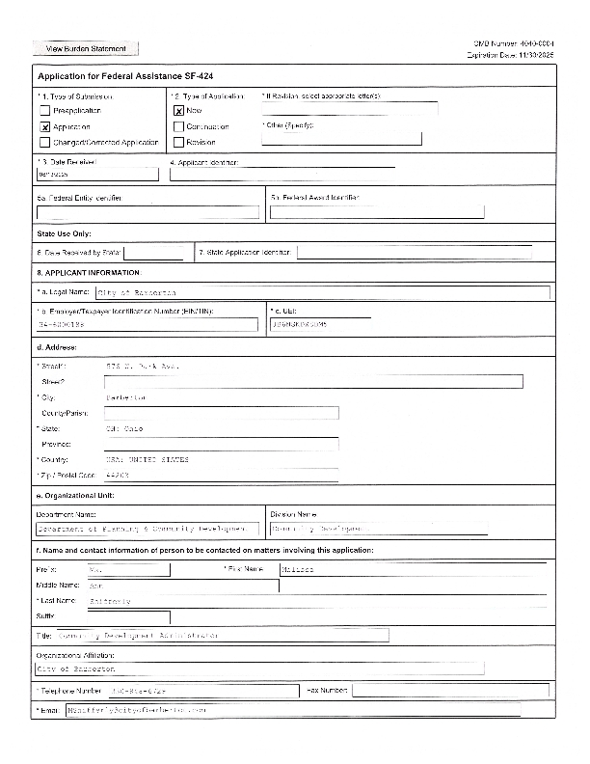
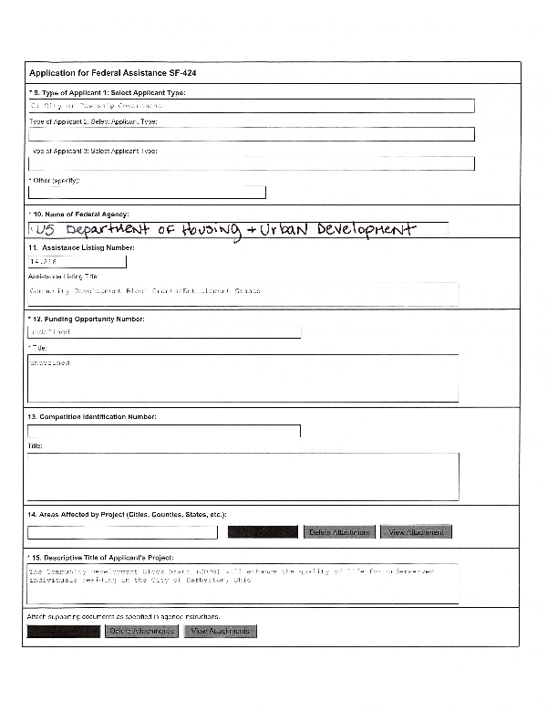
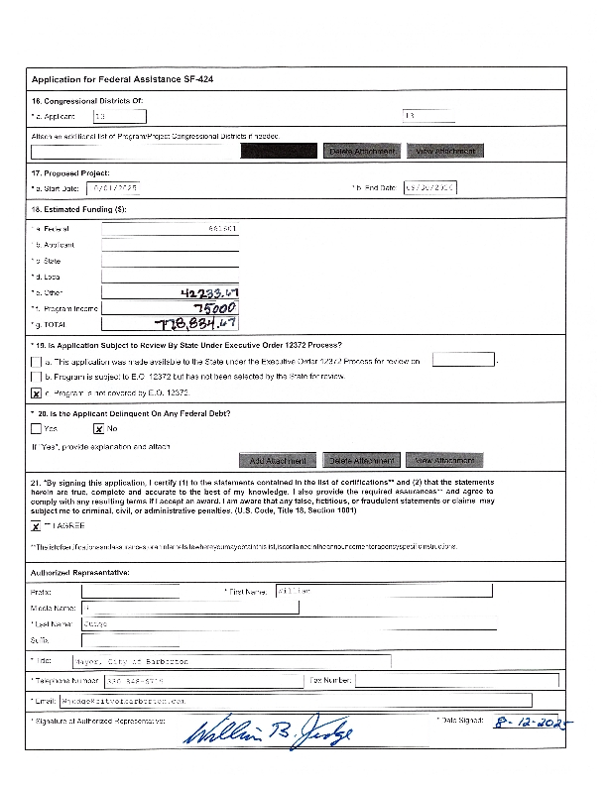
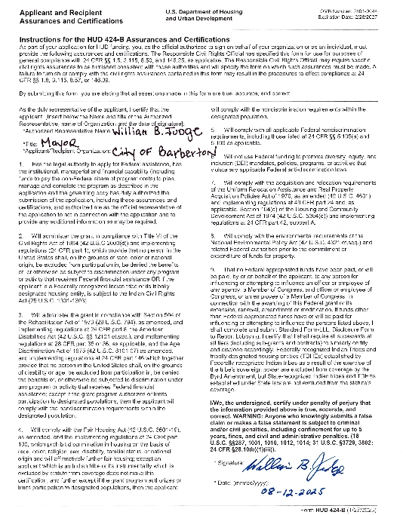
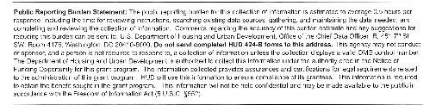
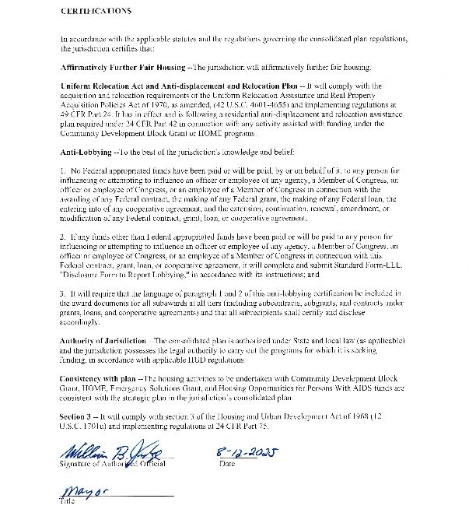
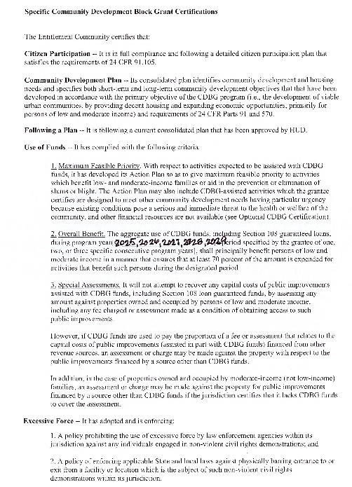
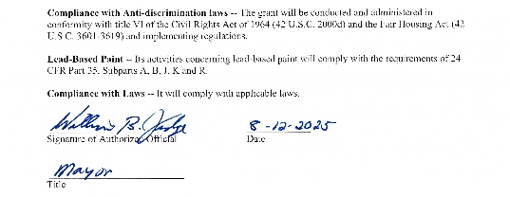

Appendix - Alternate/Local Data Sources
1 | Data Source Name  2025 Referrals for LMI Resources
1 | List the name of the organization or individual who originated the data set.  United Way of Summit County provided their call log by category from 2024 of Barberton residents who needed assistance.
1 | Provide a brief summary of the data set.  From 2020 through 2024 there were 13,060 calls from Barberton residents and 15,326 referrals for assistance. There were also 1,742 unmet needs documented.
1 | What was the purpose for developing this data set?  To determine to volume of calls going to 211 services and where the most assistance was needed to determine our city's needs.
1 | How comprehensive is the coverage of this administrative data? Is data collection concentrated in one geographic area or among a certain population?  The data covers the entire city of Barberton.
1 | What time period (provide the year, and optionally month, or month and day) is covered by this data set?  Period is from 2020 through 2024
1 | What is the status of the data set (complete, in progress, or planned)?  Data is complete.
2 | Data Source Name  Barberton Court Eviction Cases
2 | List the name of the organization or individual who originated the data set.  Barberton Municipal Court provided the data
2 | Provide a brief summary of the data set.  Data presented was all eviction cases in the Barberton Municipal Court over the course of the last 7 years. Data proved to be steady over this period without any spikes in evictions.
2 | What was the purpose for developing this data set?  Our neighboring city, Akron, was seeing a high number of evictions in their community and Akron judges were working to pass a new rule that would allow some eviction cases to be sealed allowing LMI individuals the opportunity to find decent housing. This study was to determine the severity of Barberton's eviction rate and if our court system needed to look at passing a rule as Akron was. This seemed to be an impediment for many in Akron to be able to secure housing and we wanted to find out if it was the same in Barberton.
2 | How comprehensive is the coverage of this administrative data? Is data collection concentrated in one geographic area or among a certain population?  In addition to Barberton, our municipal court covers surrounding cities such as Norton, Green, Copley, and New Franklin. The data provided included all of these cities; however as stated above the eviction rate 7 years ago (2012) was 588 cases which is actually higher than what was reported in 2019 which was 558 cases.
2 | What time period (provide the year, and optionally month, or month and day) is covered by this data set?  2012 - 2018, 7 years of data.
2 | What is the status of the data set (complete, in progress, or planned)?  Data is complete.
3 | Data Source Name  Central Intake Data
3 | List the name of the organization or individual who originated the data set.  United Way Summit County Centralized Intake
3 | Provide a brief summary of the data set.  Central Intake helps place individuals in shelters or prides referrals for needed resources. The data provided in these reports showed the number of Barberton clients served by central intake over the course of four years. The reports take into condition the prior living situation of individuals and where they were placed after they were assisted by central intake.  For 1/1/2020 to 12/31/2024 there are 355 unduplicated individuals & 222 unduplicated Families in 44203 whom completed CI intake. In 2024 specifically, 51 households containing 82 individuals completed a CI Intake from 44203.
3 | What was the purpose for developing this data set?  To determine the increase or decrease in homeless cases or individuals needing assistance with housing. Over the years, our homeless population has grown. We wanted to find out if additional support was needed for this population.
3 | How comprehensive is the coverage of this administrative data? Is data collection concentrated in one geographic area or among a certain population?  The data received was from individuals from Barberton who were experiencing homelessness or at risk of becoming homeless.
3 | What time period (provide the year, and optionally month, or month and day) is covered by this data set?  2020-2024
3 | What is the status of the data set (complete, in progress, or planned)?  Complete
4 | Data Source Name  Point In Time Count
4 | List the name of the organization or individual who originated the data set.  Continuum of Care
4 | Provide a brief summary of the data set.  This data represents the number of sheltered and unsheltered homeless individuals during a Point in Time when volunteers and staff count each person to gauge the homeless population at that given moment. The individuals are categorizied into Emergency shelter, Safe Haven, and Transitional Housing.
4 | What was the purpose for developing this data set?  To determine if there was an increase in homeless population across Summit County which would more than likely affect the City of Barberton.
4 | How comprehensive is the coverage of this administrative data? Is data collection concentrated in one geographic area or among a certain population?  The data included homeless individuals of Summit County during the Point In Time Count.
4 | What time period (provide the year, and optionally month, or month and day) is covered by this data set?  Typically the data is collected one day a year, usually in January. This report covers 2020 -2024.
4 | What is the status of the data set (complete, in progress, or planned)?  Complete

