City of Barberton
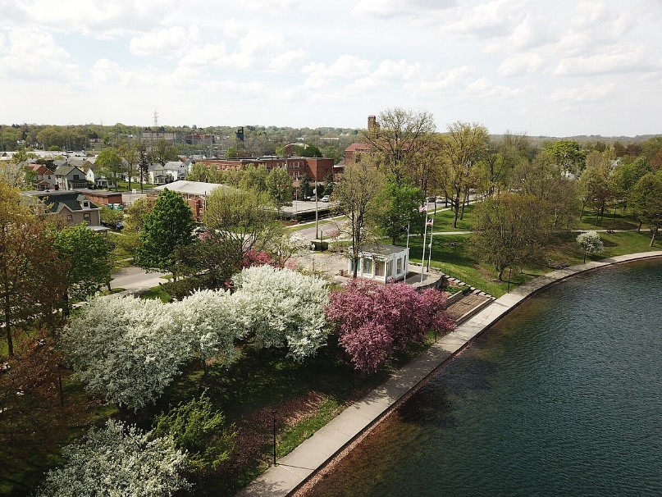

Request for Proposals
for
City-Wide Master Plan

City of Barberton Planning Department
576 W. Park Ave
Barberton, Ohio 44203
Phone 330.848.6729
Cityofbarberton.com

City of Barberton, Ohio

Comprehensive City-wide Master Plan (ten-year vision) RFP Summary

Issue Date: December 18, 2025
Proposal Due Date: Thursday, January, 29, 2026 by 4:00pm
Contact: Stacy Carr, Planning Director 330.848.6729, planning@cityofbarberton.com

1. Introduction and Background
The City of Barberton, known as the Magic City, (population 25,000) seeks qualified planning firms to develop a Comprehensive City-wide Master Plan guiding development over the next decade. This plan will guide Barberton’s development over the next ten years, addressing current challenges while positioning the city of sustainable growth and improved quality of life.

Barberton’s last comprehensive plan was completed in 2006. Significant changes in economic conditions, population demographics, development trends, and environmental considerations necessitate a new forward-looking plan that addresses current realities and future plans.

Key Challenges and Opportunities:
- Aging infrastructure requiring modernization
- Downtown revitalization needs
- Changing demographics and housing needs
- Post-industrial economic transition
- Underutilized natural assets
- Strategic neighborhood investment

2. Project Purpose and Objectives
To develop a practical, implementable Comprehensive Master Plan serving as the primary policy guide for development, housing, transportation, infrastructure, and resource conservation decisions.

The Master Plan Shall:
- Establish a clear vision reflecting community values
- Provide policy framework and implementation strategies
- Analyze existing conditions, trends, and projected needs
- Incorporate innovative urban solutions
- Ensure diverse stakeholder participation
- Develop measurable goals with implementation steps
- Balance aspirational goals with practical implementation
- Position Barberton competitively while maintaining identity

3. Scope of Services
3.1 Project Management
- Detailed work plan and schedule
- Progress meetings and monthly reports
- Project documentation
3.2 Public Engagement
- Comprehensive participation strategy
- Minimum three community workshops
- Eight focus group meetings
- Project steering committee
- Surveys (online/paper)
- Interactive web tools
- Spanish translation for key materials
3.3 Data Collection and Analysis
- Review existing plans and policies
- Demographic, economic, housing data analysis
- Gap analysis for services/infrastructure
3.4 Plan Elements
- Land Use and Development Analysis
- Housing Analysis
- Economic Development
- Transportation and Mobility
- Infrastructure and Utilities
- Parks, Recreation, and Open Spaces
- Community and Services
- Urban Design and Community Character
- Environmental Sustainability and Resilience
3.5 Implementation Strategy
- Clear implementation steps for all elements
- Responsible parties and timeframes
- Cost estimates and funding sources
- KPI’s for measuring progress

4. Deliverables
- Detailed project management documentation
- Public engagement materials and summary report
- Comprehensive existing conditions report
- Draft plan components for review
- Executive Summary (standalone, max 20 pages)
- Final Master Plan with technical appendices
- Implementation matric and digital dashboard
- Ten printed copies of final plan, 20 copies of executive summary
- Digital files (editable formats, PDF’s, GIS data
- Required presentations (Planning Commission, City Council)
5. RFP Timeline
- RFP Issued: December 19, 2025
- Proposals Due: January 29, 2026
- Consultant Selection: Week of February 16, 2026
6. Budget Information
- Budget range: $100,000 – $175,000. Proposals must include detailed budget breakdown by task
7. Submission Requirements
- Transmittal Letter
- Executive Summary
- Project Understanding and approach
- Project Team
- Relevant Experience
- Project Schedule
- Budget Proposal
- One original and 10 printed copies
- One digital copy
8. Evaluation Criteria
- Understanding of Project Requirements (20 points)
- Qualifications and Experience (25 points)
- Public Engagement Approach (15 points)
- Project Management Approach (15 points)
- Technical Capabilities (15 points)
- Cost Proposal (10 points)

9. Required Qualifications (Firm/Team)
- Minimum 8 years in urban planning
- Completion of 3+ similar plans within 7 years
- Ohio Business license
- $2M professional liability insurance
- Project Manager with 10+ years experience
- Team expertise in land use, urban design, economic development, transportation, infrastructure, housing, environmental planning, public engagement, and implementation

Proposals must be submitted to:
Barberton Planning Department
Attn: Stacy Carr
576 W. Park Ave
Barberton, Ohio 44203

Proposals shall be clearly marked with the RFP title and proposer’s name. Please submit in a sealed package marked “Proposal: Barberton Master Plan”.

Proposals must be submitted no later thank 4:00pm on Thursday, January 29, 2026

All inquiries regarding this RFP should be submitted in writing (email preferred) to:
Barberton Planning Department
Attn: Stacy Carr
576 W. Park Ave
Barberton, Ohio 44203
330.848.6729
planning@cityofbarberton.com

