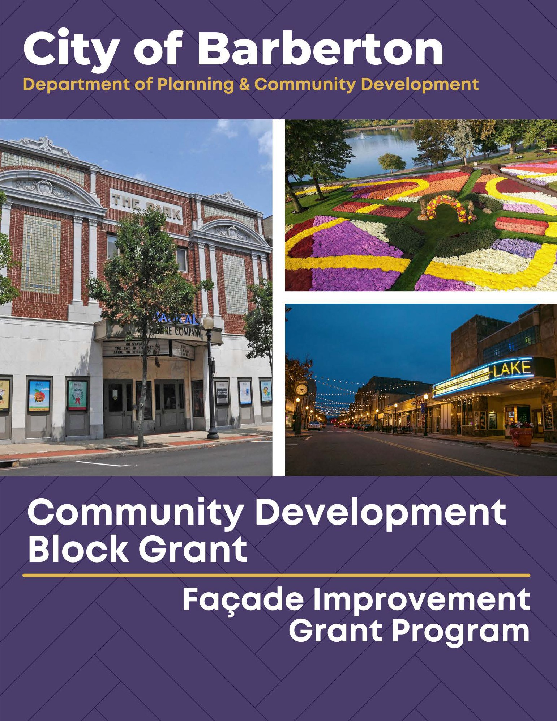

About the Community Development Block Grant (CDBG)
The Community Development Block Grant (CDBG) program was enacted in 1974 to provide block grant funding for community development programs. The program assists urban, suburban, and rural communities in improving housing and living conditions and expanding economic opportunities for low and moderate-income persons. CDBG helps create jobs through the expansion and retention of businesses and is an excellent tool for assisting local governments in overcoming serious challenges facing their communities. CDBG funds partner with the private and non-profit sectors to support economic development and improve community conditions. The City of Barberton, through the Community Development Block Grant (CDBG), has created a program to provide grants to property owners for economic development purposes. The primary purpose of this program is to assist with small project improvements that may be holding back a business from opening and creating jobs in the City of Barberton. CDBG is federally funded; therefore, all construction projects that receive two thousand dollars ($2,000) or more will be subject to Davis Bacon Prevailing Wage requirements.

Project Eligibility Guidelines
All work completed must be for a commercial building located in a low to moderate-income census tract in the City of Barberton. Our program is available to businesses and property owners for work on first- and second-floor spaces with an active street presence and where other funding sources have not been obtained. Façade improvements are strictly for the exterior of the building, visible from the public right of way. The primary purpose of this program is to improve the condition and curb appeal of commercial buildings. Funds cannot be used to correct property damaged by collision, acts of nature, or occurrences covered by insurance. Only work begun after execution of the grant agreement will be eligible for funds. All work must comply with federal, state, and local laws, ordinances, codes, and regulations.

*Buildings located in the Downtown Barberton Historic District require Design Review Board approval before any façade improvements are completed. For more information, please contact us at MShifferly@cityofbarberton.com.*

Elements that are eligible include, but are not limited to:

- Exterior painting;
- Removal of inappropriate or incompatible exterior finishes and materials (false fronts such as aluminum panels);
- Restoration of exterior finishes and materials;
- Installation of safety glass;
- Reconfiguration of existing doors and entrances;
- Repair or replacement of existing storefront window systems;
- Signage (new, repair, replace, or remove);

Ineligible elements include:
- Sidewalks, light posts, and/or parking;
- Streetscape features (plantings, benches, etc.);
- Building interiors;
- Signage not connected to the building;
- Generally, purchase of equipment with CDBG funds;
- Mowing of recreational areas;
- Exterior lighting (building, signs, display areas);
- Awnings (new, repair or replacement of existing);
- Improving exterior architectural barriers that restrict the mobility and accessibility of elderly or severely disabled persons to public facilities and improvements;
- Outdoor sculptures, pools of water, and fountains, and other works of art;
- Installation of outdoor security devices.

- Personal property that is not an integral structural fixture;
- Political activities;
- Fees associated with the Design Review Board & zoning approval process;
- General work in FEMA designated special flood areas unless specific precautions are undertaken.

Application Review & Process
Applicants applying for a façade improvement grant must complete a pre-approval application to ensure project eligibility and feasibility. Grants will not be awarded to projects currently under construction or completed. During this initial review, the Department of Planning & Community Development (DPCD) will determine if the project meets an eligible activity, if zoning is compatible, and if environmental and historical studies need further assessment. Following an approved initial review, the Applicant must complete a full application with required documentation (review Checklist of Required Documentation). During this second review, the DPCD will determine if the documentation is adequate/complete and find any outstanding violations (e.g., building code violations, tax delinquency, liens, and a general background check). Following an approved secondary review, the Project Review Committee (PRC) will invite the Applicant to present the proposed project and determine if the grant will be awarded based on all elements presented. The DPCD will then follow all final procurement procedures to ensure financial accountability. Following final procurement approval, the Applicant will be presented with a legally bound grant agreement. Once signed, the City will remit payment, file necessary lending documents, and monitor/report project status for the grant duration.

NOTE: The City has limited funds, and grants are offered first-come, first-serve basis.

Application packages must include enough documentation to illustrate the visual impact of the project and its costs. Failure to provide the required information will delay the review process.

This grant is reimbursable upon completion of the project. Funds will not be distributed until all administrative, financing, legal, and construction requirements are satisfied.

Project Review Committee
The Project Review Committee (PRC) reserves the right to refuse reimbursements in whole or in part for work that:
- Does not conform to the project eligibility guidelines, application review/process, or program policy;
- Does not conform to the proposals submitted with your application and authorized by the PRC;
- Are not commensurate with the workmanship and cost customary to the industry;
- Are not completed within six (6) months. Since the Committee cannot reserve funds indefinitely, your grant may be subject to cancellation if not completed, or significant progress has not been made by the completion date. Request for extensions will be considered by the PRC only if made in writing and progress towards completion has been demonstrated.

The PRC reserves the right to offer grant amounts different from the amount requested by the Applicant.

Match Requirement
The economic development grant requires an eighty/twenty percent (80/20) match. The grant can pay up to a maximum of eighty (80%) of a project’s total cost. The Applicant will be responsible for the twenty (20%) match.

Questions & Comments
If you have any questions or comments regarding this application, please contact us at MShifferly@cityofbarberton.com or 330-848-6729.

PRE-APPROVAL APPLICATION

Applicant Information
Legal Name:
Relation to Property:
Phone Number:
Email Address:

Property Information
Address:
City/State/Zip Code:
Parcel Number:
Property Owner (if different)
Owner Phone & Email
Current Zoning: |  | Total Number of Tenants:
Number of Residential Units: |  | Number of Business Units:
Current Use:
Current Tenants:
Is the Property mortgaged? |  | Amount Owed:
Located in Historic District? |  | Located in floodplain?

Attach a separate sheet including the information below for each business tenant.

Business Information
Legal Name:
Address:
City/State/Zip Code:
Business Owner (if different):
Owner Phone & Email:
Business NAICS Code: |  | Business EIN Number:
Business DUNS Number: |  | Business CAGE Code:

*To obtain a DUNS Number, go to dnb.com. Once the business has a DUNS Number, go to sam.gov/content/entity-landing to receive a CAGE Code. (Note: Obtaining a DUNS Number and CAGE Code are FREE.)*

**Due to using Community Development Block Grant funding, buildings must be located in a low to moderate-income census tract. To confirm that the building is in a low to moderate-income area (LMA), please contact us at MShifferly@cityofbarberton.com.**

***Buildings located in the Downtown Barberton Historic District require Design Review Board approval before any façade improvements are completed. For more information, please contact us at MShifferly@cityofbarberton.com.***

****Construction projects that receive two thousand dollars ($2,000) or more will be subject to Davis Bacon Prevailing Wage requirements. These projects will require competitive sealed bids and formal advertising.****

PRE-APPROVAL APPLICATION (CONTINUED)
Project Information
Total Project Cost: |  | Amount Requesting:
Amount Leveraged: |  | Amount Matching:
Identify the scope of work related to this project. Please provide a quote with an accurate/competitive estimate. Please
also provide current photos and conditions of the property. You may attach a separate sheet if necessary.
Please provide a timeline of events for the use of funds if approved. Projects should be completed within six (6) months. You may attach a separate sheet if necessary.

I understand the façade improvement grant project eligibility guidelines and application review process. I attest that all information provided in this pre-approval application to be true to my best ability.
APPLICANT’S SIGNATURE: DATE:

APPLICANT’S PRINTED NAME:

FULL APPLICATION
This section of the application is to be completed following after initial review of the pre-approval application. Once approved, please provide the following required documentation.

Checklist of Required Documentation
- Design Review Board Approval, if applicable
- Articles of Incorporation or other Business Organization Documents (for all business tenants)
  - EIN, NAICS Code, DUNS Number, and CAGE Code (for all business tenants)
- Insurance Documentation
  - Proof of Business Insurance (for all business tenants)
  - Proof of Real Estate Insurance held in the State of Ohio (for Property Owner)
  - Proof of Flood Insurance, if applicable (for Property Owner)
- Evidence of Liquid Assets
  - Must be able to provide twenty (20%) match (proof may come from bank statements/letters)
- Lease Agreement/Mortgage Deed
  - Notarized written consent from the Property Owner permitting to conduct building improvements (if Applicant is not the Property Owner)
- Building Occupancy Plan

Building Occupancy Plan
Please describe how this facade improvement project will assist in keeping the building or obtaining a long-term tenant. How do you plan on keeping all tenant spaces occupied? If unoccupied, how do you plan on filling the spaces? You may attach a separate sheet if necessary.

I certify that the building occupancy plan is true to my best ability. I understand that any documentation required must be submitted with this full application to be deemed “complete” and considered for approval.
APPLICANT’S SIGNATURE: DATE:

APPLICANT’S PRINTED NAME:

