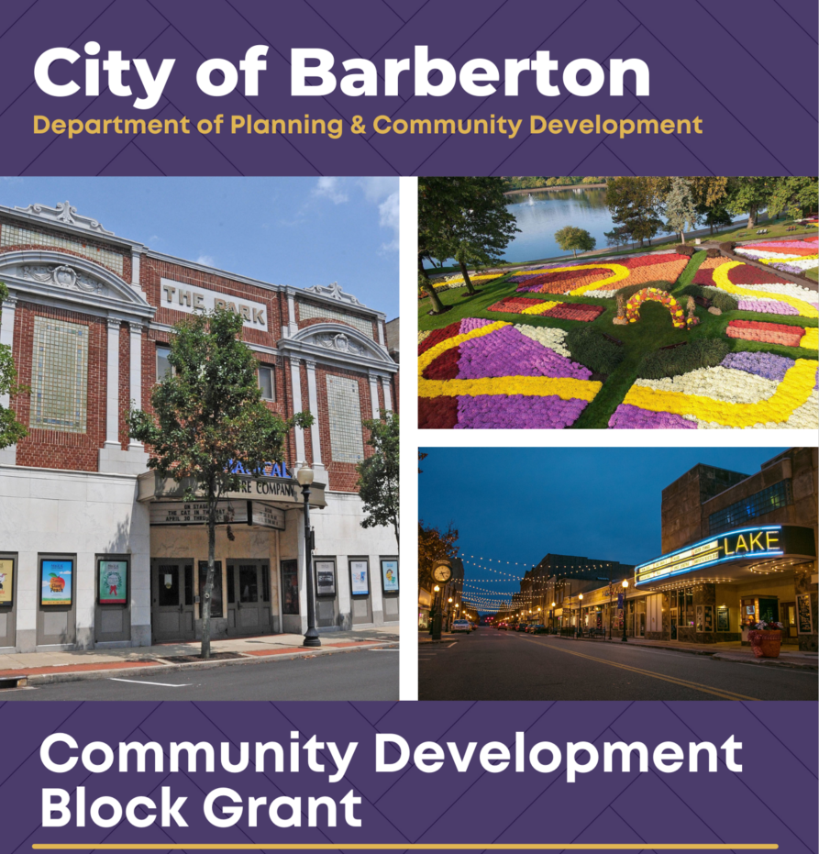
Project Year 2026
Application for Public Service Funding

About the Community Development Block Grant (CDBG)
The Community Development Block Grant (CDBG) program was enacted in 1974 to provide block grant funding for community development programs. The program assists urban, suburban, and rural communities in improving housing and living conditions and expanding economic opportunities for low and moderate-income persons.

Project Eligibility Guidelines
This application is intended for agencies that provide eligible CDBG activities for low to moderate-income (LMI) individuals and households. The project must align with at least one objective of the Consolidated Plan. All projects must be ready to start at the time of application. The project must be completed within one (1) year, and all agreements will be made with October 1, 2026 as the effective start date and September 30, 2027 as the completion date. Upon agreement execution, all eligible expenses between October 1, 2026 – September 30, 2027 will be funded. All CDBG rules and regulations are in place even if the City and the agency have not signed an executed agreement.

NOTE: Funding is contingent upon the U.S. Department of Housing and Urban Development (HUD) approval of the City’s Annual Action Plan (AAP). All CDBG grants are reimbursement-based. Agencies should have the financial capacity to provide the proposed projects until reimbursement for eligible costs is available.

Application Review & Process
Applicants must complete a full application to be considered for CDBG grant funding. It is recommended that applicants contact the Department of Planning & Community Development (DPCD) to ensure that the proposed project is an eligible CDBG activity. Applications must be typed in the space provided on the application. Applications are in fillable PDF forms. If additional space is needed, the agency may attach additional pages. Please do not provide any additional attachments beyond those that have been requested. If there are requested attachments that the agency cannot provide, there must be an explanation regarding their omission. Complete applications must be submitted by the due date to be considered for funding.

The Project Review Committee (PRC) will review applications after the DPCD determines application completion. The PRC will evaluate applications based on the following criteria:

- Application completion, including appropriate documentation attached,
- Meeting an objective of the Consolidated Plan,
- Project eligibility and feasibility,
- Agency capacity,
- Evidence of matching/leveraged funding,
- Collaboration with other agencies, and
- Other criteria deemed necessary by the PRC.

After review, the DPCD will notify agencies of application status. If awarded, the City will enter into an agreement with the agency, monitor project progress, ensure CDBG compliance, and remit payment on a reimbursement basis.

NOTE: The PRC reserves the right to offer grants different from the amount requested by the Applicant.

Questions & Comments
If you have any questions or comments regarding this application, please contact the Planning Department at 330.848.6729 or MShifferly@cityofbarberton.com

Applicant Information
Name:
Title:
Phone Number:
Email Address:

Agency Information
Agency Name:
Agency Address:
Agency NAICS Code: |  | Agency Tax ID Number:
Agency CAGE Code:

Project Information
Project Name:
Total Project Cost: |  |  |  |  |  |  |  | Amount Requesting:
Amount Leveraged: |  |  |  |  |  |  |  | Amount Matching:
Project Objective: |  |  |  |  |  | Suitable Living Environment |  |  | Rationale:
 |  |  |  |  |  | Decent Housing
 |  |  |  |  |  | Economic Opportunity
Project Outcome: |  |  |  |  |  | Availability/Accessibility |  |  | Rationale:
 |  |  |  |  |  | Affordability
 |  |  |  |  |  | Sustainability
Which CDBG criterion below does your project meet? (select one, unless subpart is required)
 | Area Benefit (At least 51% of the targeted activity area residents are LMI)
 | Limited Clientele (select subpart below):
 |  | Special Needs Group (select benefit group from the list below):
 |  |  | Abused children
 |  |  | Elderly persons 62 years or older
 |  |  | Battered spouses
 |  |  | Severely disabled adults (not children) – Census definition; documentation required
 |  |  | Illiterate adults
 |  |  | Persons living with HIV/AIDS
 |  |  | Migrant Farm Workers
 |  |  | Homeless persons
 |  | At least 51% of clientele to be served will be documented as LMI.
 | Housing (select subpart below):
 |  | Single Family (must be 100% LMI)
 |  | Multi-Tenant (must be 51% LMI)
 | Job Creation/Retention (at least 51% of jobs for LMI persons) – documentation required
Project Description
Include supporting documentation and a statement of need. The project must meet one of the goals listed in the Consolidated Plan. Describe the target population that will benefit from the project, the estimated number of clients to be served, and how the Agency will inform the target population about the project. Use additional sheets if necessary.
Agency Capacity
Who will be the person responsible for the overall oversight of the proposed project?
Name:
Title:
Phone Number:
Email Address:
Who will be the alternate person responsible for the overall oversight of the proposed project?
Name:
Title:
Phone Number:
Email Address:
Who will be the person responsible for the daily operations and management of the proposed project?
Name:
Title:
Phone Number:
Email Address:
Who will be the person responsible for the financial oversight of the CDBG expenditures and fiscal compliance?
Name:
Title:
Phone Number:
Email Address:
List the evaluation tools your agency plans to employ to track and monitor the progress of the project. Include fiscal oversight policies, agency capacity, and any previous experience serving low to moderate-income populations. Provide a Board of Directors list or Board of Trustees with the application. Use additional sheets if necessary.
CITY OF BARBERTON
COMMUNITY DEVELOPMENT BLOCK GRANT
PROGRAM YEAR 2026 APPLCATION – PROJECT BUDGET
AGENCY/OWNER:
PROJECT:
 |  |  | CDBG Funds Requested |  | Agency/Local Funds |  | State Funds |  |  | Federal Funds |  | In Kind
Activity Delivery Costs to operate the program*
Construction
Consultant Services
Postage
Publications/Printing
Supplies
Transportation
Equipment Rental |  |  | Ineligible
Fringe Benefits |  |  | Ineligible
Insurance |  |  | Ineligible
Maintenance/Repair |  |  | Ineligible
Rent |  |  | Ineligible
Salaries & Wages |  |  | Ineligible
Telephone |  |  | Ineligible
Utilities |  |  | Ineligible
Other:
TOTAL

* Activity Delivery Costs: direct costs related to the current CDBG project application that result in a beneficiary. Activity Delivery Costs must conform with HUD/CDBG regulations, policies, notices, and guidance. *

I understand the CDBG grant project eligibility guidelines and application review process. I attest that all information provided in this pre-approval application to be true to my best ability.

APPLICANT’S SIGNATURE: __________________________________________________ DATE: ____________________

APPLICANT’S PRINTED NAME: ________________________________________________________________________

